sweep algorithm

[intro]

$$An aglorithm that$$

$$determines whether any pairs of segements intersects.$$

[concept]

$$Using lots of sweep lines (vertical dotted line)$$

[analysis]

$$O(n\lg{n})$$

[term]

$$\left(1\right)comparable:$$

$$If s_{1} and s_{2} is comparable iff$$

$$s_{1} and s_{2} both intersect with a same sweep line.$$

$$\left(2\right)above:$$

$$If s_{1} is above s_{2} iff$$

$$s_{1} and s_{2} is comparable and$$

$$the intersection of s_{1} and the sweep line is higher than$$

$$the intersection of s_{2} and the same sweep line.$$

$$Written as$$

$$s_{1}≽_{x} s_{2}$$

[donation]

$$\left(1\right)≽_{x}:$$

$$s_{1}≽_{x} s_{2}$$

$$means that s_{1} is above s_{2} on the sweep line x.$$

[property]

$$\left(1\right)transitivity:$$

$$s_{1}≽_{x} s_{2} and s_{2}≽_{x} s_{3}=>s_{1}≽_{x} s_{3}$$

$$\left(2\right)my thought and contents in textbook are different.$$

$$my thought$$

$$NO reflexivity:$$

$$s_{1}≽_{x} s_{1} is always false.$$

$$contents in textbook$$

$$reflexivity$$

$$\left(3\right)NO symmetry:$$

$$s_{1}≽_{x} s_{2}=>s_{2}≽_{x} s_{1} is always false.$$

$$s_{1}≽_{x} s_{2}$$

$$\left(4\right)NO anti-symmetry:$$

$$s_{1}≽_{x} s_{2} and s_{2}≽_{x} s_{1}=>s_{1}=s_{2} is always false$$

$$since s_{1}≽_{x} s_{2}=>s_{2}≽_{x} s_{1} is always false$$

$$\left(see property\left(3\right)\right).$$

$$\left(5\right)preorder relation:$$

$$Since property \left(1\right) to \left(4\right).$$

[E.g.]

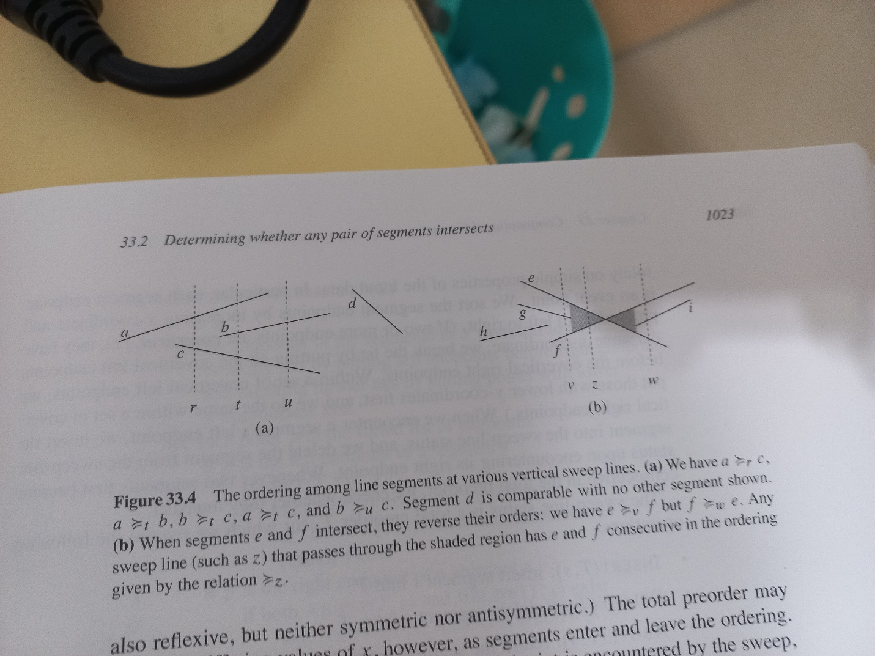

[pseudo code]

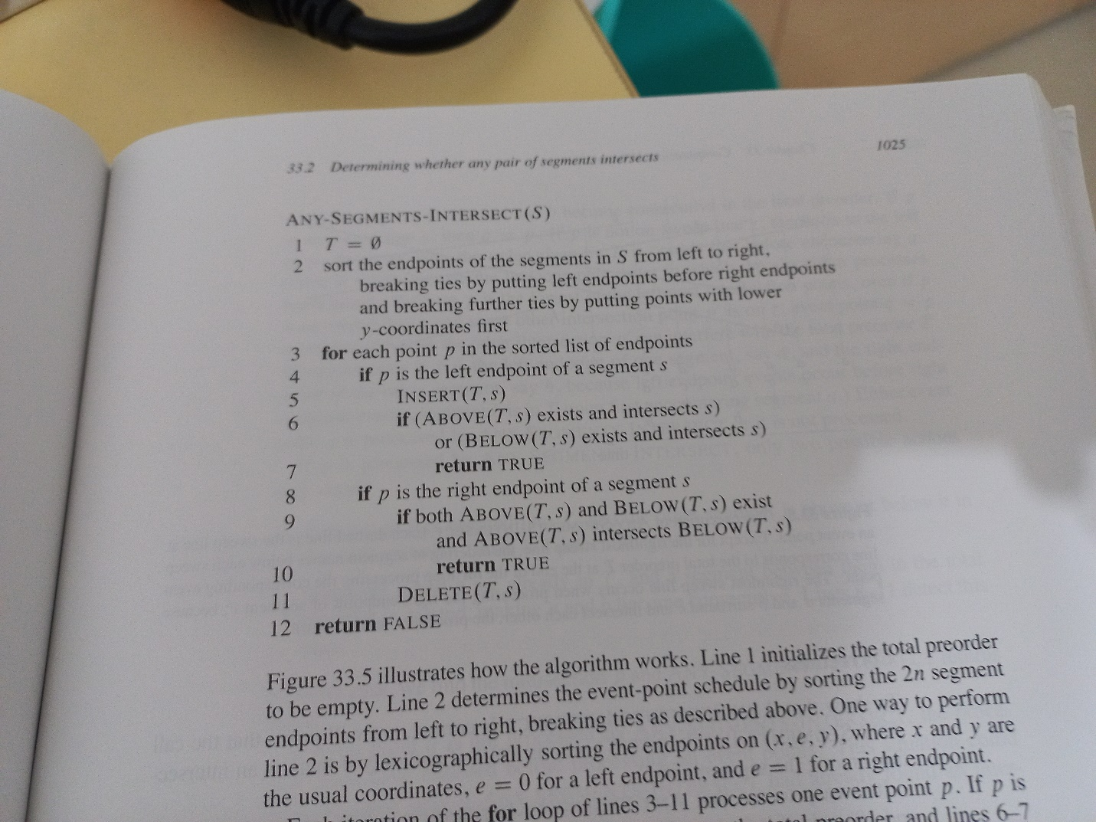

$$Operations such as INSERT DELETE ABOVE BELOW$$

$$are represented in algorithm textbook CH13$$

$$(using red-black tree)$$

[ref]

$$algorithm textbook CH33-2$$