Toom Cook multiplication

[intro]

[step]

$$Given m and n.$$

$$Define D\left(n\right)=number of digit of n.$$

$$Define\deg\left(p\right) is the degree of the polynomial p.$$

$$\left(1\right)Splitting.$$

$$Select the Base B=b^{i}$$

$$such that D\left(n\right),D\left(m\right) is at most k.$$

$$A typical choice of i is$$

$$i=\max\left\{\left\lfloor \frac{\left\lfloor \log_{b}{m}\right\rfloor }{k}\right\rfloor ,\left\lfloor \frac{\left\lfloor \log_{b}{n}\right\rfloor }{k}\right\rfloor \right\}+1$$

$$\left(2\right)Create two polynomials p and q$$

$$with both degree \left(k-1\right)$$

$$where$$

$$p=\sum_{i=1}^{k-1}{m_{i}x^{i}},$$

$$q=\sum_{i=1}^{k-1}{n_{i}x^{i}}$$

$$\left(3\right)Call d_{t}$$

$$d_{t}=\deg\left(pq\right)-1=\deg\left(p\right)+\deg\left(q\right)-1.$$

$$\left(4\right)Find any d_{t} points.$$

$$For convenience, we usually selected values nearly to 0.$$

$$PTS=\left\{pts_{1},pts_{2},…,pts_{d_{t}}\right\}$$

$$\left(5\right)Evaluate.$$

$$p\left(pts_{i}\right),q\left(pts_{i}\right)∀ i=1,2,…,d_{t}$$

$$\left(6\right)Pointwise mulitplication.$$

$$Find r\left(pts_{i}\right) such that$$

$$r\left(pts_{i}\right)=p\left(pts_{i}\right)*q\left(pts_{i}\right) ∀i=1,2,…,d_{t}$$

$$\left(7\right)Interpolation.$$

$$\left(8\right)$$

$$Find r_{i} with r\left(pts_{i}\right)$$

$$r_{0}=r\left(pts_{0}\right),$$

$$r_{4}=r\left(pts_{4}\right),$$

$$r_{3}=\frac{r\left(pts_{3}\right)-r\left(pts_{1}\right)}{3},$$

$$r_{1}=\frac{r\left(pts_{1}\right)-r\left(pts_{2}\right)}{2},$$

$$r_{2}=r\left(pts_{2}\right)-r\left(pts_{0}\right),$$

$$r_{3}=\frac{r_{2}-r_{3}}{2}+2r\left(pts_{4}\right)$$

$$r_{2}=r_{2}+r_{1}-r_{4},$$

$$r_{1}=r_{1}-r_{3}$$

$$(8)Create a polynomial r with cofficients$$

$$r_{i} ∀i=1,2,…,d_{t}$$

$$r\left(x\right)=\sum_{i=1}^{d_{t}-1}{r_{i}*x^{i}}$$

$$\left(9\right)Recomposition.$$

$$r\left(B\right) is our answer.$$

[E.g.]

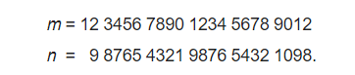

$$For example, we want to multiply$$

$$m=12,3456,7890,1234,5678,9012$$

$$and$$

$$n= 9,8765,4321,9876,5432,1098$$

$$\left(1\right)Select$$

$$k=3,b=10$$

$$i=\max\left\{\left\lfloor \frac{\left\lfloor \log_{b}{m}\right\rfloor }{k}\right\rfloor ,\left\lfloor \frac{\left\lfloor \log_{b}{n}\right\rfloor }{k}\right\rfloor \right\}+1$$

$$=\max\left\{\left\lfloor \frac{\left\lfloor \log_{10}{m}\right\rfloor }{3}\right\rfloor ,\left\lfloor \frac{\left\lfloor \log_{10}{n}\right\rfloor }{3}\right\rfloor \right\}+1$$

$$=\max\left\{\left\lfloor \frac{21}{3}\right\rfloor ,\left\lfloor \frac{20}{3}\right\rfloor \right\}+1=8$$

$$B=b^{i}={10}^{8}$$

$$\left(2\right)We seperate m and n into m_{i}=D\left(m\right), n_{i}=D\left(n\right).$$

$$m_{2}=12,3456$$

$$m_{1}=7890,1234$$

$$m_{0}=5678,9012$$

$$n_{2}=9,8765$$

$$n_{1}=4321,9876$$

$$n_{0}=5432,1098$$

$$\left(3\right)$$

$$p\left(x\right)=\sum_{i=0}^{k-1}{m_{i}*x^{i}}$$

$$=m_{2}x^{2}+m_{1}x^{1}+m_{0}$$

$$=12,3456x^{2}+7890,1234x+5678,9012$$

$$q\left(x\right)=\sum_{i=0}^{k-1}{n_{i}*x^{i}}$$

$$=n_{2}x^{2}+n_{1}x+n_{0}$$

$$=9,8765x^{2}+4321,9876x+5432,1098$$

$$\left(4\right)d_{t}=\deg{p}+\deg{q}-1=3+3-1=5$$

$$\left(5\right)Select five points$$

$$PTS=\left\{0,1,-1,-2,∞\right\}$$

$$\left(6\right)Compute$$

$$p\left(pts_{i}\right),q\left(pts_{i}\right)∀i=1,2,…,d_{t}$$

$$p\left(pts_{0}\right)=m_{0}=5678,9012$$

$$p\left(pts_{1}\right)=m_{0}+m_{1}+m_{2}=1,3581,3702$$

$$p\left(pts_{2}\right)=m_{0}-m_{1}+m_{2}=-219,8876$$

$$p\left(pts_{3}\right)=m_{0}-2m_{1}+4m_{2}=-1,0051,9632$$

$$p\left(pts_{4}\right)=m_{2}=12,3456$$

$$q\left(pts_{0}\right)=n_{0}=5432,1098$$

$$q\left(pts_{1}\right)=n_{0}+n_{1}+n_{2}=9763,9739$$

$$q\left(pts_{2}\right)=n_{0}-n_{1}+n_{2}=1119,9987$$

$$q\left(pts_{3}\right)=n_{0}-2n_{1}+4n_{2}=-3172,3594$$

$$q\left(pts_{4}\right)=n_{2}=9,8765$$

$$\left(7\right)r\left(pts_{i}\right)=p\left(pts_{i}\right)q\left(pts_{i}\right)$$

$$∀i=1,2,…,d_{t}$$

$$r\left(pts_{0}\right)=5678,9012*5432,1098$$

$$=3084,8414,8617,5176$$

$$r\left(pts_{1}\right)=1,3581,3702*9763,9739$$

$$=1,3260,8144,1590,3778$$

$$r\left(pts_{2}\right)=-219,8876*1119,9987$$

$$=-246,2738,9334,6042$$

$$r\left(pts_{3}\right)=-1,0051,9632*-3172,3594$$

$$=-246,2738,9334,6042$$

$$r\left(pts_{4}\right)=12,3456*9,8765$$

$$=121,9313,1840$$

$$\left(8\right)$$

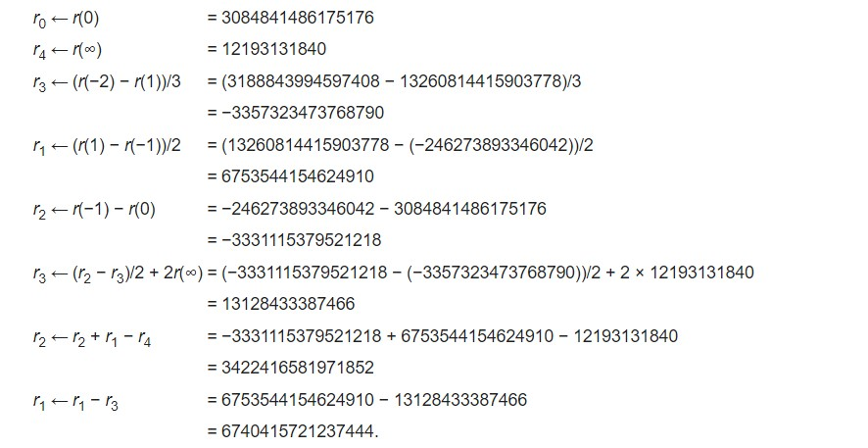

$$(9)$$

$$r\left(x\right)=3084,8414,8617,5176$$

$$+6740,4157,2123,7444x$$

$$+3422,4165,8197,1852x^{2}$$

$$+13,1284,3338,7466x^{3}$$

$$+121,9313,1840x^{4}$$

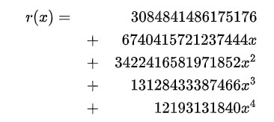

$$\left(10\right)$$

$$r\left(B\right)=121,9326,3124,6761,1632,$$

$$4937,6009,5208,5858,8617,5176=m*n$$

[ref]

[Toom–Cook multiplication - Wikipedia](https://en.wikipedia.org/wiki/Toom%E2%80%93Cook_multiplication#Pointwise_multiplication)