Pointer in C.

What is pointer?

A pointer points to an object.

The following figure illustrates how a pointer points to an object.

The following statement

p=&x;

means that the pointer p refers the address of the variable x.

Thus, value (*p) will be equivalent to value of x.

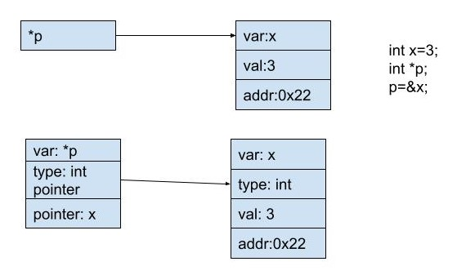

What is null pointer?

A null pointer points to null (nothing).

Take the following figure for example.

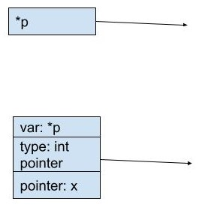

What is nullptr in C++?

nullptr in C++ is a macro which means NULL.

A pointer which is assigned to nullptr is a null pointer.

[type]

There are many types of pointer in C and C++.

$$\left\{\begin{aligned}auto_ptr(deprecated in C++11 or above) \\ shared_ptr(only supports in C++11 or above) \\ weak_ptr(only supports in C++11 or above) \\ unique_ptr(only supports in C++11 or above.)\end{aligned}\right.$$

[intro]

Since the auto_ptr is deprecated, in this section, I will NOT discuss the auto_ptr.

1. For weak_ptr:



$$weak_ptr is a container for a raw pointer.$$

$$It is created as a copy of shared_ptr.$$

$$The existence or destruction of weak_ptr copies a shared ptr have no effect on the shard_ptr or its other copies.$$

$$After all copies of shared_ptr have been destroyed, all weak_ptr copies become empty.$$

1. For shared_ptr:



$$A shared_ptr is a container for a raw pointer.$$

$$It maintains reference counting ownership of its contained pointer in cooperation with all copies of shared_ptr.$$

$$An object referenced by a raw container will be destroyed when and only when all copies of shared_ptr are destroyed.$$

$$Consider the following example:$$

std::shared_ptr<int> p0(**new** int(5)); *// Valid, allocates 1 integer and initialize it with value 5.*

std::shared_ptr<int[]> p1(**new** int[5]); *// Valid, allocates 5 integers.*

std::shared_ptr<int[]> p2 = p1; *// Both now own the memory.*

p1.reset(); *// Memory still exists, due to p2.*

p2.reset(); *// Frees the memory, since no one else owns the memory.*

$$shared_ptr consists of\left\{\begin{aligned}stored pointer:The pointes points to the object it manages. \\ \\ owned pointer\left(possibly shared\right):a pointer the ownership group is in charge of deleting at same point.\end{aligned}\right.$$

$$Consider the following example:$$

std::shared_ptr<int> p1 = std::make_shared<int>(5);

std::weak_ptr<int> wp1 {p1}; *// p1 owns the memory.*

{

std::shared_ptr<int> p2 = wp1.lock(); *// Now p1 and p2 own the memory.*

*// p2 is initialized from a weak pointer, so you have to check if the*

*// memory still exists!*

**if** (p2) {

DoSomethingWith(p2);

}

}

*// p2 is destroyed. Memory is owned by p1.*

p1.reset(); *// Free the memory.*

std::shared_ptr<int> p3 = wp1.lock();

*// Memory is gone, so we get an empty shared_ptr.*

**if** (p3) { *// code will not execute*

ActionThatNeedsALivePointer(p3);

}

$$\left[feature\right]$$

$$\left(1\right)It does NOT support arthimetic operations.$$

$$\left(2\right)But it supports copy assignments.$$

(3)For unique_ptr

$$unique_ptr consists of\left\{\begin{aligned}stored pointer:The pointes points to the object it manages. \\ store deleter:a callable object which is called iff the object is ready to be deleted.\end{aligned}\right.$$

$$\left[feature\right]$$

$$(1)It does NOT support arthimetic operations.$$

$$(2)It does NOT support copy assignments.$$

$$It uses move assignment instead.$$

$$Consider the following example:$$

std::unique_ptr<int> p1(**new** int(5));

//std::unique_ptr<int> p2 = p1; *// Compile error.*

std::unique_ptr<int> p3 = std::move(p1); *// Transfers ownership. p3 now owns the memory and p1 is set to nullptr.*

p3.reset(); *// Deletes the memory.*

p1.reset(); *// Does nothing.*

$$The following table illustrates what actions can a stored pointer and store deleter do and when they will do the action of shared_ptr and unique_ptr.$$

|  |  |  |  |  |
| --- | --- | --- | --- | --- |
| item | stored pointer | | store deleter | |
| action | What situation when value is changed? | Value can be accessed via? | What situation when value is changed? | Value can be accessed via? |
| shared_ptr | One the following cases.  (1)Assignment.  (2)Calling method reset. | Method of get | One the following cases.  (1)Assignment.  (2)Calling method reset. | Method of get_deleter |
| Unique_ptr | Method of get and release |

|  |  |  |
| --- | --- | --- |
| Item | $$shared_ptr$$ | $$unique_ptr$$ |
| Garbage collection facility | Yes (But limited) | Yes (But limited) |
| Objects ability of taking ownership | Yes | Yes |
| Delete the management when | (1)They are destroyed.  (2)Value changed either by assignment.  (3)Value changed either by explicit call of reset. | (1)They are destroyed.  (2)Value changed either by assignment.  (3)Value changed either by explicit call of reset. |
| Ownership relationship  (Can they be shared?) | They can be shared. | Unique, they can NOT be shared.  Unique_ptr own the pointer unique.  i.e. No other facility should take care of deleting the object. |

[ref]

1. Introduction to weak_ptr, shared_ptr, unique_ptr on the following link.

<https://en.wikipedia.org/wiki/Smart_pointer>

1. For method and properties etc on the following links.

<https://cplusplus.com/reference/memory/weak_ptr/weak_ptr/>

<https://cplusplus.com/reference/memory/shared_ptr/>

<https://cplusplus.com/reference/memory/unique_ptr/>

<https://cplusplus.com/reference/memory/>