How to count the frequency of a value?

[intro]

count

[namespace]

std

[library]

<algorithm>

[code]

#include <iostream>

#include <algorithm>

#include <vector>

using namespace std;

int main ()

{

int myints[] = {10,20,30,30,20,10,10,20};

int mycount = count (myints, myints+8, 10);

cout << "10 appears " << mycount << " times.\n";

vector<int> myvector (myints, myints+8);

mycount = count (myvector.begin(), myvector.end(), 20);

cout << "20 appears " << mycount << " times.\n";

return 0;

}

[result]

10 appears 3 times.

20 appears 3 times.

[screenshot]

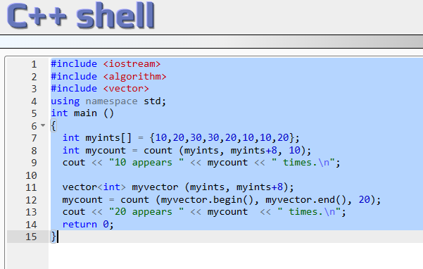

[ref]

<https://cplusplus.com/reference/algorithm/count/>