How to count how many value meet the condition?

[intro]

count_if

[namespace]

std

[library]

<algorithm>

[code]

#include <iostream>

#include <algorithm>

#include <vector>

using namespace std;

bool IsOdd (int i)

{

return ((i%2)==1);

}

int main ()

{

vector<int> myvector;

for (int i=1; i<10; i++)

{

myvector.push_back(i);

}

int mycount = count_if (myvector.begin(), myvector.end(), IsOdd);

cout << "myvector contains " << mycount << " odd values.\n";

return 0;

}

[result]

myvector contains 5 odd values.

[screenshot]

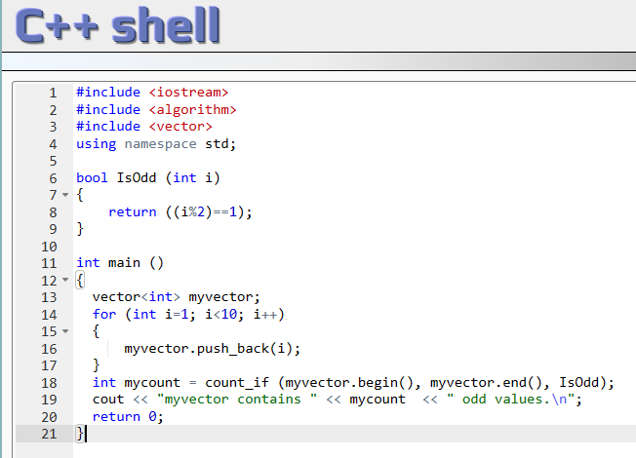

[ref]

<https://cplusplus.com/reference/algorithm/count_if/>