How to get an element of tuple in C++?

[intro]

std::get<>()

[syntax]

T std:get<template int idx>(tuple tup);

where

tup is a tuple.

idx refers the index of tuple.

type of T is auto type (it is determined by the idx of the tuple).

[return]

It will return the index of the tuple.

[code]

#include <iostream>

#include <tuple>

using namespace std;

int main ()

{

tuple<int,char> foo (10,'x');

cout << get<0>(foo) << ' ';

cout << get<1>(foo) << endl;

cout<<"-------------"<<endl;

get<0>(foo)=100;

get<1>(foo)='y';

int fooInt=0;

char fooChar='a';

tie(fooInt,fooChar)=foo;

cout<<fooInt<<' ';

cout<<fooChar<<endl;

return 0;

}

[result]

10 x

-------------

100 y

[screenshot]

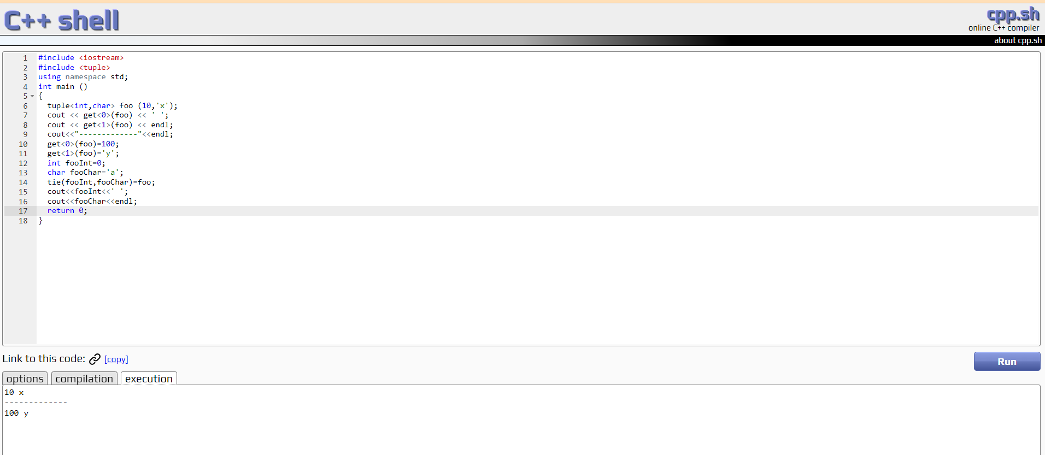

[ref]

<https://cplusplus.com/reference/tuple/get/>