How to check the first position of two arrays or vectors are NOT have same value?

[intro]

mismatch

[namespace]

std

[library]

<algorithm>

[code]

#include <iostream>

#include <algorithm>

#include <vector>

#include <utility>

using namespace std;

bool mypredicate (int i, int j)

{

return (i==j);

}

int main ()

{

vector<int> myvector;

for (int i=1; i<6; i++)

{

myvector.push_back (i*10);

}

int myints[] = {10,20,80,320,1024};

std::pair<std::vector<int>::iterator,int*> mypair;

mypair = std::mismatch (myvector.begin(), myvector.end(), myints);

cout << "First mismatching elements: " << *mypair.first<< " and " << *mypair.second << '\n';

++mypair.first; ++mypair.second;

mypair = std::mismatch (mypair.first, myvector.end(), mypair.second, mypredicate);

cout << "Second mismatching elements: " << *mypair.first << " and " << *mypair.second << '\n';

return 0;

}

[result]

The contents of both sequences are equal.

The contents of both sequences differ.

[screenshot]

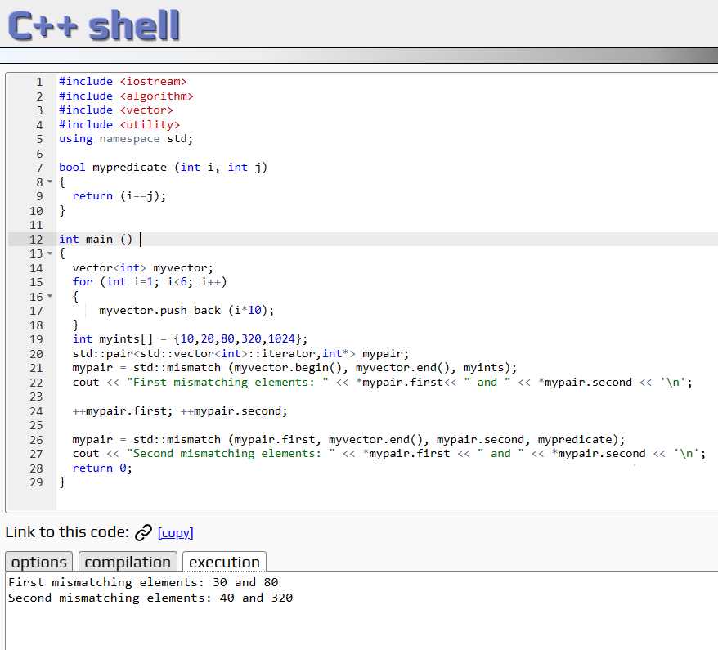

[ref]

<https://cplusplus.com/reference/algorithm/mismatch/>