not1

[intro]

not1 negates the unary comparison.

Take the following code for example.

The following example find the number of non-odd numbers (i.e. even numbers).

[P.S.]

It is important when you run the following code in the following link (which is provided by CPlusPlus).

<https://cpp.sh/>

You must pay a lot of attention on this compiler, or you may stuck in the compiler error for a long time.

I’m lucky to solve it within a few minutes.

Hope this notice can help you.

I recommend you to use C++ 17 compiler to run this code.

At present, I’ve tried to use C++ 20 compiler, then I got this error.

main.cpp:14:50: error: no member named 'not1' in namespace 'std'

int cx = std::count_if (values, values+5, std::not1(IsOdd()));

However, when I’ve tried to use C++ 17, C++ 14, C++ 11, C++ 98 compiler, I did NOT get any compiler error.

I think the reason is the C++ 20 compiler does NOT support std::not1 function.

How to change compiler version in C++ shell (provided by CPlusplus)?

It is simple.

1. Open the C++ shell.
2. Click options on the menu bar which was located at the bottom of the page.
3. In Standard section, select the compiler version you want to use.

(There are also instructions in my note Cplusplus_ChangeOption.docx )

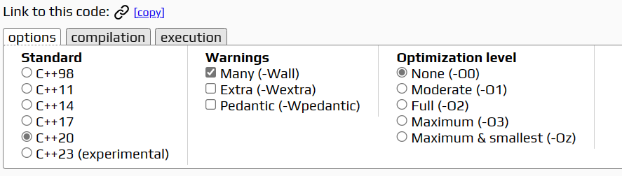

[code]

#include <iostream>

#include <functional>

#include <algorithm>

struct IsOdd

{

bool operator() (const int& x) const {return x%2==1;}

typedef int argument_type;

};

int main ()

{

int values[] = {1,2,3,4,5};

int cx = std::count_if (values, values+5, std::not1(IsOdd()));

std::cout << "There are " << cx << " elements with even values.\n";

return 0;

}

[result]

There are 2 elements with even values.

[screenshot]

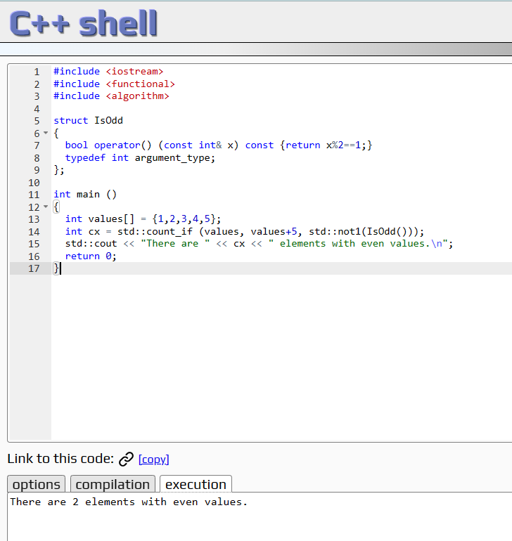

[ref]

<https://cplusplus.com/reference/functional/not1/>