array -- a contiguous storage in C.

[intro]

An array in C consists of contiguous storage, thus the index element can be offset.

$$Suppose A is an int array, and the address of A\left[0\right] is 0xE0.$$

$$Then the address of A\left[49\right] is$$

$$address of A\left[0\right]+\left(49-0+1\right)*sizeof\left(int\right)$$

$$=0xE0+50*4=0x1A8$$

$$since the sizeof an int variable holds 4 bytes$$

$$i.e.sizeof\left(int\right)=4 in C.$$

NOTE that in C, an array is row-based.

Row-based means that in 2D array, when the element is search, it is done by row first then by column.

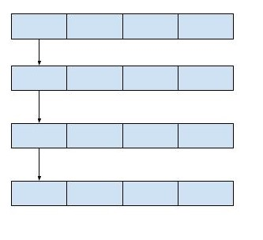

In Python, an array is column-based.

Column-based means that in 2D array, when the element is search, it is done by column first then by row.

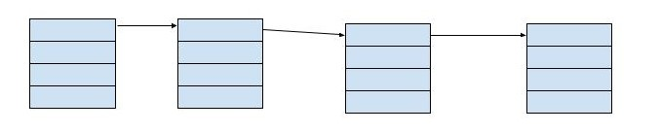

[namespace]

std

[library]

<array>