not2

[intro]

not2 negates binary expressions.

Take the following code for example.

The statement

$$firstmismatch = std::mismatch (foo, foo+5, bar, std::equal_to<int>());$$

will return the value of first mismatch of foo and bar. That is,

the statement will return the value of first index whose two values foo[index] and bar[index] are NOT same.

The statement

$$firstmatch = std::mismatch (foo, foo+5, bar, std::not2(std::equal_to<int>()));$$

will return the value of first match of foo and bar. That is,

the statement will return the value of first index whose two values foo[index] and bar[index] are same.

[P.S.]

It is important when you run the following code in the following link (which is provided by CPlusPlus).

<https://cpp.sh/>

You must pay a lot of attention on this compiler, or you may stuck in the compiler error for a long time.

I’m lucky to solve it within a few minutes.

Hope this notice can help you.

I recommend you to use C++ 17 compiler to run this code.

At present, I’ve tried to use C++ 20 compiler, then I got this error.

main.cpp:14:50: error: no member named 'not1' in namespace 'std'

int cx = std::count_if (values, values+5, std::not1(IsOdd()));

However, when I’ve tried to use C++ 17, C++ 14, C++ 11, C++ 98 compiler, I did NOT get any compiler error.

I think the reason is the C++ 20 compiler does NOT support std::not1 function.

(More details about how to change compiler version on my note Cplusplus_ChangeOptions.docx

which has been published in GitHub. At present, it is located in [CPP](https://github.com/40843245/CPP)/[website](https://github.com/40843245/CPP/tree/main/website)/[manual](https://github.com/40843245/CPP/tree/main/website/manual)/**Cplusplus**/)

[namespace]

std

[library]

<functional>

[code]

#include <iostream>

#include <functional>

#include <algorithm>

#include <utility>

int main ()

{

int foo[] = {10,20,30,40,50};

int bar[] = {0,15,30,45,60};

std::pair<int*,int*> firstmatch,firstmismatch;

firstmismatch = std::mismatch (foo, foo+5, bar, std::equal_to<int>());

firstmatch = std::mismatch (foo, foo+5, bar, std::not2(std::equal_to<int>()));

std::cout << "First mismatch in bar is " << *firstmismatch.second << '\n';

std::cout << "First match in bar is " << *firstmatch.second << '\n';

return 0;

}

[result]

First mismatch in bar is 0

First match in bar is 30

[screenshot]

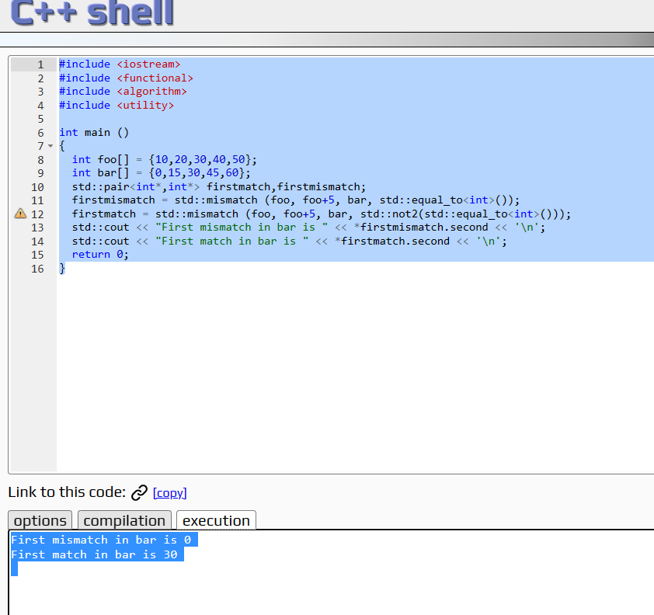

[ref]

<https://cplusplus.com/reference/functional/not2/>