Tuple in C++

[intro]

I’m amazing. This is the first time I’ve known this.

One can use a tuple in C++, packing and unpacking in C++.

Although it is NOT more convenient than tuple in Python and MatLab,

it provides a way to pack values into tuple.

[code]

#include <iostream> // std::cout

#include <tuple> // std::tuple, std::make_tuple, std::tie

int main ()

{

int myint;

char mychar;

std::tuple<int,float,char> mytuple;

mytuple = std::make_tuple (10, 2.6, 'a'); // packing values into tuple

std::tie (myint, std::ignore, mychar) = mytuple; // unpacking tuple into variables

std::cout << "myint contains: " << myint << '\n';

std::cout << "mychar contains: " << mychar << '\n';

return 0;

}

[result]

myint contains: 10

mychar contains: a

[screenshot]

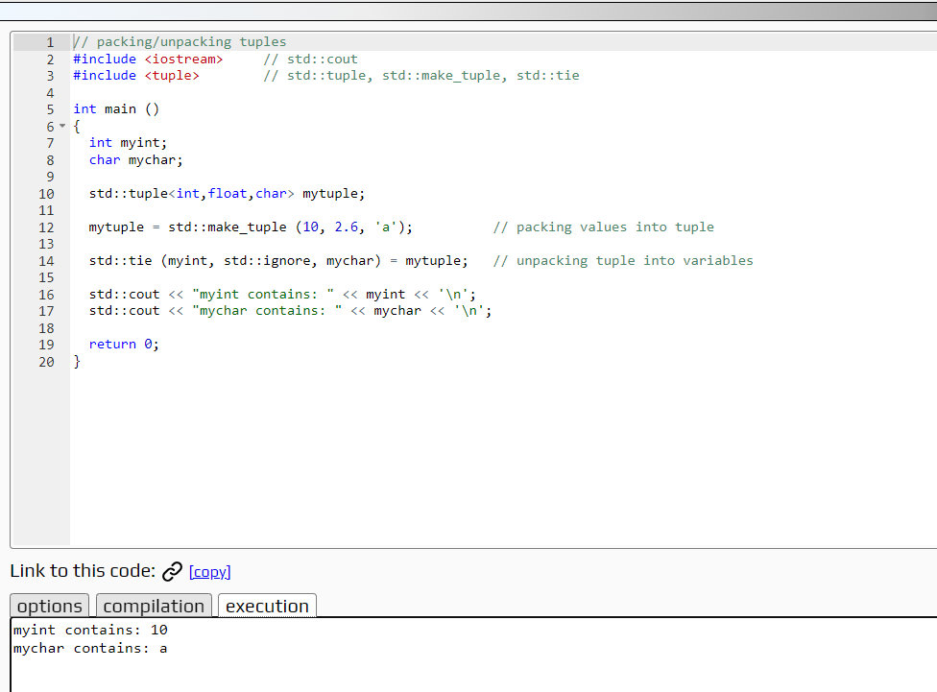

[ref]

<https://cplusplus.com/reference/tuple/tuple/>