How to check all elements of array meet an requirement in C++ with only one function call?

[intro]

all_of

[namespace]

std

[library]

<algorithm>

[code]

// all_of example

#include <iostream> // std::cout

#include <algorithm> // std::all_of

#include <array> // std::array

int main ()

{

std::array<int,8> foo = {3,5,7,11,13,17,19,23};

if ( std::all_of(foo.begin(), foo.end(), [](int i){return (i%2==1);}) )

{

std::cout << "All the elements are odd numbers.\n";

}

else

{

std::cout << "At least one of the elements are even numbers.\n";

}

return 0;

}

[result]

All the elements are odd numbers.

[screenshot]

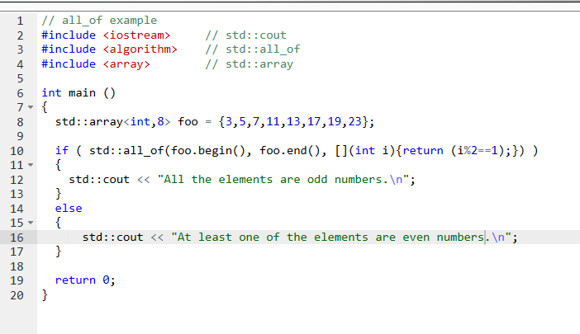

[ref]

<https://cplusplus.com/reference/algorithm/all_of/>