How to find all elements NOT meet the condition?

[intro]

any_of

any_of returns true iff any of elements in the array meets the condition.

How can we use this func to find all elements NOT meet the condtion?

Although we can write our own function, we can use this function with a trick.

The statement is true

any of elements meets the condition

is equivalent to the following statement is false

all element are NOT meet this condition.

Using the math representation as follows.

$$Given an array A=\left\{a_{1},a_{2},…,a_{n}\right\}.$$

$$Suppose the elements in A which meets the condition C_{1} are A^{'}=\left\{a_{c\left(1\right)},a_{c\left(2\right)},…,a_{c\left(m\right)}\right\}$$

$$∀ m<n,c\left(i\right)<c\left(j\right) ∀i<j, and c\left(i\right)∈\left\{1,2,…,n\right\} ∀i=1,2,…,n$$

$$Donate the function C_{1}:a→b where a∈A and b∈\left\{false,true\right\}.$$

$$In our assumption, we always have$$

$$C_{1}\left(a_{c\left(i\right)}\right)=true ∀i=1,2,…,n$$

$$=>C_{1}\left(j\right)=false ∀j∈\left\{1,2,…,n\right\}-\left\{c\left(1\right),c\left(2\right),…,c\left(m\right)\right\}$$

$$Hence proved.$$

[code]

// any_of example

#include <iostream> // std::cout

#include <algorithm> // std::any_of

#include <array> // std::array

int main ()

{

std::array<int,7> foo = {0,1,-1,3,-3,5,-5};

if ( std::any_of(foo.begin(), foo.end(), [](int i){return i<0;}) )

{

std::cout << "There are at least one negative element in the range.\n";

}

else

{

std::cout << "There are NO negative elements in the range.\n";

}

return 0;

}

[result]

There are at least one negative element in the range.

[screenshot]

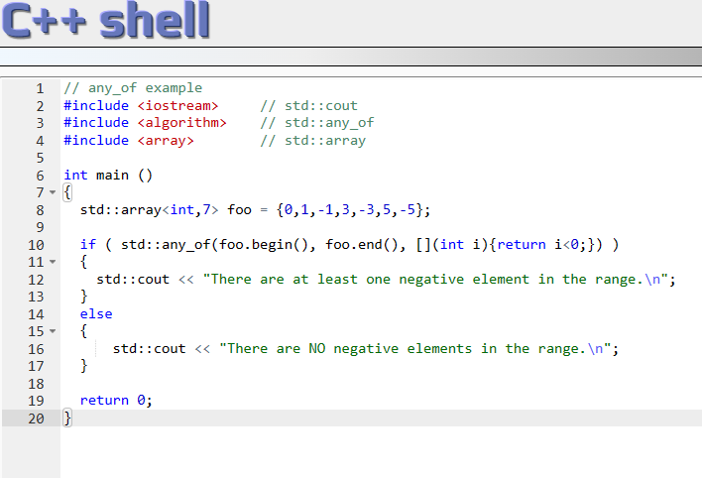

[ref]

<https://cplusplus.com/reference/algorithm/any_of/>