How to compare two arrarys or vectors are equal (have same elements and they are in same order)?

[intro]

equal

[namespace]

std

[library]

<algorithm>

[code]

#include <iostream>

#include <algorithm>

#include <vector>

using namespace std;

bool mypredicate (int i, int j)

{

return (i==j);

}

int main ()

{

int myints[] = {20,40,60,80,100};

vector<int>myvector (myints,myints+5);

if ( std::equal (myvector.begin(), myvector.end(), myints) )

{

cout << "The contents of both sequences are equal.\n";

}

else

{

cout << "The contents of both sequences differ.\n";

}

myvector[3]=81; // myvector: 20 40 60 81 100

if ( std::equal (myvector.begin(), myvector.end(), myints, mypredicate) )

{

cout << "The contents of both sequences are equal.\n";

}

else

{

cout << "The contents of both sequences differ.\n";

}

return 0;

}

[result]

The contents of both sequences are equal.

The contents of both sequences differ.

[screenshot]

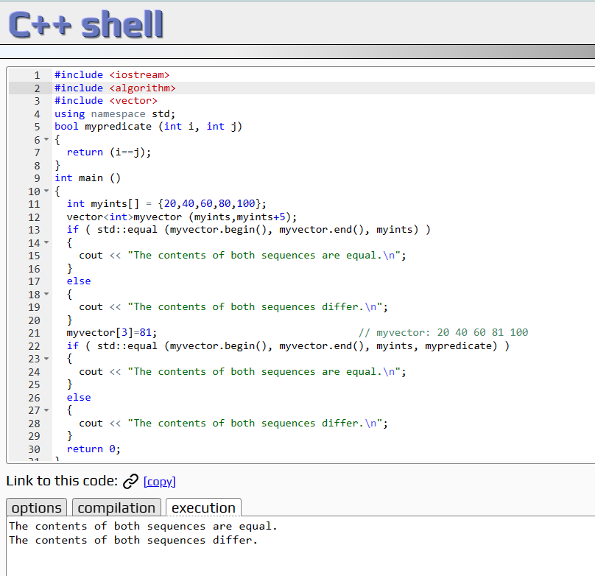

[ref]

<https://cplusplus.com/reference/algorithm/equal/>