forward_as_tuple

[namespace]

std

[library]

<tuple>

[code]

// forward_as_tuple example

#include <iostream> // std::cout

#include <tuple> // std::tuple, std::get, std::forward_as_tuple

#include <string> // std::string

void print_pack (std::tuple<std::string&&,int&&> pack) {

std::cout << std::get<0>(pack) << ", " << std::get<1>(pack) << '\n';

}

int main() {

std::string str ("John");

print_pack (std::forward_as_tuple(str+" Smith",25));

print_pack (std::forward_as_tuple(str+" Daniels",22));

return 0;

}

[result]

John Smith, 25

John Daniels, 22

[screenshot]

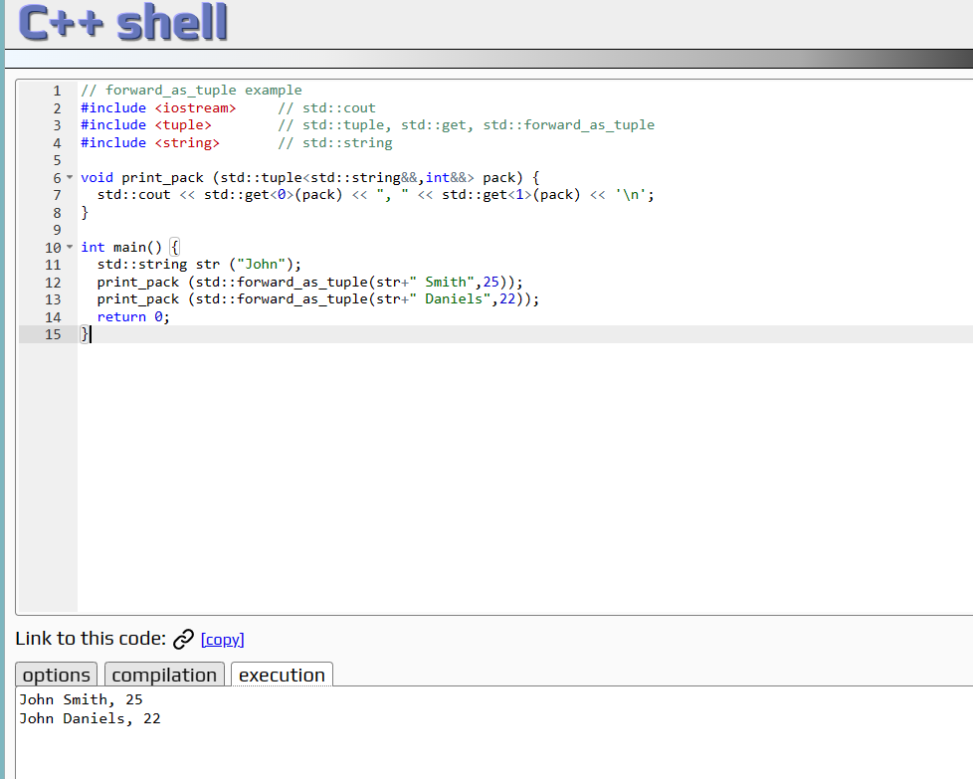

[ref]