How to create pair when not declaration?

[intro]

make_pair

[namespace]

std

[library]

<utility>

[code]

// make_pair example

#include <utility> // std::pair

#include <iostream> // std::cout

int main () {

std::pair <int,int> foo;

std::pair <int,int> bar;

foo = std::make_pair (10,20);

bar = std::make_pair (10.5,'A'); // ok: implicit conversion from pair<double,char>

std::cout << "foo: " << foo.first << ", " << foo.second << '\n';

std::cout << "bar: " << bar.first << ", " << bar.second << '\n';

return 0;

}

[result]

foo: 10, 20

bar: 10, 65

[screenshot]

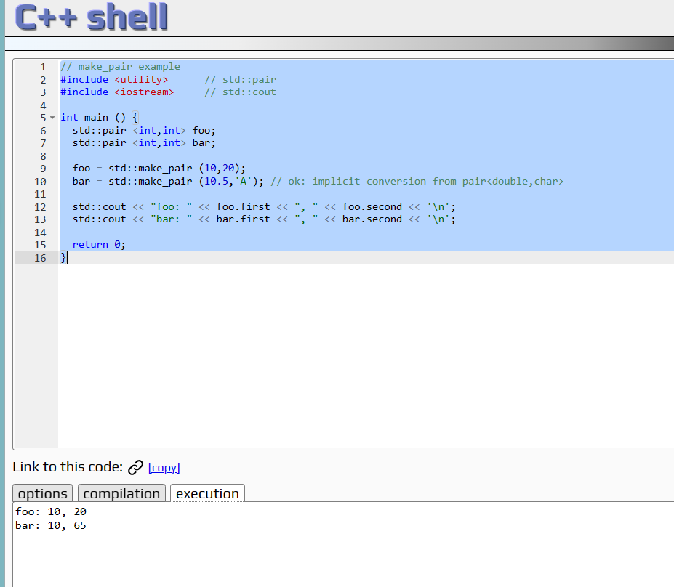

[ref]

<https://cplusplus.com/reference/utility/make_pair/>