How to find the min value and max value in an array in C++?

[intro]

minmax

[namespace]

std

[library]

<algorithm>

[syntax]

(1)

template <class T>

pair <const T&,const T&> minmax (const T& a, const T& b)

(2)

template <class T>

pair <const T&,const T&> minmax (const T& a, const T& b,Compare comp)

(3)

template <class T>

pair<T,T> minmax (initializer_list<T> il);

(4)

template <class T, class Compare>

pair<T,T> minmax (initializer_list<T> il, Compare comp);

[return]

Returns pair(a,b) iff compare(a,b) returns true.

Otherwise, returns pair(b,a).

If comp is given, then it uses comp to compare(a,b).

If comp is NOT given, then it uses < to compare(a,b).

[equivalent]

template <class T>

pair <const T&,const T&> minmax (const T& a, const T& b)

{

return (b<a) ? std::make_pair(b,a) : std::make_pair(a,b);

}

[code]

#include <iostream>

#include <algorithm>

using namespace std;

int main ()

{

auto result = minmax({11,12,13,14,15});

cout << "minmax({11,12,13,14,15}): ";

cout << result.first << ' ' << result.second << '\n';

return 0;

}

[result]

minmax({11,12,13,14,15}): 11 15

[screenshot]

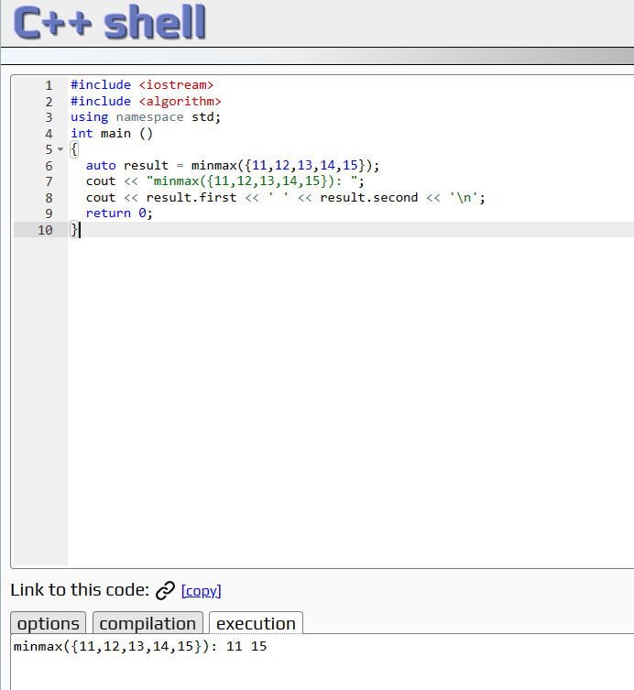

[ref]

<https://cplusplus.com/reference/algorithm/minmax/>