How to unpack a tuple into variables?

[intro]

tie

[namespace]

std

[library]

<tuple>

[code]

#include <iostream>

#include <tuple>

using namespace std;

int main ()

{

int myint;

char mychar;

tuple<int,float,char> mytuple;

mytuple = std::make_tuple (10, 2.6, 'a'); // packing values into tuple

tie (myint, std::ignore, mychar) = mytuple; // unpacking tuple into variables

cout << "myint contains: " << myint << endl;

cout << "mychar contains: " << mychar << endl;

return 0;

}

[result]

myint contains: 10

mychar contains: a

[screenshot]

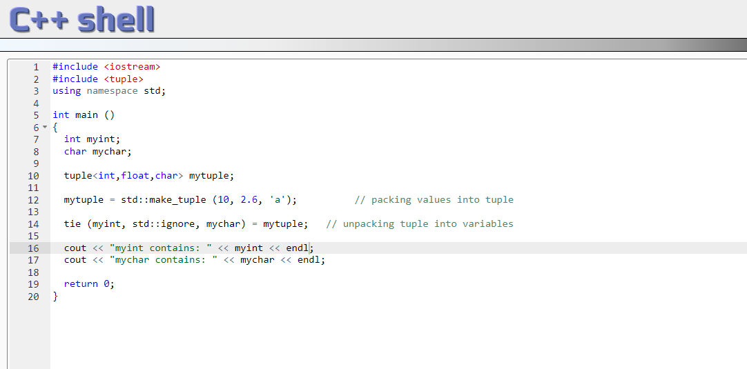

[ref]

<https://cplusplus.com/reference/tuple/tie/>