Binomial heap

[intro]

A binomial heap is a collection of a binomial tree.

A binomial heap=binomial trees + heap structure.

[property]

1.



[operation]

1. merge: merge 2 binomial trees as 1 binomial heap.

merge: merge 2 binomial heaps as 1 binomial heap.

1. insert: insert a node.

It can be done by creating a binomial heap with the node and merging them.

1. find: find the minimum element of the heap.

It can be done that find the minimum among the roots of binomial trees.

1. extract-min: delete the minimum element of the heap.

step (1) find the minimum element of the heap using operation 3.

step (2) remove the element.

Third, transform the list of its child subtrees into a separate binomial heap by reordering them from smallest to largest order.

1. decrease: decrease the key:

step (1) decrease the key.

step (2) check the min-heap property holds (can only check keys of x and its key of x’s parent)

step (3) if it does NOT hold, exchange x and x’s parent. And jump to step 2.

(In this time, compare x’s parent and x grandparent.)

step (4) if it does hold, That’s done!!!

1. deletion: deletion any element.

step (1) decrease: decrease the element to neg inf $-∞$

step (2) extract min.

[pseudo code]

1. Merge 2 binomial trees as 1 binomial heap.

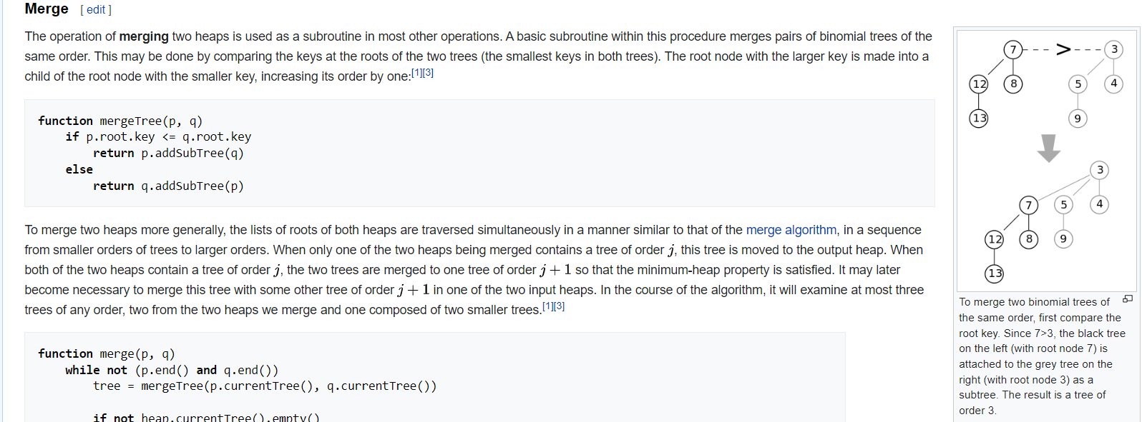

1. Merge 2 binomial heaps as 1 binomial heap.

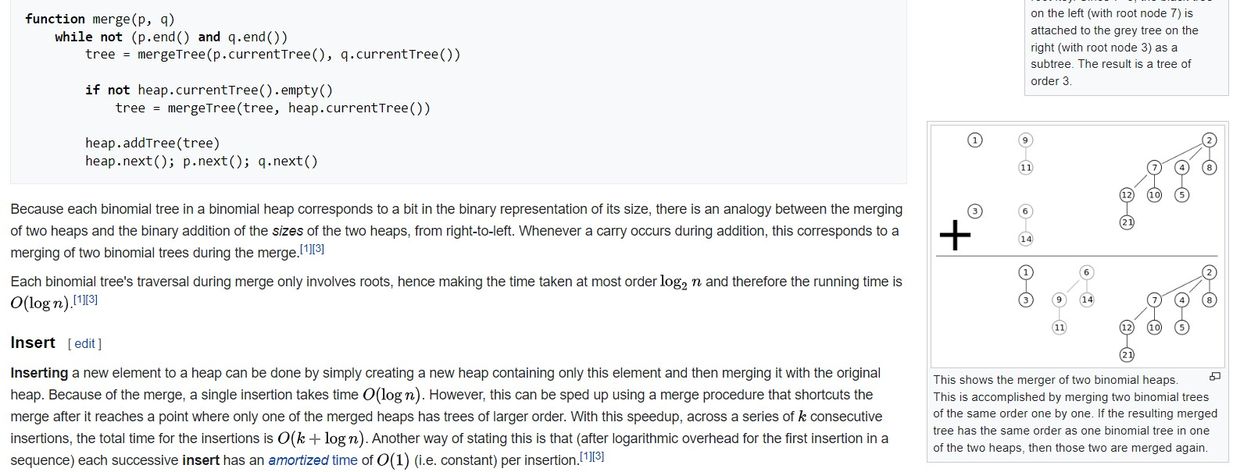

1. Deletion

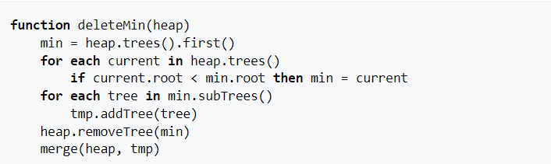

[ref]

[(32) Binomial heap : Part-1 (Properties, Representation and Operations) - YouTube](https://www.youtube.com/watch?v=lR3OBllTkTA&list=PL_shkhYMxegy0Nnmt7tlti-w5PqNZVXrW&index=28)

[(32) Binomial Heap: Part 2 (UNION operation, INSERT, EXTRACT_MIN etc.) - YouTube](https://www.youtube.com/watch?v=llAJy4N23Fw&list=PL_shkhYMxegy0Nnmt7tlti-w5PqNZVXrW&index=30)

[Binomial heap - Wikipedia](https://en.wikipedia.org/wiki/Binomial_heap)