Binomial tree

[intro]

A binomial tree is an ordered tree defined recursively.

[E.g.]

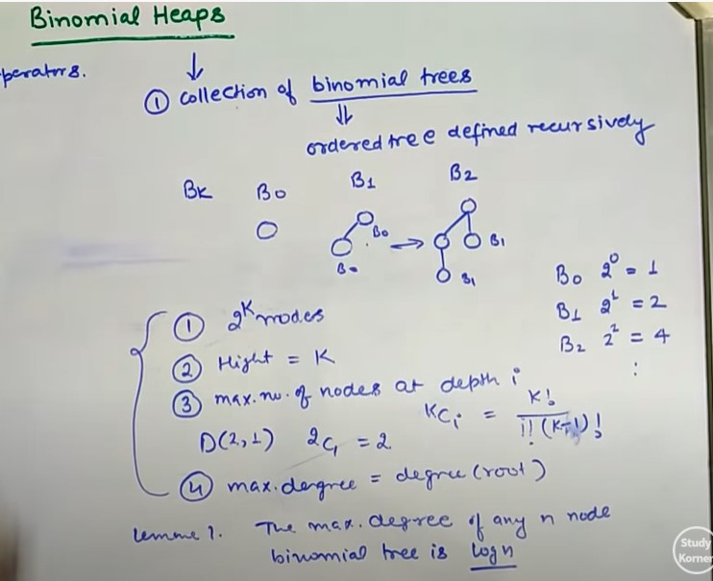



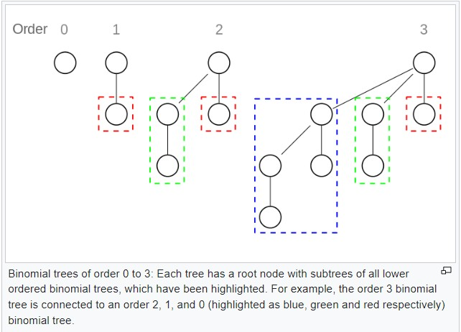

[property]

$$∀k∈N=\{0,1,2,…\}$$

1. nodes:
$$2^{k} nodes$$

2. height: s
$$k$$

3. max number of nodes at depth i:
$$D\left(k,i\right)=\left({k \atop i}\right)=\frac{k!}{i!\left(k-i\right)!}$$

4. max degree of binomial tree:

$$\max{degree of binomial tree} occurs at the root node.$$

$$\max\left(degree(T)\right)=degree(T.root)$$

[theorem]

1.

$$\max\left(degree(T)\right)=degree\left(T.root\right)=\lg{n}$$

[pf]

1.

$$Since each binomial tree follows$$

$$the min-heap property,$$

$$∀k∈N=\{0,1,2,…\}$$

[ref]

[(32) Binomial heap : Part-1 (Properties, Representation and Operations) - YouTube](https://www.youtube.com/watch?v=lR3OBllTkTA&list=PL_shkhYMxegy0Nnmt7tlti-w5PqNZVXrW&index=28)