Introduction to Hash Function.

What is a function?

A function will computer output with given input.

It behaves like a machine.

For example,

image that you want to make a chocolate cookie.

One pound of chocolate cookie consists of ½ pound of dark chocolate, 1/3 pound of milk, ½ pound of flour and 3 eggs.

When you mix them and put them into an oven to bake.

After baking, the delicious cookie is made.

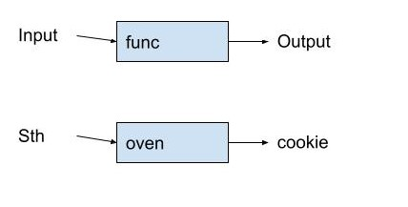

What is a hash function?

A hash function maps the arbitrary keys into fixed-sized values.

It is defined as the following using mathematics.

$$h:U×\left\{0,1,…,m-1\right\}→\{0,1,…,m-1\}$$

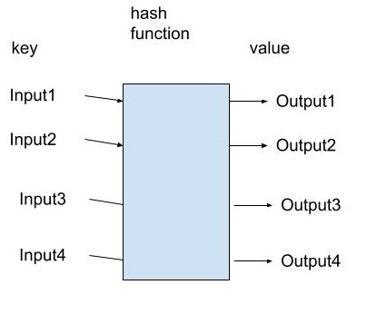

Collision in a hash function and a perfect hash function.

Given a sequence of key (input), there may be same values (output).

The phenomenon is called collision.

When there is a collision or collisions in the hash function, it is NOT a perfect hash function. It is NOT perfect.

When there are no any collisions in the hash function, it is a perfect hash function. It is perfect.

Using the mathematical way.

$$Given a sequence of keys K=\left\{k_{1},k_{2},…k_{m}\right\} and a hash function H.$$

$$The sequence of values is H\left(k_{i}\right) ∀i=1,2,…,m$$

$$\left\{\begin{aligned}∃i,j∈R,i≠j, H\left(k_{i}\right)=H\left(k_{j}\right)=>H is NOT a perfect hash function. \\ H\left(k_{i}\right)≠H\left(k_{j}\right) ∀i,j∈R,i,j=1,2,…,m,i≠j=>H is a perfect hash function.\end{aligned}\right.$$

What is hashing?

Hashing is a technique to make a hash function.

The following sections are more advanced.

But it can be found in Algorithm textbooks.

Hashing two times.

The following figure hashes the keys two times using hashing functions.

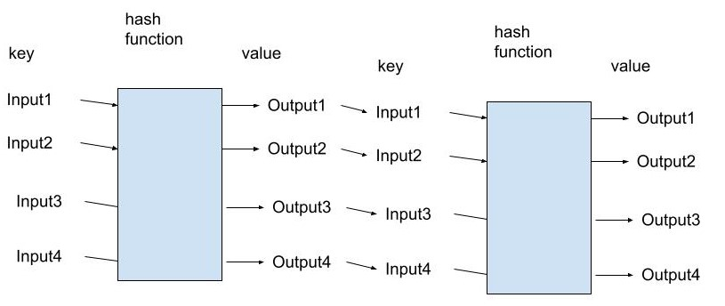

The following section will talk about the common types of hashing which hashes the key two times.

Common types of hashing?

[intro]

1. Linear probing:

The forms looks like the following:

$$h\left(k,i\right)=\left(h^{'}\left(k\right)+i\right) mod m$$

$$where$$

$$h^{'} is an auxilary hash function$$

$$and m is the base.$$

1. Quadratic probing:

The forms looks like the following:

$$h\left(k,i\right)=\left(h^{'}\left(k\right)+c_{1}*i+c_{2}*i^{2}\right) mod m$$

$$where$$

$$h^{'} is an auxilary hash function$$

$$,m is the base$$

$$and c_{1} and c_{2} are positive constants.$$

1. Double hashing:

$$h\left(k,i\right)=\left(h_{1}\left(k\right)+ih_{2}\left(k\right)\right) mod m$$

$$where$$

$$h_{1} and h_{2} are auxilary hash functions.$$

What is open addressing?

With open addressing, we require that for every key k, the probe sequence

$$<h\left(k,0\right),h(k,1),…,h(k,m-1)>$$

be a permutation of

$$<0,1,…,m-1>$$

What is load factor of a hash table?

The load factor of a hash table is a way to the analyze the open addressing.

Load factor is defined as

$$α=\frac{n}{m}$$

$$where$$

$$m=number of keys$$

$$and n=number of distinct values after hashing.$$

$$i.e. n=The number of different i=1,2,…,m satisfies H\left(k_{i}\right)≠H\left(k_{j}\right) for all j=1,2,..,m and i≠j.$$

[Axiom]

$$\left(1\right)For all hash tables,$$

$$the load factor must less than or equal to 1 and greater than 0.$$

$$i.e.0<α=\frac{n}{m}≤1$$

$$\left[pf\right]$$

$$\left(1\right)n>0,m>0=>α=\frac{n}{m}>0$$

$$\left(2\right)n≤m=>α=\frac{n}{m}≤1$$

$$\left(When n=m, the hash function is perfect\right).$$

$$Thus,0<α=\frac{n}{m}≤1$$