Kruskal’s algorithm

[step]

$$\left(1\right)select the edge with minimum cost.$$

$$\left(2\right)check the edge will create a cycle.$$

$$the edge\left(u,v\right)will create a cycle?$$

$$\left\{\begin{aligned}yes, discard and jump to step\left(2\right) \\ no, add the edge and jump to step \left(3\right)\end{aligned}\right.$$

$$\left(3\right)IfMST is NOT generated, jump to step \left(2\right).$$

$$\left(4\right)Done‼!$$

[analogy]

It is like a person who likes to veiw all.

[analysis]

$$O(E\lg{V})$$

[E.g.]

The original graph G as follows.

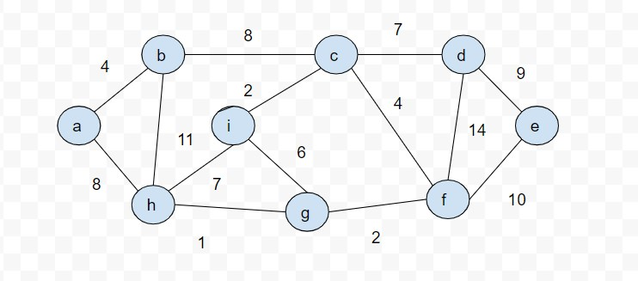



































[pseudo code]

$MST-KRUSHAL\left(G,w\right):\{$

$A=∅;$

$for each vertex v ∈G.V:\{$

$MAKE-SET\left(v\right);$

$\}$

$$sort the edge of G.E into nodescreasing order by weight w;$$

$for each edge\left(u,v\right)∈G.E,$

$taken in nondecreasing order by weight w:\{$

$if FIND-SET\left(u\right)≠FIND-SET\left(v\right):\{$

$A=A∪\left\{\left(u,v\right)\right\};$

$UNION\left(u,v\right);$

$\}$

$return A;$

$\}$

[ref]

[Kruskal's algorithm - Wikipedia](https://en.wikipedia.org/wiki/Kruskal%27s_algorithm)