Pairing heap

[intro]

Pairing heaps have a heap-ordered multiway tree structure.

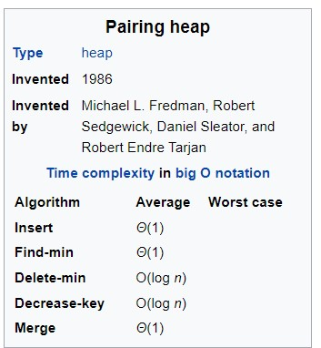

[operation]

1. Merge: merge 2 pairing heaps as 1 pairing heap.
2. Find: find the minimum element.
3. Insert: insert an element into the pairing heap.
4. Extract-min: deletion minimum element.
5. Decrease: decrease the key of the element.
6. Deletion: deletion of any element.

[comparison]

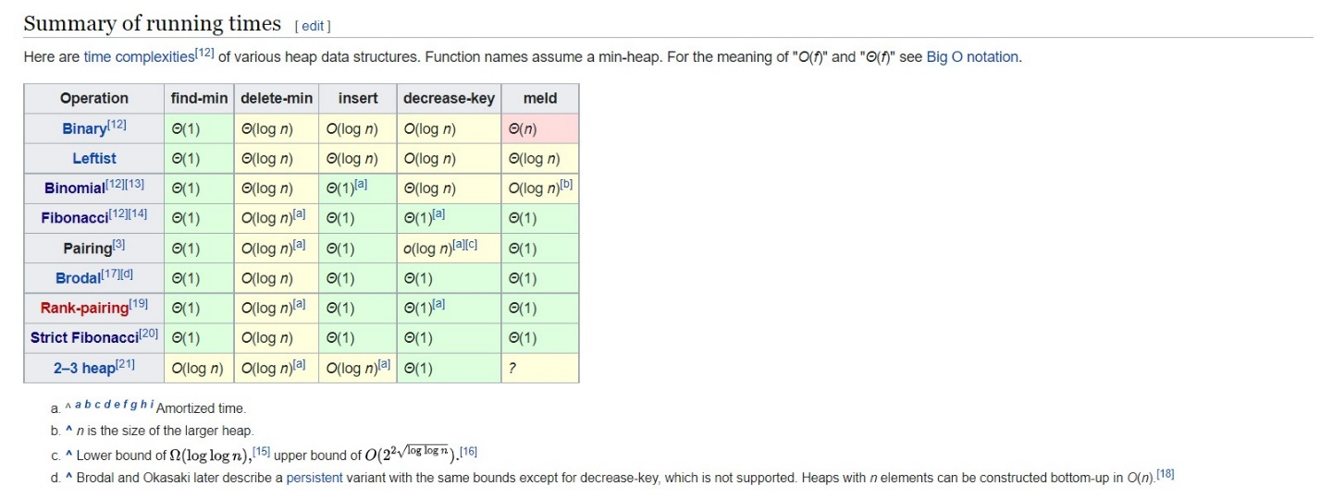

[ref]

[Pairing heap - Wikipedia](https://en.wikipedia.org/wiki/Pairing_heap)