Prim’s algorithm

[step]

$$same as DFS.$$

$$\left(1\right)Find a start vertex s, add s into a vertex set V^{'},$$

$$make Q are empty set$$

$$\left(2\right)find an edge \left(u,v\right)$$

$$where u∈V^{'}and v∈Q with minimum cost.$$

$$\left(3\right)add the edge \left(u,v\right)$$

$$\left(4\right)add v into V^{'}.$$

$$\left(5\right)remove v from Q.$$

$$\left(6\right)IfMST is NOT generated, jumpt to step \left(2\right).$$

$$\left(7\right)Done‼!$$

[analogy]

It is like an octopus.

[analysis]

$$O(E+V\lg{V})$$

[result]

$$When the algorithm terminates,$$

$$the min-priority queue Q is empty and$$

$$the minimun spanning tree A for G is$$

$$A=\{\left(v,v.π\right):v∈V-\{r\}\}$$

[E.g.]

The original graph G as follows.

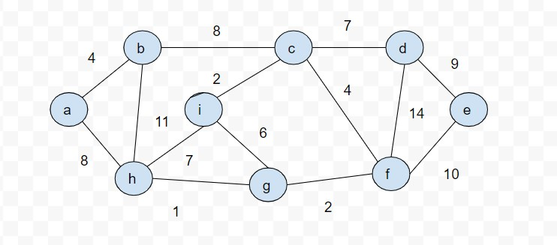

|  |  |  |  |  |  |  |  |  |  |
| --- | --- | --- | --- | --- | --- | --- | --- | --- | --- |
|  |  |  |  |  |  |  |  |  |  |
|  |  |  |  |  |  |  |  |  |  |
|  |  |  |  |  |  |  |  |  |  |

|  |  |  |  |  |  |  |  |  |  |
| --- | --- | --- | --- | --- | --- | --- | --- | --- | --- |
|  |  |  |  |  |  |  |  |  |  |
|  |  |  |  |  |  |  |  |  |  |
|  |  |  |  |  |  |  |  |  |  |





|  |  |  |  |  |  |  |  |  |  |
| --- | --- | --- | --- | --- | --- | --- | --- | --- | --- |
|  |  |  |  |  |  |  |  |  |  |
|  |  |  |  |  |  |  |  |  |  |
|  |  |  |  |  |  |  |  |  |  |





|  |  |  |  |  |  |  |  |  |  |
| --- | --- | --- | --- | --- | --- | --- | --- | --- | --- |
|  |  |  |  |  |  |  |  |  |  |
|  |  |  |  |  |  |  |  |  |  |
|  |  |  |  |  |  |  |  |  |  |





|  |  |  |  |  |  |  |  |  |  |
| --- | --- | --- | --- | --- | --- | --- | --- | --- | --- |
|  |  |  |  |  |  |  |  |  |  |
|  |  |  |  |  |  |  |  |  |  |
|  |  |  |  |  |  |  |  |  |  |





|  |  |  |  |  |  |  |  |  |  |
| --- | --- | --- | --- | --- | --- | --- | --- | --- | --- |
|  |  |  |  |  |  |  |  |  |  |
|  |  |  |  |  |  |  |  |  |  |
|  |  |  |  |  |  |  |  |  |  |





|  |  |  |  |  |  |  |  |  |  |
| --- | --- | --- | --- | --- | --- | --- | --- | --- | --- |
|  |  |  |  |  |  |  |  |  |  |
|  |  |  |  |  |  |  |  |  |  |
|  |  |  |  |  |  |  |  |  |  |





|  |  |  |  |  |  |  |  |  |  |
| --- | --- | --- | --- | --- | --- | --- | --- | --- | --- |
|  |  |  |  |  |  |  |  |  |  |
|  |  |  |  |  |  |  |  |  |  |
|  |  |  |  |  |  |  |  |  |  |





|  |  |  |  |  |  |  |  |  |  |
| --- | --- | --- | --- | --- | --- | --- | --- | --- | --- |
|  |  |  |  |  |  |  |  |  |  |
|  |  |  |  |  |  |  |  |  |  |
|  |  |  |  |  |  |  |  |  |  |





|  |  |  |  |  |  |  |  |  |  |
| --- | --- | --- | --- | --- | --- | --- | --- | --- | --- |
|  |  |  |  |  |  |  |  |  |  |
|  |  |  |  |  |  |  |  |  |  |
|  |  |  |  |  |  |  |  |  |  |





|  |  |  |  |  |  |  |  |  |  |
| --- | --- | --- | --- | --- | --- | --- | --- | --- | --- |
|  |  |  |  |  |  |  |  |  |  |
|  |  |  |  |  |  |  |  |  |  |
|  |  |  |  |  |  |  |  |  |  |

[pseudo code]

$MST-PRIM\left(G,w,r\right):\{$

$for each u∈G.V:\{$ $u.key=∞;u.π=NIL;\}r.key=0;$

$Q=G.V;$

$while Q≠∅:\{$

$u=EXTRACT-MIN\left(Q\right);$

$for each v∈G.Adj\left[u\right]:\{$

$$if v∈Q and w\left(u,v\right)<v.key:\left\{v.π=u;v.key=w\left(u,v\right);\right\}$$

$\}$

[ref]

[Prim's algorithm - Wikipedia](https://en.wikipedia.org/wiki/Prim%27s_algorithm)