Priority queue

[intro]

A priority queue is similar to a queue but each element has priority.

Elements with higher priority will be served first.

[application]

1. graph searching
2. event-driven simulation
3. statistics.

[operation]

ADT and analysis of ADT are as follows.

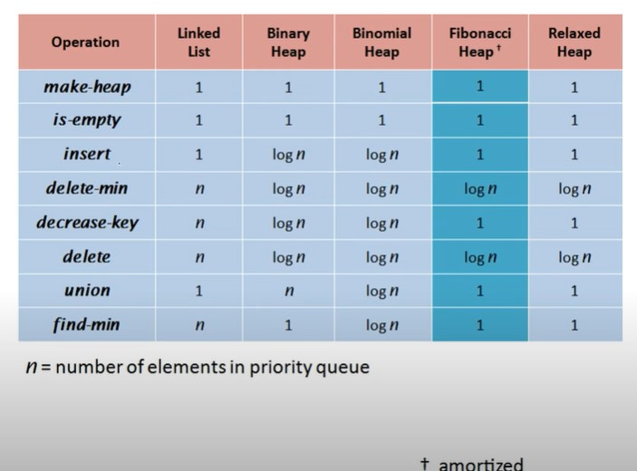

[ref]

[Priority queue - Wikipedia](https://en.wikipedia.org/wiki/Priority_queue)

At beginning of the tutorial.

[(32) Fibonacci Heap - An efficient priority Queue data structure (Introduction) - YouTube](https://www.youtube.com/watch?v=GUML34YFCZs&list=PL_shkhYMxegy0Nnmt7tlti-w5PqNZVXrW&index=30)