Sollin’s algorithm

[alias]

Borůvka's algorithm

[step]

$$\left(1\right)Consider every vertex is a component.$$

$$\left(2\right)select a incoming or outcoming edge with minimum cost$$

$$for each component.$$

$$\left(3\right)connect the edge and combine components together.$$

$$\left(4\right)ifMST is not generate then jump to step \left(2\right).$$

$$\left(5\right)Done‼!$$

[E.g.]

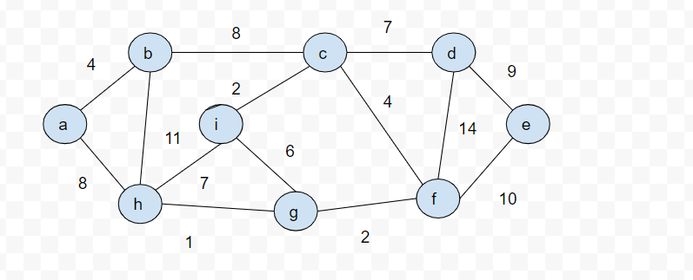

$$G=\left(V,E\right)$$

$$V=\left\{a,b,c,d,e,f,g,h,i\right\}$$

$$E=\{\left(a,b,4\right),\left(b,c,8\right),\left(c,d,7\right),\left(d,e,9\right),\left(e,f,10\right),\left(d,f,14\right),$$

$$\left(c,f,4\right),\left(f,g,2\right),\left(i,g,6\right),\left(h,g,1\right),\left(c,i,2\right),\left(h,i,7\right),\left(a,h,8\right),(b,h,11)\}$$

$$\left(1\right)At begin:$$

$$(1.1)there are 9 vertices. Consider each vertex as a set.$$

$$C=\left\{\left\{a\right\},\left\{b\right\},\left\{c\right\},\left\{d\right\},\left\{e\right\},\left\{f\right\},\left\{g\right\},\left\{h\right\},\left\{i\right\}\right\}$$

$$\left(1.2\right)sort the edges with nondescreasing order by weight.$$

$$In this example, the edges will be$$

$$E_{S}=\{\left(h,g,1\right),\left(c,i,2\right),\left(f,g,2\right),\left(a,b,4\right),\left(c,f,4\right),\left(i,g,6\right),$$

$$\left(c,d,7\right),\left(h,i,7\right),\left(a,h,8\right),\left(b,c,8\right),\left(d,e,9\right),\left(e,f,10\right),\left(b,h,11\right),$$

$$(d,f,14)\}$$

$$\left(1.3\right)E_{S}^{'}=∅$$

$$\left(2\right)After 1^{st}round:$$

$$a:\left(a,b,4\right)$$

$$b:\left(a,b,4\right)$$

$$c:\left(c,i,2\right)$$

$$d:\left(c,d,7\right)$$

$$e:\left(d,e,9\right)$$

$$f:\left(f,g,2\right)$$

$$g:\left(g,h,1\right)$$

$$h:\left(g,h,1\right)$$

$$=>$$

$$C=\left\{\begin{aligned}\left\{\left(a,b,4\right)\right\}, \\ \left\{\left(c,i,2\right),\left(c,d,7\right),\left(d,e,9\right)\right\}, \\ \left\{\left(f,g,2\right),\left(g,h,1\right)\right\}\end{aligned}\right\}$$

$$\left(3\right)After 2^{nd}round:$$

$$b:\left(b,c,8\right)$$

$$c:\left(c,f,4\right)$$

$$f:\left(c,f,4\right)$$

$$=>$$

$$C=\left\{\begin{aligned}\begin{aligned}\left(a,b,4\right), \\ \left(c,i,2\right),\left(c,d,7\right),\left(d,e,9\right), \\ \left(f,g,2\right),\left(g,h,1\right), \\ \left(b,c,8\right),\end{aligned} \\ (c,f,4)\end{aligned}\right\}$$

$$\left(3\right)Done‼!$$

$$Since C contains all verices, it is done.$$

$$the cost of MST=\sum{c_{w_{i}}}$$

$$=4+2+7+9+2+1+8+4=37$$

$$where c_{w_{i}}=\{w:\left(u,v,w\right) ∈C\}$$

[ref]

[Borůvka's algorithm - Wikipedia](https://en.wikipedia.org/wiki/Bor%C5%AFvka's_algorithm)

[4.3.3 - Sollin's algorithm - Data Structure (gitbook.io)](https://garychang.gitbook.io/data-structure/4-graph/4.3-spanning-tree/4.3.3-sollins-algorithm)

[discrete mathematics - Sollin's Minimum Spanning Tree Algorithm - Stack Overflow](https://stackoverflow.com/questions/4229212/sollins-minimum-spanning-tree-algorithm)