GARCH

Intro

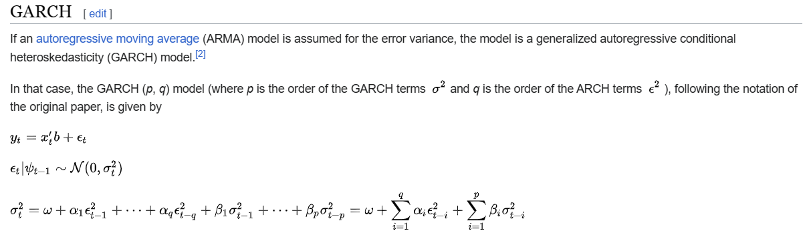

Def

Ref

See Garch section in Wiki.

[Autoregressive conditional heteroskedasticity - Wikipedia](https://en.wikipedia.org/wiki/Autoregressive_conditional_heteroskedasticity)