Continuity

Def

Open interval

A function f is continuous at open interval $$\left(a,b\right)$$ iff

f is continuous at each point in $$\left(a,b\right)$$.

Example

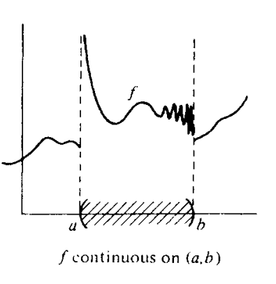

Closed interval

A function f is continuous at closed interval $$\left[a,b\right]$$ iff

f is continuous at open interval $$\left(a,b\right)$$,

f is continuous on the right of $$a$$, and

f is continuous on the left of $$b$$.

Example

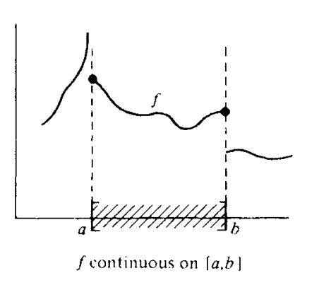

Left open interval

A function f is continuous at left open interval $$\left[a,b\right)$$ iff

f is continuous at open interval $$\left(a,b\right)$$, and

f is continous on the right of $$a$$.

Right open interval

A function f is continuous at right open interval $$\left(a,b\right]$$ iff

f is continuous at open interval $$\left(a,b\right)$$, and

f is continuous on the left of $$b$$.

Generalization for interval

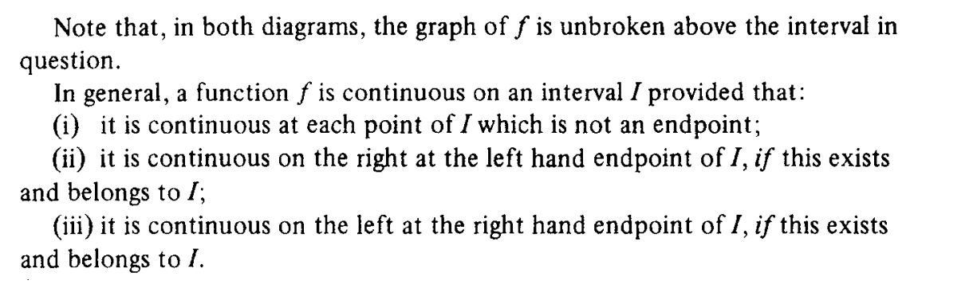

Proposition

Epsilon-delta definition

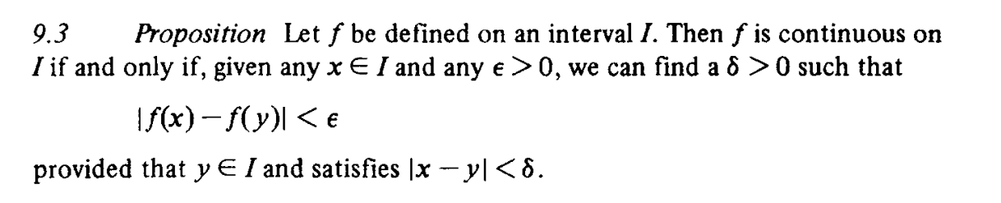

Proof

1. Backward

Since there exists a real number $$eps$$ which is very close to 0 but larger than 0.

(i.e. $$eps→0^{+}$$) such that

$$\left|f\left(x\right)−f\left(y\right)\right|<eps$$

one can imply that

$$\left|f\left(x\right)−f\left(y\right)\right|<eps$$

=> $$−eps<f\left(x\right)−f\left(y\right)<eps$$

On the other hand, since there exist a real number $$delta>0$$ such that

$$0<\left|x−y\right|<delta$$

for all $$x,y$$ at the interval $$I$$.

Now, use proof by contradiction of this subclaim.

The subclaim is, one of neccesity conditions of the claim

when $$\left|f\left(x\right)−f\left(y\right)\right|<eps$$ for a small $$eps>0$$ (i.e. $$eps→0^{+}$$)

is that $$f$$ is continuous at each point on the interval $$I$$.

Suppose $$f$$ is NOT continuous at interval $$I$$,

then by definition of continuous function at interval, there must exist at least one point called $$p$$ such that $$f$$ is NOT continous at that point $$p$$.

Therefore, there exist at least one point $$p$$ such that either one the following requirements satisfied (or more) by the definition of continuous function at one point.

1. $$\lim\left(x→p^{+},f\left(x\right)\right)$$ does NOT exist
2. $$\lim\left(x→p^{−},f\left(x\right)\right)$$ does NOT exist
3. $$\lim\left(x→p^{−},f\left(x\right)\right)$$!= $$\lim\left(x→p^{+},f\left(x\right)\right)$$

When one of the above requirement satisfied, one can find the fact that

neither $$\left|f\left(x\right)−f\left(y\right)\right|$$ does exist nor $$\left|f\left(x\right)−f\left(y\right)\right|<eps$$ for a small number $$eps>0$$

(i.e. $$eps→0^{+}$$)

which completes the proof of first subclaim.

Notes:

$$\lim\left(x→p^{+},f\left(x\right)\right)$$ does NOT exist

=> $$f\left(x\right)$$ does NOT exist

=> $$\left|f\left(x\right)−f\left(y\right)\right|$$ does NOT exist

Similarly, when $$\lim\left(x→p^{−},f\left(x\right)\right)$$ does NOT exist , then $$\left|f\left(x\right)−f\left(y\right)\right|$$ does NOT exist.

On the other hand, when $$\lim\left(x→p^{+},f\left(x\right)\right)$$!= $$\lim\left(x→p^{−},f\left(x\right)\right)$$,

then $$\lim\left(x→p,f\left(x\right)\right)$$ does NOT exist. Thus, $$\left|f\left(x\right)−f\left(y\right)\right|$$ does NOT exist.

Then, to prove second subclaim,

If $$x→y$$ is NOT true, then $$\left|f\left(x\right)−f\left(y\right)\right|<eps$$ for $$eps→0^{+}$$ is also NOT true.

If $$x→y$$ is NOT true, then it is NOT true that

for $$delta>0$$, $$\left|x−y\right|<delta$$.

Thus, it is also NOT true that

$$\left|f\left(x\right)−f\left(y\right)\right|<eps$$ for $$eps→0^{+}$$

which completes the second subclaim.

1. Forward

$$f$$ is continuous on interval $$I$$, and $$x,y$$ belongs to $$I$$.

=> $$f\left(x\right),f\left(y\right)$$ exists

When $$x→y$$, then for $$delta>0$$, $$\left|x−y\right|<delta$$.

Since $$f\left(x\right),f\left(y\right)$$ exists and $$\left|x−y\right|<delta$$ when $$x,y$$ is at interval $$I$$, one can imply that

$$\left|x−y\right|<delta$$ for $$x,y$$ at interval $$I$$

=> $$−delta<x−y<delta$$

Then there exist a real number $$eps$$ which is very close to 0 but larger than 0.

(i.e. $$eps→0^{+}$$) such that

$$−eps<f\left(x\right)−f\left(y\right)<eps$$

=> $$\left|f\left(x\right)−f\left(y\right)\right|<eps$$

Linear transformation

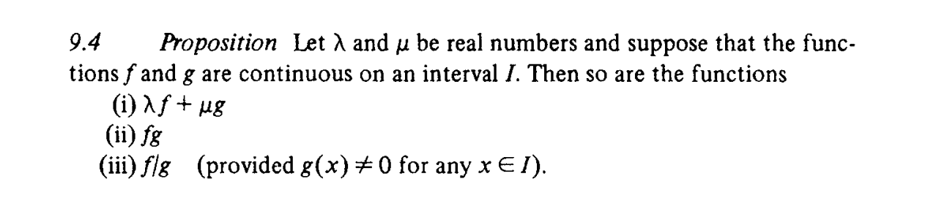

Proof

Since $$f$$ and $$g$$ are continuous on the interval $$I$$, then

$$f$$ and $$g$$ is continuous at each point $$x$$ on the interval $$I$$,

Therefore, at each point $$x$$ on the interval $$I$$, $$\lim\left(x_{a}→x,f\left(x\right)\right)$$ exists and so is $$\lim\left(x_{a}→x,g\left(x\right)\right)$$.

Thus, for any scalar $$lemma$$ and $$mu$$,

$$lemma⋅\lim\left(x_{a}→x,f\left(x\right)\right)$$ + $$mu⋅\lim\left(x_{a}→x,g\left(x\right)\right)$$

= $$\lim\left(x_{a}→x,lemma⋅f\left(x\right)\right)$$ + $$\lim\left(x_{a}→x,mu⋅g\left(x\right)\right)$$

= $$\lim\left(x_{a}→x,lemma⋅f\left(x\right)+mu⋅g\left(x\right)\right)$$

does also exist.

Therefore,

$$lemma⋅f+mu⋅g$$ is continuous on interval $$I$$.

$$\lim\left(x_{a}→x,f\left(x\right)\right)$$ $$\lim\left(x_{a}→x,g\left(x\right)\right)$$

\*

= $$\lim\left(x_{a}→x,f\left(x\right)⋅g\left(x\right)\right)$$

does exist too. And so is $$fg$$.

Doing so for $$\frac{f}{g}$$.

Composition function

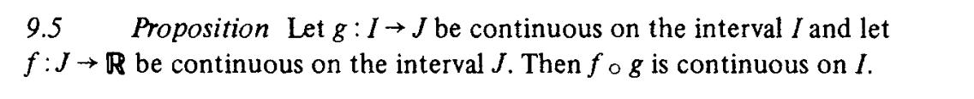

Proof

Since $$g:I→J$$ is continuous on interval $$I$$ and $$f:J→R$$ is continuous on interval $$J$$,

then $$g$$ is continuous at each point on interval $$I$$ and so for $$f$$ at each point on interval $$J$$.

Therefore,

For all point $$x_{a}$$ on interval $$I$$, $$\lim\left(x→x_{a},f\left(x\right)\right)$$ exists.

Now, let $$L$$ = $$\lim\left(x→x_{a},f\left(x\right)\right)$$.

Since $$L$$ is always on interval $$J$$ and $$g$$ is continuous at eacg point on interval $$J$$, then $$\lim\left(x→L,g\left(x\right)\right)$$ does also exist.

which can imply that

$$\lim\left(x_{1}→L,g\left(x\right)\right)$$

= $$\lim\left(x_{1}→\lim\left(x→x_{a},f\left(x\right)\right),g\left(x\right)\right)$$

= $$\lim\left(x→x_{a},f\left(g\left(x\right)\right)\right)$$

for all $$x_{a}$$ on interval $$I$$ intersects with $$J$$.

does also exist.

Therefore,

$$f⋅g$$ is continuous.

Sequence

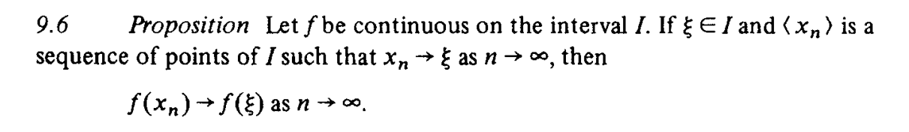

Proof

Since

(1) all points of sequence $$<x_{n}>$$ are on interval $$I$$

(2) $$f$$ is continuous on interval $$I$$.

then when $$n→\inf{}$$,

$$\lim\left(a→x_{inf} , f\left(a\right)\right)$$ exists.

On the other hand, since $$c$$ on the interval $$I$$.

$$\lim\left(b→c , f\left(b\right)\right)$$ does also exists.

By above claim, one has that

$$\left|\lim\left(b→c,f\left(b\right)\right)−\lim\left(a→x_{inf},f\left(a\right)\right)\right|<eps$$

where

$$eps→0^{+}$$

Thus,

$$\left|\lim\left(a→x_{inf},f\left(a\right)\right)−\lim\left(b→c,f\left(b\right)\right)\right|<eps$$

$$f\left(x_{n}\right)→f\left(c\right)$$ as $$n→\inf{}$$

which completes the proof.

Continuity theorem

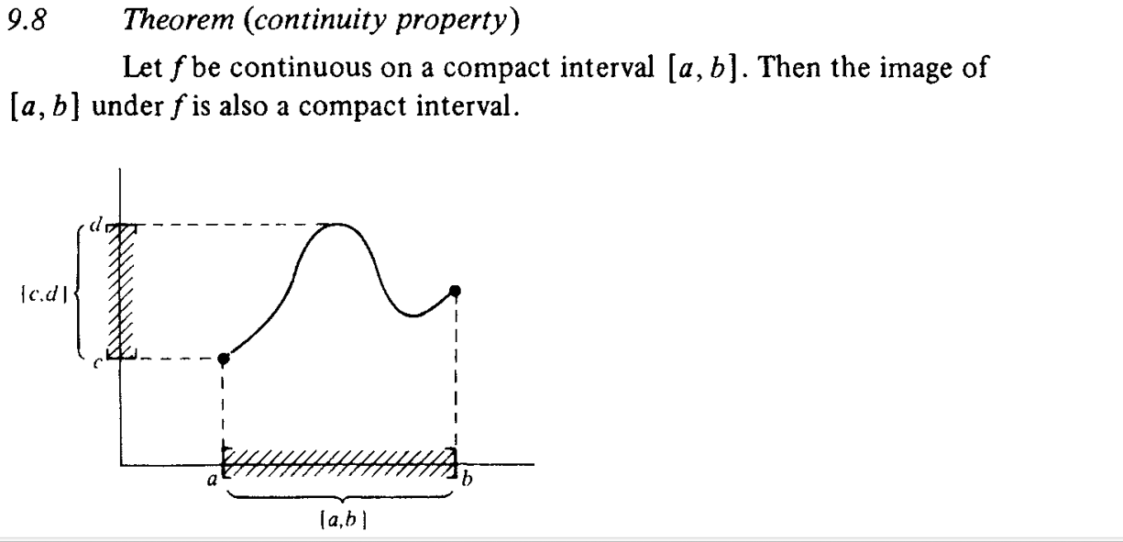

Proof

See section 9.8 in page 87 in cookbook.



Proof

See section 9.9 page 88 in cookbook.

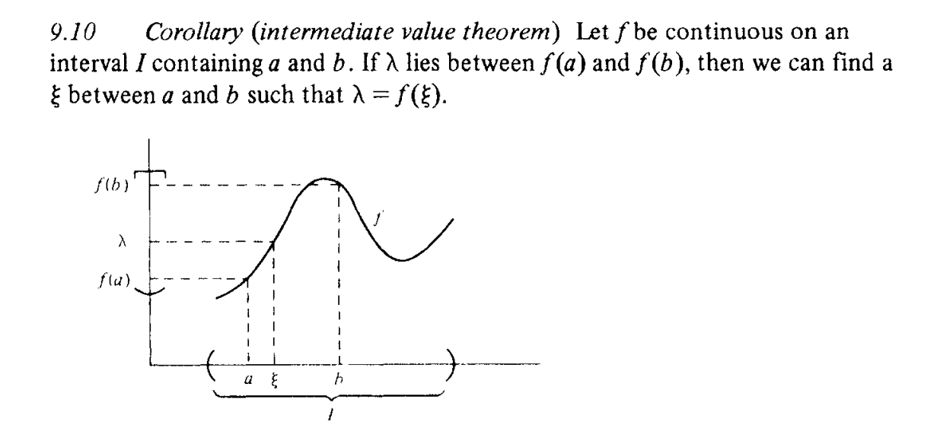

Proof

Method 1:

See section 9.10 page 89 in cookbook.

It is a clumsy restatement of theroem 9.9.

Given $$f:\left(a,b\right)→⋅$$.

Since $$f$$ is continuous on interval $$\left(a,b\right)$$,

then for $$c$$ on interval $$\left(a,b\right)$$, the corresponding point to the image of $$f$$ is also on the interval $$\left(f\left(a\right),f\left(b\right)\right)$$.

See the above figure for more detailed explanation.

Bounded function



Proof

Proof by contradiction.

For more details, see section 9.11 page 88 in the cookbook.

Min value and Max value



Proof

For more details, see section 9.12 page 89 in the cookbook.