Neighborhood

Intro

Def

Neighborhood of something s in X is a subset V of X that includes an open set U containing p.

For a point p, one adopts the “element-of” symbol.

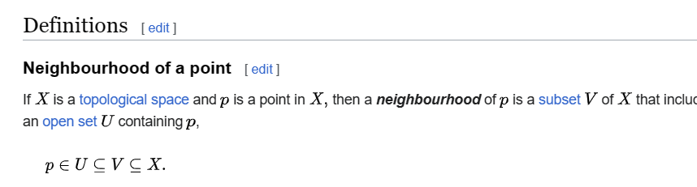

On the other hand, for a set S, one adopts the “subset-of” symbol.

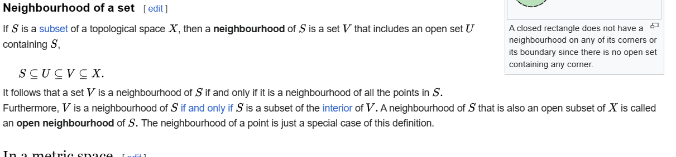

In metric space,

Neighborhood of $$p$$ in the open ball $$B$$ is the set of all distances that closer to $$r$$ (of course $$r>0$$) in the open ball $$B$$.

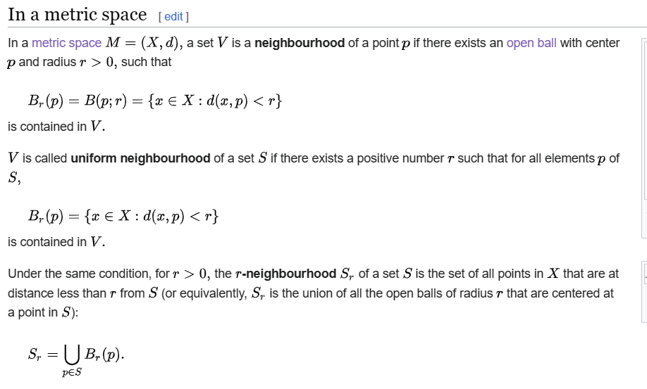

However, their concepts is very similar.

Examples

Example 1 (Has Neighborhood)

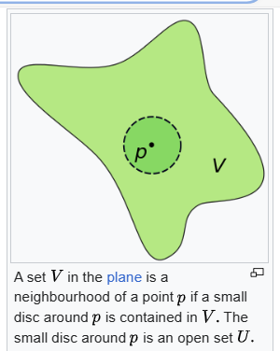

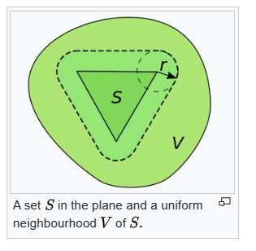

Example 2 (Has No Neighborhood)

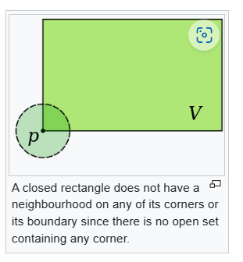

Ref

[Neighbourhood (mathematics) - Wikipedia](https://en.wikipedia.org/wiki/Neighbourhood_(mathematics))