Eigenvalue (linear algebra)

Def

The definition of eigenvalues and eigenvectors

$$Av_{i}=l_{i}v_{i}$$

$$AV=VD$$

$$D=\left[D_{i,j}\right]=d_{i,j}⋅l_{i}$$

where

$$d_{i,j}$$ is Kronecker delta.

That is,

$$d_{i,j}=0$$, if $$i != j$$

$$d_{i,j}=1$$, otherwise

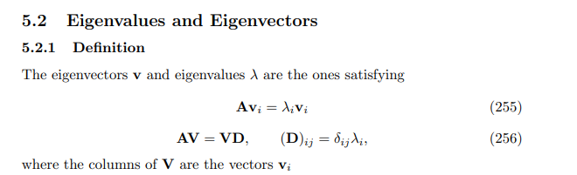

Property

Given matrix $$A$$ with size $$n⋅m$$ and matrix $$B$$ with size .

1.

2. has at most distinct $$\min\left(n,m\right)$$ eigenvalues.

3 . If $$rank\left(A\right)=r$$ => At most $$r$$ non-zero eigenvalues.

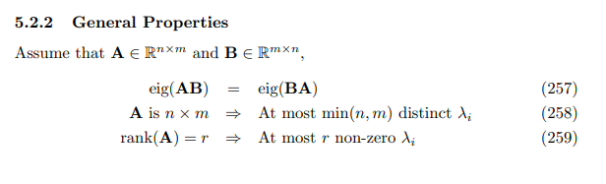

$$tr\left(AB\right)$$ = $$tr\left(BA\right)$$

=> summation of eigenvalue of $$AB$$ and $$BA$$ is equivalent.

The row rank of $$A$$ $$n$$ or $$m$$. The column rank of $$A$$ is $$m$$ or $$n$$. There are at most

$$\min\left(rowrank\left(A\right),colrank\left(A\right)\right)$$ = $$\min\left(m,n\right)$$ distinct eigenvalues.

Consider the relationship between nullity and rank.

$$nullity\left(A\right)+rank\left(A\right)$$ = $$\min\left(m,n\right)$$

Since there are at least $$nullity\left(A\right)$$ eigenvalues that are zero in matrix $$A$$,

there are at most $$\min\left(m,n\right)−nullity\left(A\right)$$ = $$rank\left(A\right)$$ eigenvalues that are non-zero at matrix $$A$$.

Ref

[Kronecker Delta -- from Wolfram MathWorld](https://mathworld.wolfram.com/KroneckerDelta.html)

[Wayback Machine (archive.org)](https://web.archive.org/web/20090521075124/http://www2.imm.dtu.dk/pubdb/views/edoc_download.php/3274/pdf/imm3274.pdf)