Matrix

Intro

A 2D matrix consists of a collection of vectors.

Property

Symmetric matrix

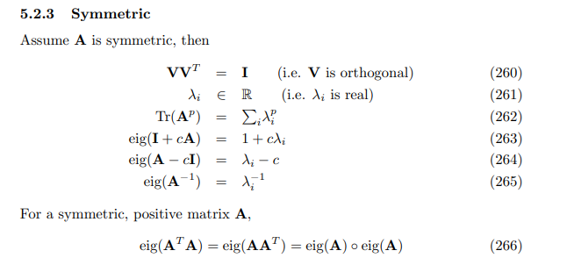

Proof of property of symmetric matrix

By Vieta’s formula, one can prove that

$$tr\left(A\right)$$ = $$sigma\left(eig{\left(A\right)}_{i},i=1,i=n\right)$$

=> $$tr\left(A^{p}\right)$$ = $$sigma\left({\left[eig{\left(A\right)}_{i}\right]}^{p},i=1,i=n\right)$$

$$tr\left(I+cA\right)$$ = $$tr\left(I\right)+tr\left(cA\right)$$

=> $$eig{\left(I+cA\right)}_{i}$$ = $$eig{\left(I\right)}_{i}+eig{\left(cA\right)}_{i}$$

$$tr\left(A−cI\right)$$ = $$tr\left(A\right)−tr\left(cI\right)$$

=> $$eig{\left(A−cI\right)}_{i}$$ = $$eig{\left(A\right)}_{i}−eig{\left(cI\right)}_{i}$$ = $$eig{\left(A\right)}_{i}−c$$

$$A$$ is symmetric

=> $$A=A^{T}$$

=> $$A^{+}$$ = $$A^{−1}$$ = $$\frac{1}{2}\left(A+A^{T}\right)$$ = $$A$$ = $$A^{T}$$

( since $$A$$ is square if $$A$$ is symmetric, it is one of requirements of a symmetric matrix. )

On the other hand, for an invertible matrix, by definition, one has

$$AA^{−1}$$ = $$I$$

which implies

$$AA^{−1}$$ = $$I$$

=> $$tr\left(AA^{−1}\right)$$ = $$tr\left(I\right)$$

=> $$eig{\left(AA^{−1}\right)}_{i}$$ = $$eig{\left(I\right)}_{i}$$

=> $$eig{\left(A\right)}_{i}eig{\left(A^{−1}\right)}_{i}$$ = $$eig{\left(I\right)}_{i}$$ = $$1$$

=> $$eig{\left(A^{−1}\right)}_{i}$$ = $${\left[eig{\left(A\right)}_{i}\right]}^{−1}$$

A positive matrix refers a matrix whose all elements are positive.

For all positive matrix,

$$A$$ = $$A^{T}$$

=> $$eig{\left(AA^{T}\right)}_{i}$$ = $$eig{\left(A\right)}_{i}eig{\left(A^{T}\right)}_{i}$$ = $$eig{\left(A^{T}\right)}_{i}eig{\left(A\right)}_{i}$$ = $$eig{\left(A^{T}A\right)}_{i}$$ = $$eig{\left(A\right)}_{i}eig{\left(A\right)}_{i}$$

(due to communicativity of multiplications for two scalars.)

On the other hand,

$$product\left(eig{\left(A\right)}_{i},i=1,i=n\right)$$ = $$\det\left(A\right)$$

=> $${\det\left(A\right)}^{2}$$ = $$\det\left(A\right)\det\left(A\right)$$ = $$\det\left(A^{2}\right)$$ = $$product\left({\left[eig{\left(A\right)}_{i}\right]}^{2},i=1,i=n\right)$$

=> $$product\left({\left[eig{\left(A\right)}_{i}\right]}^{2},i=1,i=n\right)$$ = $${\det\left(A\right)}^{2}$$ = $$\det\left(Kron\left(A,A\right)\right)$$

=> $${\left(eig{\left(A\right)}_{i}\right)}^{2}$$ = $$Kron{\left(eig\left(A\right),eig\left(A\right)\right)}_{i,i}$$

Conclude the above equations.

$$A=A^{T}$$

=> $$eig\left(AA^{T}\right)$$ = $$eig\left(A^{T}A\right)$$ = $$Kron\left(eig\left(A\right),eig\left(A\right)\right)$$

Ref

[Symmetric matrix - Wikipedia](https://en.wikipedia.org/wiki/Symmetric_matrix)