Trace

Intro

Trace is defined as sum of diagonal entries.

Def

Given $$A$$ with size $$n⋅n$$.

$$tr\left(A\right)$$ = $$sigma\left(a_{i,i},i=1,i=n\right)$$

Def of terms related to trace

$$tr\left(AB\right)$$ = 0 iff $$A$$ is trace orthogonal to $$B$$.

Myth

Non-communicativity

$$tr\left(A\right)$$ $$tr\left(B\right)$$!= $$tr\left(AB\right)$$

Proof of myth

Non-communicativity

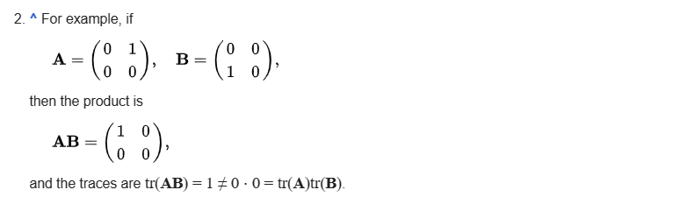

Property

Given:

Given matrix $$A$$, $$B$$ with size $$n⋅n$$ and scalar $$c$$.

Linear mapping (1)

$$tr\left(A+B\right)$$ = $$tr\left(A\right)$$ + $$tr\left(B\right)$$

Linear mapping (2)

$$tr\left(cA\right)$$ = $$c⋅tr\left(A\right)$$

Communicativity of product

$$tr\left(AB\right)$$ = $$tr\left(BA\right)$$

Trace of a product

$$tr\left(A^{T}B\right)$$ = $$tr\left(AB^{T}\right)$$ = $$tr\left(B^{T}A\right)$$ = $$tr\left(BA^{T}\right)$$ = $$sigma\left(sigma\left(a_{i,j}⋅b_{i,j},i=1,i=m\right),j=1,j=n\right)$$

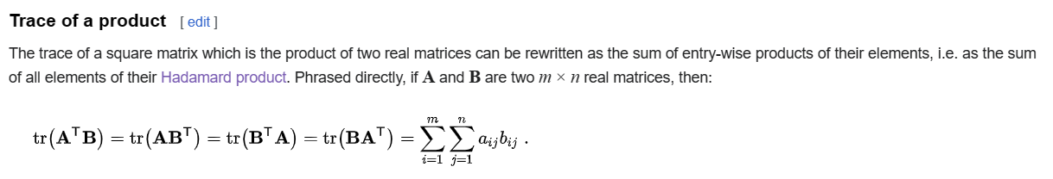

Trace of transpose for matrix

$$tr\left(A\right)$$ = $$tr\left(A^{T}\right)$$

Trace of transpose for two vectors

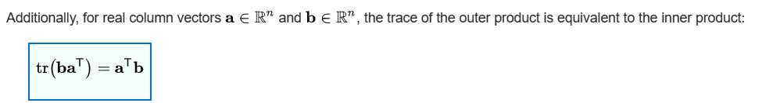

Cyclic

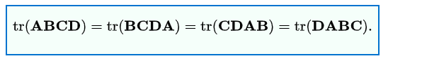

Trace as sum eigenvalue

The trace of $$A$$ is sum of $$l_{i}$$ which refers eigenvalue of A.

$$tr\left(A\right)$$ = $$sigma\left(l_{i},i=1,i=n\right)$$

Trace of Kronecker product

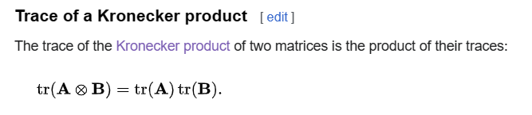

Communicativity of derivatives

$$tr\left(dX\right)$$ = $$d tr\left(X\right)$$

Root and coefficients

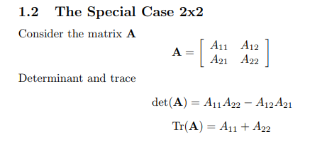

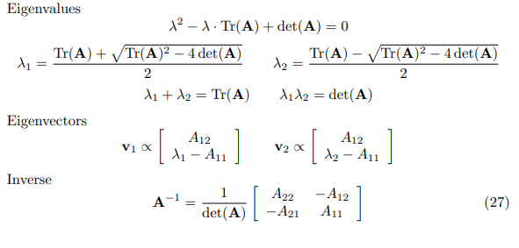

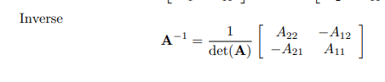

Proof of property

Linear mapping (1)

$$tr\left(A+B\right)$$

= $$sigma\left(a_{j,j}+b_{j,j},j=1,j=n\right)$$

= $$sigma\left(a_{j,j},j=1,j=n\right)$$ + $$sigma\left(b_{j,j},j=1,j=n\right)$$

= $$tr\left(A\right)$$ + $$tr\left(B\right)$$

Linear mapping (2)

$$tr\left(cA\right)$$

= $$sigma\left(c⋅a_{j,j},j=1,j=n\right)$$

= $$c⋅sigma\left(a_{j,j},j=1,j=n\right)$$

= $$c⋅tr\left(A\right)$$

Communicativity of product

$$tr\left(AB\right)$$

= $$sigma\left(e_{j,j},j=1,j=n\right)$$

where

$$e_{r,w}$$ = $$sigma\left(a_{r,i}⋅b_{i,w},i=1,i=n\right)$$

if the fact is assumed $$E$$ = $$AB$$.

On the other hand,

$$tr\left(BA\right)$$

= $$sigma\left(f_{j,j},j=1,j=n\right)$$

where

$$f_{r,w}$$

= $$sigma\left(b_{r,i}⋅a_{i,w},i=1,i=n\right)$$

if the fact is assumed $$F$$ = $$BA$$.

Because one only wants to evaluate the sum of diagonal entries,

One puts $$j$$ to $$r$$, $$w$$ for matrix $$E$$ and $$F$$. Getting:

1. $$e_{j,j}$$ = $$sigma\left(a_{j,i}⋅b_{i,j},i=1,i=n\right)$$

=>

$$tr\left(AB\right)$$

= $$sigma\left(e_{j,j},j=1,j=n\right)$$

= $$sigma\left(sigma\left(a_{j,i}⋅b_{i,j},i=1,i=n\right),j=1,j=n\right)$$

1. $$f_{j,j}$$ = $$sigma\left(b_{j,i}⋅a_{i,j},i=1,i=n\right)$$

=>

$$tr\left(BA\right)$$

= $$sigma\left(f_{j,j},j=1,j=n\right)$$

= $$sigma\left(sigma\left(b_{j,i}⋅a_{i,j},i=1,i=n\right),j=1,j=n\right)$$

Due to communicativity of multiplication bewteen numbers,

one has

$$sigma\left(sigma\left(a_{j,i}⋅b_{i,j},i=1,i=n\right),j=1,j=n\right)$$

= $$sigma\left(sigma\left(b_{i,j}⋅a_{j,i},i=1,i=n\right),j=1,j=n\right)$$

Interchange $$i$$ to $$j$$ and $$j$$ to $$i$$, one gets

$$sigma\left(sigma\left(b_{i,j}⋅a_{j,i},i=1,i=n\right),j=1,j=n\right)$$

= $$sigma\left(sigma\left(b_{j,i}⋅a_{i,j},j=1,j=n\right),i=1,i=n\right)$$

= $$sigma\left(sigma\left(b_{j,i}⋅a_{i,j},i=1,i=n\right),j=1,j=n\right)$$

Combining above equations, one has

$$tr\left(AB\right)$$

= $$sigma\left(sigma\left(a_{j,i}⋅b_{i,j},i=1,i=n\right),j=1,j=n\right)$$

= $$sigma\left(sigma\left(b_{i,j}⋅a_{j,i},i=1,i=n\right),j=1,j=n\right)$$

= $$sigma\left(sigma\left(b_{j,i}⋅a_{i,j},j=1,j=n\right),i=1,i=n\right)$$

= $$sigma\left(sigma\left(b_{j,i}⋅a_{i,j},j=1,j=n\right),i=1,i=n\right)$$

= $$sigma\left(sigma\left(b_{j,i}⋅a_{i,j},i=1,i=n\right),j=1,j=n\right)$$

= $$tr\left(BA\right)$$

which completes the proof.

For simpler proof, see Notes section in Wiki.

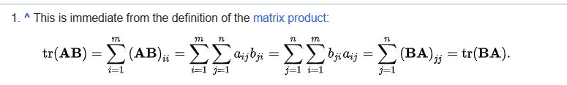

Trace of transpose for matrix

$$tr\left(A\right)$$

= $$sigma\left(a_{j,j},j=1,j=n\right)$$

= $$tr\left(A^{T}\right)$$

Trace of transpose for two vectors



$$tr\left(ba^{T}\right)$$

= $$tr\left(sigma\left(b_{j,⋅}⋅a_{⋅,j},j=1,j=n\right)\right)$$

= $$sigma\left(b_{j,⋅}⋅a_{⋅,j},j=1,j=n\right)$$

= $$sigma\left(a_{⋅,j}⋅b_{j,⋅},j=1,j=n\right)$$

= $$tr\left(sigma\left(a_{⋅,j}⋅b_{j,⋅},j=1,j=n\right)\right)$$

= $$tr\left(a^{T}b\right)$$

Cyclic

Since $$A$$ and $$B$$ has both size $$n⋅n$$, it holds

$$tr\left(AB\right)$$ = $$tr\left(BA\right)$$

Extending it to $$A$$, $$B$$, $$C$$, and $$D$$. One has



which completes the proof.

Trace as sum eigenvalue

By definition of eigenvalue and eigenvector, one has

$$Ax$$ = $$lx$$

where

$$A$$ is an arbitrary matrix,

$$x$$ is a eigenvector of $$A$$,

$$l$$ is the eigenvalue of $$A$$

One can imply property by definition, which is,

We can reduce $$A$$ to $$A−l⋅I$$

$$tr\left(A\right)$$

= $$tr\left(A−l⋅I\right)$$

= $$sigma\left(l_{i},i=1,i=n\right)$$

Root and coefficients

By roots and coefficients,

Since $$l_{1},l_{2}$$ are roots of $$A$$

$$tr\left(A\right)$$ = $$l_{1}+l_{2}$$ $$\det\left(A\right)$$ = $$l_{1}l_{2}$$

Then simply use quadratic formula.

Special case

Identity matrix

$$tr\left(I_{n}\right)$$ = $$n$$

Zero matrix

$$tr\left(O_{n}\right)$$ = 0

Idempotent matrix

$$tr\left(P_{x}\right)$$ = $$rank\left(x\right)$$

Hermitian matrix

$$tr\left(A\right)$$ is always a real number.

Proof of special case

Identity matrix

$$tr\left(I_{n}\right)$$

= $$sigma\left(I_{j,j},j=1,j=n\right)$$

= $$sigma\left(1,j=1,j=n\right)$$

= $$n$$

Zero matrix

$$tr\left(0_{n}\right)$$

= $$sigma\left(O_{j,j},j=1,j=n\right)$$

= $$sigma\left(0,j,j=1,j=n\right)$$

= $$0$$

Idempotent matrix

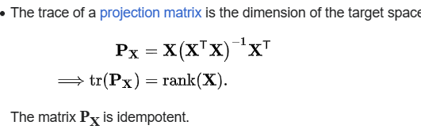

The second proof of claim:

$$A$$ = $$A^{2}$$

=> $$tr\left(A\right)$$ = $$tr\left(A^{2}\right)$$

Hermitian matrix

By definition of Hermitian, the diagonal entries are real numbers, thus

$$tr\left(A\right)$$

= $$sigma\left(a_{j,j},j=1,j=n\right)$$

= $$k$$

which is a real number.

End of proof.

Ref

[Trace (linear algebra) - Wikipedia](https://en.wikipedia.org/wiki/Trace_(linear_algebra))

[Web Cookbook](https://web.archive.org/web/20090521075124/http://www2.imm.dtu.dk/pubdb/views/edoc_download.php/3274/pdf/imm3274.pdf)