Norm

Def

Matrix

Generalized form

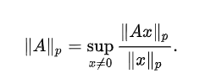

Matrix norms induced by vector α-norms and β-norms



Examples

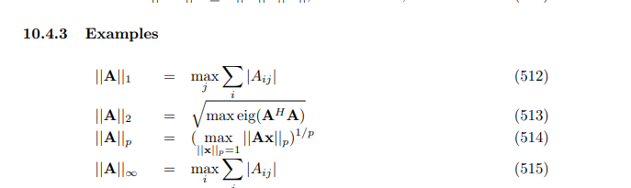

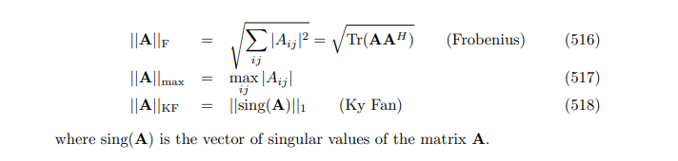

Preliminary

Generalized form



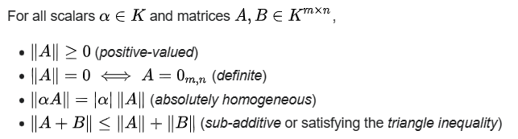



Induced form

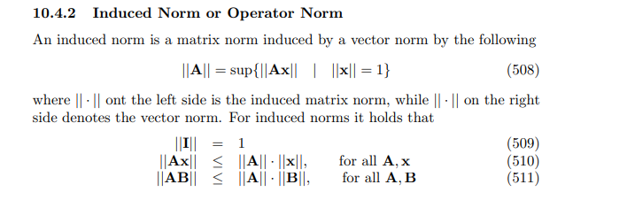

Proof of preliminary

Generalized form

Positive-valued

Preface:

Although the claim is intuitive, one has to proof it.

Proof:

By definition of norm of matrix induced by vector p-norms,

$${\left|\left|A\right|\right|}_{p}$$ = $$\sup\left(x!=0,\frac{{\left|\left|Ax\right|\right|}_{p}}{{\left|\left|x\right|\right|}_{p}}\right)$$ where $$x$$ is a scalar.

where

$${\left|\left|T\right|\right|}_{p}$$ denotes of Schatten norm.

Recall that in Schatten norm,

$${\left|\left|T\right|\right|}_{p}$$ = $${\left[tr\left({\left[\left|T\right|\right]}^{p}\right)\right]}^{\frac{1}{p}}$$

where

$$\left|T\right|$$ = $${\left(T⋅T\right)}^{\frac{1}{2}}$$

$$tr\left(T\right)$$ refers the trace of matrix $$T$$

Now, simplify the definition of Schatten norm, getting

$${\left|\left|T\right|\right|}_{p}$$

= $${\left[tr\left({\left[\left|T\right|\right]}^{p}\right)\right]}^{\frac{1}{p}}$$

= $${\left[tr\left({\left[{\left(T⋅T\right)}^{\frac{1}{2}}\right]}^{p}\right)\right]}^{\frac{1}{p}}$$

= $${\left[tr\left({\left(T⋅T\right)}^{\frac{p}{2}}\right)\right]}^{\frac{1}{p}}$$

Next, simplify the definition of norm of matrix induced by vector p-norms.

$${\left|\left|A\right|\right|}_{p}$$

= $$\sup\left(x!=0,\frac{{\left|\left|Ax\right|\right|}_{p}}{{\left|\left|x\right|\right|}_{p}}\right)$$

= $$\sup\left(x!=0,\frac{tr{\left({\left(Ax⋅Ax\right)}^{\frac{p}{2}}\right)}^{\frac{1}{p}}}{tr{\left({\left(x⋅x\right)}^{\frac{p}{2}}\right)}^{\frac{1}{p}}}\right)$$

= $$\sup\left(x!=0,\frac{tr{\left({\left(Ax⋅Ax\right)}^{\frac{p}{2}}\right)}^{\frac{1}{p}}}{tr{\left({\left(x⋅x\right)}^{\frac{p}{2}}\right)}^{\frac{1}{p}}}\right)$$

= $$\sup\left(x!=0,\frac{tr{\left({\left(A^{2}⋅x^{2}\right)}^{\frac{p}{2}}\right)}^{\frac{1}{p}}}{tr{\left({\left(x^{2}\right)}^{\frac{p}{2}}\right)}^{\frac{1}{p}}}\right)$$

(since $$x$$ is a scalar , $$Ax$$ = $$xA$$)

= $$\sup\left(x!=0,\frac{tr{\left(A^{p}⋅x^{p}\right)}^{\frac{1}{p}}}{tr{\left(x^{p}\right)}^{\frac{1}{p}}}\right)$$

= $$\sup\left(x!=0,\frac{tr{\left(A^{p}⋅x^{p}\right)}^{\frac{1}{p}}}{tr{\left(x^{p}I\right)}^{\frac{1}{p}}}\right)$$

(where $$I$$ refers Identity matrix)

= $$\sup\left(x!=0,\frac{tr{\left(A^{p}⋅x^{p}\right)}^{\frac{1}{p}}}{{\left[x^{p}⋅tr\left(I\right)\right]}^{\frac{1}{p}}}\right)$$

(by property of trace: since $$x$$ is scalar, $$tr\left(xI\right)$$ = $$x⋅tr\left(I\right)$$)

= $$\sup\left(x!=0,\frac{tr{\left(A^{p}⋅x^{p}\right)}^{\frac{1}{p}}}{x}\right)$$

= $$\sup\left(x!=0,\frac{x⋅tr{\left(A^{p}\right)}^{\frac{1}{p}}}{x}\right)$$

= $$\sup\left(x!=0,tr{\left(A^{p}\right)}^{\frac{1}{p}}\right)$$

= $$\sup\left(tr{\left(A^{p}\right)}^{\frac{1}{p}}\right)$$

$$≥0$$

Why it is always greater than or equal to zero?

1. $$\sup\left({\left(sigma\left({\left(l_{A_{i}}\right)}^{p},i=1,i=n\right)\right)}^{\frac{1}{p}}\right)$$ Suppose:

Matrix $$A$$ has $$n$$ eigenvalues $$l_{A}$$ = $$\left\{l_{A_{1}},.., l_{A_{n}}\right\}$$.

Then the matrix $$A^{p}$$ has n eigenvalues $$l_{A^{P}}$$ = $$\left\{{\left(l_{A_{1}}\right)}^{p},…,{\left(l_{A_{n}}\right)}^{p}\right\}$$.

And by the property of trace, the above equation will be

$${\left|\left|A\right|\right|}_{p}$$

= $$\sup\left({\left(sigma\left({\left(l_{A_{i}}\right)}^{p},i=1,i=n\right)\right)}^{\frac{1}{p}}\right)$$

When $$p$$ is an even real number $${\left(l_{A_{i}}\right)}^{p}$$ will be always greater than or equal to zero.

Adding them up, $$sigma\left({\left(l_{A_{i}}\right)}^{p},i=1,i=n\right)$$ will be too.

One takes its superierum for $$p$$ from $$0$$ to $$\inf{}$$. Thus,

$$\sup\left(sigma{\left({\left(l_{A}\right)}^{p},i=1,i=n\right)}^{\frac{1}{p}}\right)$$ $$≥0$$

Definite

One has to prove it forward and backward.

Backward:

By previous procedure, one has

$$A$$ = $$O_{m,n}$$

=> $$tr\left(A\right)$$ = $$0$$

=> $${\left|\left|A\right|\right|}_{p}$$ = $$\sup\left(tr{\left(A^{p}\right)}^{\frac{1}{p}}\right)$$ = $$0$$

Forward,

$${\left|\left|A\right|\right|}_{p}$$ = $$\sup\left(tr{\left(A^{p}\right)}^{\frac{1}{p}}\right)$$ = $$0$$

=> $$tr{\left(A^{p}\right)}^{\frac{1}{p}}$$ = $$0$$

=> $$tr\left(A^{p}\right)$$ = $$0$$

=> $$A^{p}$$ = $$O$$

=> $$A$$ = $$O$$

Absolutely homogenuous

$${\left|\left|cA\right|\right|}_{p}$$

= $$\sup\left(tr{\left({\left(cA\right)}^{p}\right)}^{\frac{1}{p}}\right)$$

= $$\sup\left(tr{\left(c^{p}⋅A^{p}\right)}^{\frac{1}{p}}\right)$$

= $$\sup\left(c⋅tr{\left(A^{p}\right)}^{\frac{1}{p}}\right)$$

= $$\left|c\right|⋅\sup\left(tr{\left(A^{p}\right)}^{\frac{1}{p}}\right)$$

= $$\left|c\right|⋅{\left|\left|A\right|\right|}_{p}$$

Here, since $$c$$ is a scalar, $$\left|c\right|$$ refers absolute value of $$c$$.

Triangle inequality

$${\left|\left|A+B\right|\right|}_{p}$$

= $$\sup\left(tr{\left({\left(A+B\right)}^{p}\right)}^{\frac{1}{p}}\right)$$

$$≤$$ $$\sup\left(tr{\left(\left(A^{p}+B^{p}\right)\right)}^{\frac{1}{p}}\right)$$

= $$\sup\left({\left(tr\left(A^{p}\right)+tr\left(B^{p}\right)\right)}^{\frac{1}{p}}\right)$$

$$≤$$ $$\sup\left(tr{\left(A^{p}\right)}^{\frac{1}{p}}+tr{\left(B^{p}\right)}^{\frac{1}{p}}\right)$$

= $$\sup\left(tr{\left(A^{p}\right)}^{\frac{1}{p}}\right)+\sup\left(tr{\left(B^{p}\right)}^{\frac{1}{p}}\right)$$

= $${\left|\left|A\right|\right|}_{p}+{\left|\left|B\right|\right|}_{p}$$

Induced form

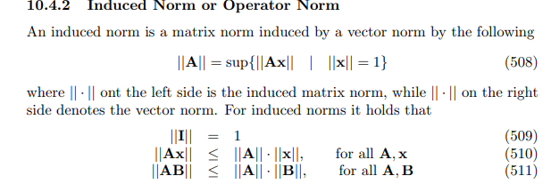

For eq (509),

Prove it with definition.

For eq (510),

By definition of induced norm, one has these equations.

$$\left|\left|A⋅vec\left(x\right)\right|\right|$$ = $$\sup\left(\left|\left|vec\left(y\right)\right|\right|=1,\left|\left|A⋅vec\left(x\right)⋅vec\left(y\right)\right|\right|\right)$$

$$\left|\left|A\right|\right|$$ = $$\sup\left(\left|\left|vec\left(y\right)\right|\right|=1,\left|\left|A⋅vec\left(y\right)\right|\right|\right)$$

$$\left|\left|vec\left(x\right)\right|\right|$$ = $$\sup\left(\left|\left|vec\left(y\right)\right|\right|=1,\left|\left|vec\left(x\right)⋅vec\left(y\right)\right|\right|\right)$$

Thus,

$$\left|\left|A⋅vec\left(x\right)\right|\right|$$

= $$\left|\left|A⋅vec\left(x\right)\right|\right|$$

= $$\sup\left(\left|\left|vec\left(y\right)\right|\right|=1,\left|\left|A⋅vec\left(x\right)⋅vec\left(y\right)\right|\right|\right)$$

= $$\sup\left(\left|\left|vec\left(y\right)⋅vec\left(z\right)\right|\right|=1,\left|\left|A⋅vec\left(x\right)⋅vec\left(y\right)⋅vec\left(z\right)\right|\right|\right)$$

(just simply replace $$vec\left(y\right)$$ to $$vec\left(y\right)⋅vec\left(z\right)$$)

$$≤$$ $$\sup\left(\left|\left|vec\left(y\right)⋅vec\left(z\right)\right|\right|=1,\left|\left|A⋅vec\left(y\right)\right|\right|⋅\left|\left|vec\left(x\right)⋅vec\left(z\right)\right|\right|\right)$$

( by the assumption for proof by contradiction and there are no problem even after

superum function since superum function take the largest value in the given set, and the assumption for proof by contradiction contains the less than signature)

= $$\sup\left(\left|\left|vec\left(y\right)\right|\right|⋅\left|\left|vec\left(z\right)\right|\right|\left|=1,\left|\left|A⋅vec\left(y\right)\right|\right|⋅\left|\left|vec\left(x\right)⋅vec\left(z\right)\right|\right|\right|\right)$$

( there are no problem too since $$1⋅1$$ is equal to $$1$$ and the assumption contains the less signature which it is discussed above.

Consider the following claim:

For any real scalar $$a$$ and $$b$$ such that $$a>1$$ an $$b>1$$, the following holds:

$$a⋅b>1⋅1=1$$

)

= $$\sup\left(\left|\left|vec\left(y\right)\right|\right|=1,\left|\left|A⋅vec\left(y\right)\right|\right|\right)$$ $$\sup\left(\left|\left|vec\left(z\right)\right|\right|=1,\left|\left|x⋅vec\left(z\right)\right|\right|\right)$$

*

= $$\left|\left|A\right|\right|$$ $$\left|\left|x\right|\right|$$

*

For eq (511),

Do similar things as eq (510)

Property

Matrix norm



Matrix norms induced by vector α-norms and β- norms

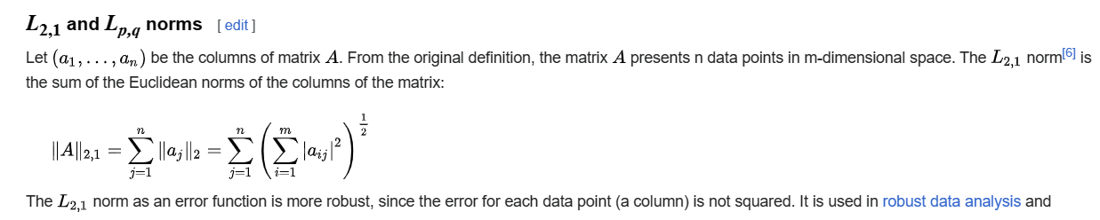

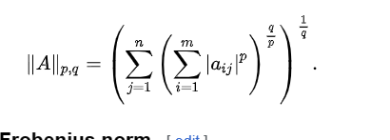

Inequality

Matrix norm with 1-dimension

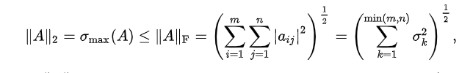

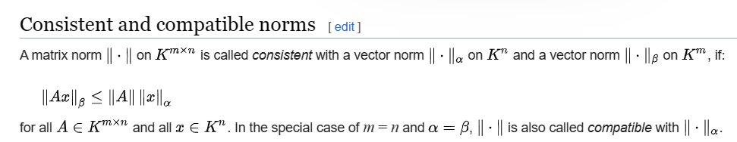

Matrix norms induced by vector α-norms and β- norms



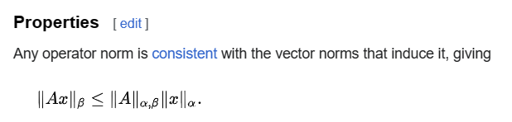



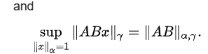

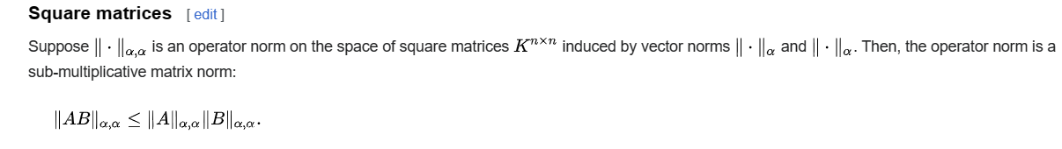

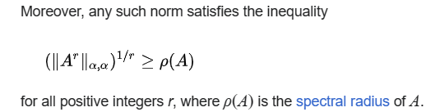

Table of inequality

Here is the table about inequality for all relationship between different measurements of norms. (From section 10.4.4 in the cookbook)

I will skip the proof.

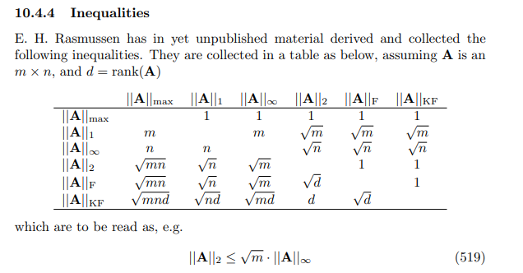

Special case

p == 2

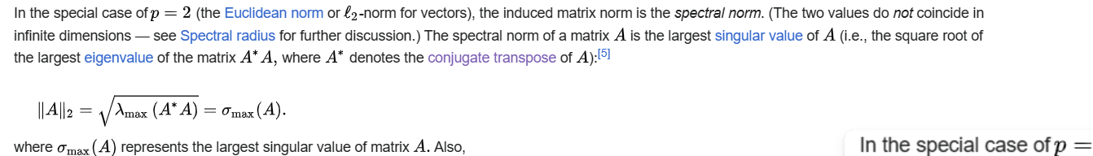

Matrix norms induced by vector α-norms and β-norms

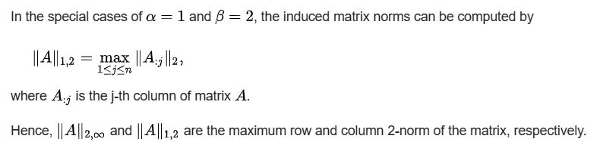

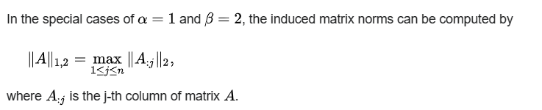

Matrix norm with 1-dimension

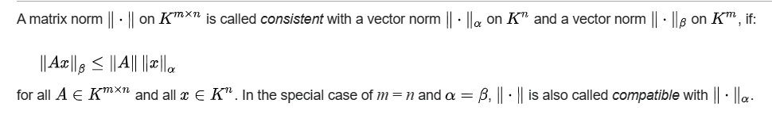

Special case for special matrix

unitary matrix



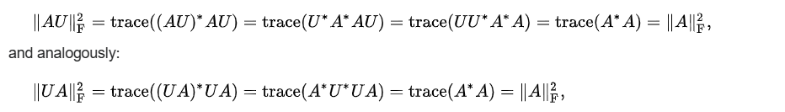

Branch

Preface:

In this article, I just simply discuss the basic concept, definition and property.

There are many different measurements of norms which has different definitions and is applied to different cases. Lucky, the basic concept is very similar so that if one understands the basic concept, one is supposed to easily catch the formula of each different measurements.

Here, I will only table the name and filename of my notes (which has the detailed explanation about different norm) for the commonly used measurements.

To find it, just type the filename (without file extension) to searchbox at GitHub.

(The filename in table may different to filename on the uploaded at GitHub due to

filename rule at GitHub.)

|  |  |
| --- | --- |
| Superum norm | Superum norm.docx |
| Maximum norm | Superum norm.docx |
| Schatten norm | Schatten norm.docx |
| P-norm | P-norm.docx |
| Euclidean norm | Euclidean norm.docx |
| Absolute-value norm | Absolute-value norm.docx |
| Zero norm | Zero norm.docx |
| Frobenius norm | Frobenius norm.docx |

Ref

[Matrix norm - Wikipedia](https://en.wikipedia.org/wiki/Matrix_norm)

[Wayback Machine (archive.org)](https://web.archive.org/web/20090521075124/http://www2.imm.dtu.dk/pubdb/views/edoc_download.php/3274/pdf/imm3274.pdf)