p-norm

Alias

p-norm

$$l_{p}$$ norm

Intro

Concept is similar to Schatten norm except that p-norm is applied to discrete function.

The tip to memorize it is that change sup function to max function and trace function to sigma function.

See the Def section.

Def

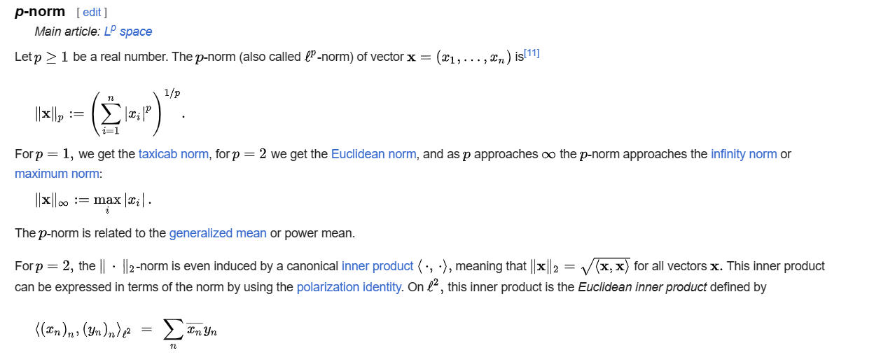

Ref

See p-norm subsection in Examples section in Wiki,

[Norm (mathematics) - Wikipedia](https://en.wikipedia.org/wiki/Norm_(mathematics)#Equivalent_norms)

For more detailed explanation, see Lp space in Wiki,

[Lp space - Wikipedia](https://en.wikipedia.org/wiki/Lp_space)