CPU scheduling

[intro]

$$\left(1\right)FCFS(First Come, First Serve)$$

$$\left(2\right)SJF (Shortest Job First)$$

$$\left(3\right)SRTF(Shortest Remaining Time First)$$

$$\left(4\right)RR(Round Robin)$$

$$\left(5\right)Priority queue$$

$$\left(6\right)MLQ (multilevel queue)$$

$$\left(7\right)MFQ (multilevel feedback queue)$$

$$Notation:$$

$$P=Preemptive$$

$$NP=NonPreemptive$$

|  |  |  |  |
| --- | --- | --- | --- |
|  | $$P or NP$$ | $$pro$$ | $$con$$ |
| $$\left(1\right)FCFS$$ $$First Come,$$ $$First Serve$$ | $$NP$$ $$(P is$$ $$meaningless)$$ | $$(1)Easy to$$ $$implement$$ | $$\left(1\right)Low$$ $$efficiency$$ |
| $$\left(2\right)SJF$$ $$Shortest$$ $$Job$$ $$First$$ | $$NP$$ | $$\left(1\right)High$$ $$Efficiency$$ $$\left(2\right)Easier to$$ $$implement$$ | $$\left(1\right)May be$$ $$starvation$$ $$(when the job$$ $$which is working$$ $$is too long.)$$ $$\left(2\right)May be$$ $$starvation$$ $$(when the job$$ $$which is ready$$ $$to work$$ $$is too long.)$$ |
| $$\left(3\right)SRTF$$ $$Shortest$$ $$Remaining$$ $$Time$$ $$First$$ | $$P$$ | $$\left(1\right)No issue$$ $$about$$ $$\left(2\right) con (1)$$ | $$\left(1\right)Uneasier$$ $$to implement.$$ $$\left(2\right)The issue$$ $$about$$ $$\left(2\right) con \left(2\right)$$ $$has NOT solved$$ $$yet.$$ |
| $$\left(4\right)RR$$ $$Round$$ $$Robin$$ | $$P$$ $$(since its$$ $$principle)$$ | $$\left(1\right)Easier to solve$$ $$\left(2\right) con (2)$$ | $$\left(1\right)More$$ $$context switch$$ $$needs.$$ |
| $$\left(5\right)Priority$$ $$queue$$ | $$NP$$ | $$\left(1\right)A job with$$ $$requirement of$$ $$fast response$$ $$can be solved$$ $$first.$$ $$(since it has$$ $$higher$$ $$priority.)$$ | $$\left(1\right)May starves.$$ $$(A job with$$ $$lower priority$$ $$be often$$ $$starved.)$$ |
| $$\left(6\right)MLQ$$ $$multilevel$$ $$queue$$ | $$NOT SURE$$ | $$\left(1\right)Low scheduling$$ $$overhead.$$ | $$\left(1\right)May starves.$$ $$(A job with$$ $$lower priority$$ $$be often$$ $$starved.)$$ $$\left(2\right)Also, it is$$ $$inflexible$$ $$in nature.$$ |
| $$\left(7\right)MFQ$$ $$multilevel$$ $$feedback$$ $$queue$$ | $$NOT SURE$$ | $$\left(1\right)Solve$$ $$\left(6\right) con \left(1\right)$$ $$\left(2\right)More$$ $$flexible.$$ | $$\left(1\right)More$$ $$scheduling$$ $$overhead.$$ $$\left(2\right)Most$$ $$complex$$ $$algorithm$$ |

The structure of MFQ

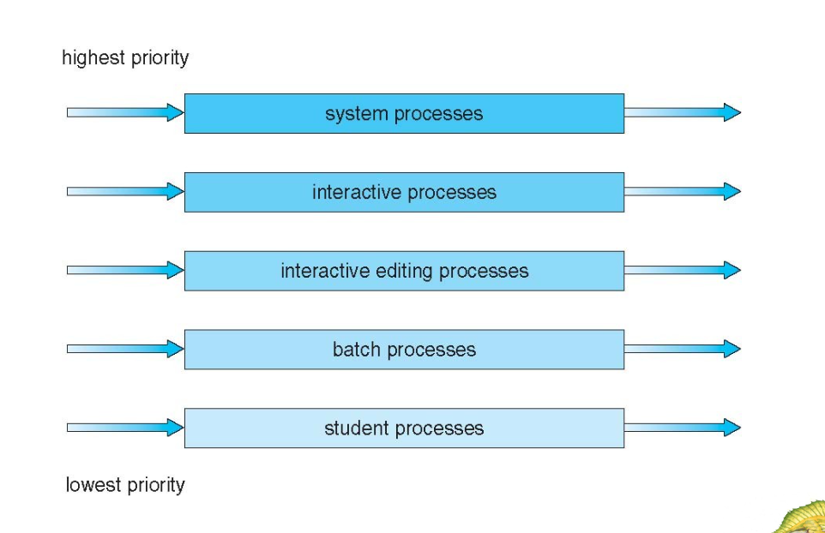

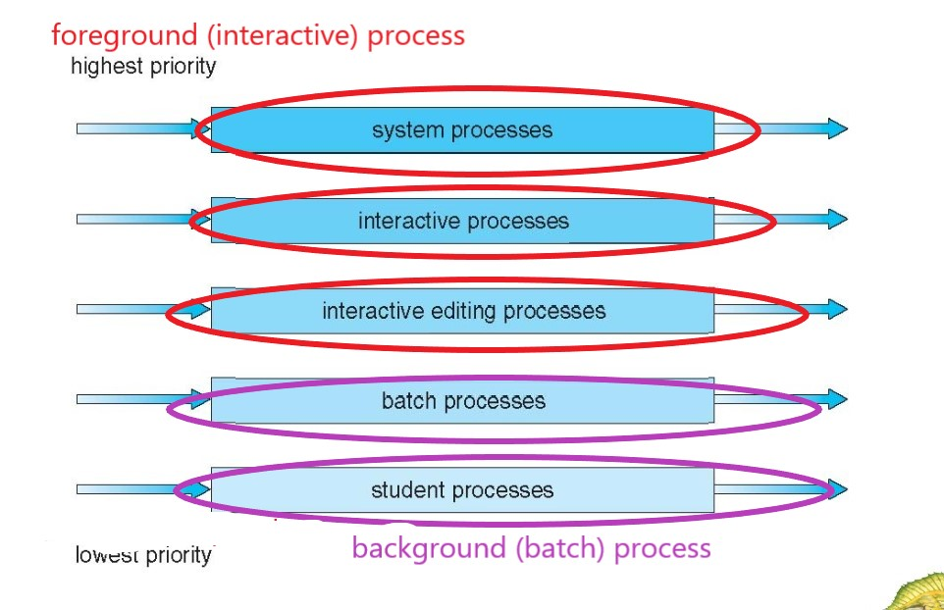

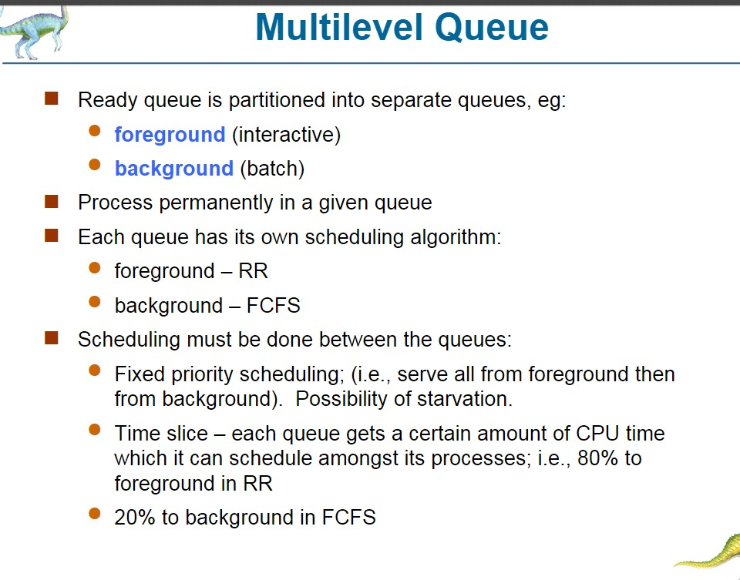

|  |  |  |  |  |
| --- | --- | --- | --- | --- |
| $$type$$ | $$alias$$ | $$algorithm$$ | $$time slice$$ | $$priority$$ |
| $$foreground$$ | $$interactive$$ | $$RR$$ | $$80\%$$ | $$higher$$ |
| $$background$$ | $$batch$$ | $$FCFS$$ | $$20\%$$ | $$lower$$ |
|  |  |  |  |  |

The structure of MLFQ

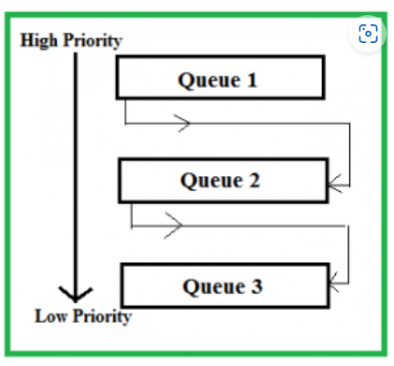



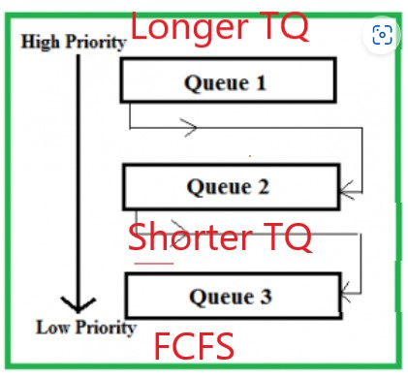

[ref]

[Multilevel Queue (MLQ) CPU Scheduling - GeeksforGeeks](https://www.geeksforgeeks.org/multilevel-queue-mlq-cpu-scheduling/)

[Multilevel Feedback Queue Scheduling (MLFQ) CPU Scheduling - GeeksforGeeks](https://www.geeksforgeeks.org/multilevel-feedback-queue-scheduling-mlfq-cpu-scheduling/)