Connection protocol

[intro]

[type]

$$The common connection protocols are as follows.$$

$$\left(1\right)\left(TCP\right)Transmission Control Protocol.$$

$$\left(2\right)\left(UDP\right)User Datagram Protocol.$$

$$\left[intro\right]$$

$$\left(1\right)\left(TCP\right)Transmission Control Protocol:$$

$$A protocol which is connection-oriented.$$

$$That is, we have to make sure that the packet is$$

$$receive by the receiver after sender sending a packet.$$

$$\left[Application\right]$$

$$\left(1\right)Application that time-delay is allowed$$

$$but the packet must be receive correctly.$$

$$Such as sending a email or a line message.$$

$$The illustration tells us the step of connection.$$

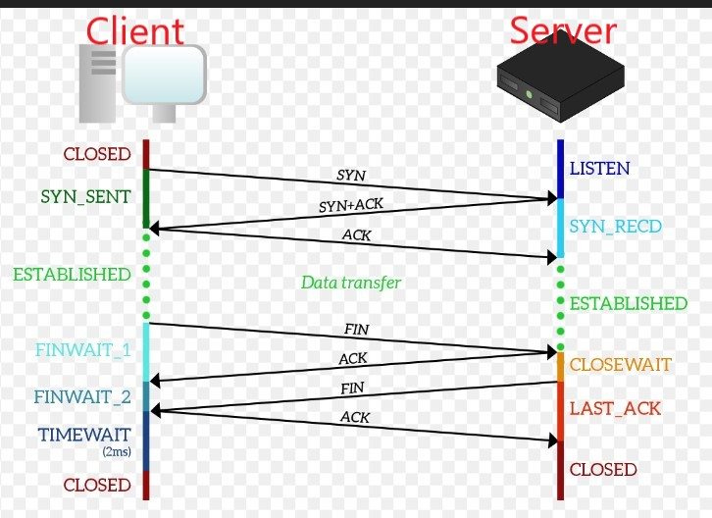

$$\left(2\right)\left(UDP\right)User Datagram Protocol.$$

$$It is connectionless.$$

$$That is,$$

$$the sender must NOT wait for receiver$$

$$after sender sends a packet.$$

$$\left[Application\right]$$

$$\left(1\right)NO time-delay tolerance:$$

$$such as telephoning or YT streaming.$$

[ref]