Context switch

[intro]

$$Context switch occurs iff$$

$$the interrupt or system call occurs.$$

$$Suppose the process P_{0} is executed intially.$$

$$After a while, an interrupt of P_{0} occurs.$$

$$At this point, suppose the process P_{1} is executed.$$

$$Before P_{1} is executed, the following steps must be done.$$

$$\left(1\right)Save state into PCB_{0} \left(PCB of P_{0}\right).$$

$$\left(2\right)Reload state from PCB_{1}\left(PCB of P_{1}\right)$$

$$\left(3\right)Execute P_{1}.$$

$$After a while, an interrupt of P_{1} occurs.$$

$$At this point, P_{0} is executed.$$

$$Similary, before P_{0} is executed,$$

$$the following steps must be done.$$

$$\left(1\right)Save state into PCB_{1}.$$

$$\left(2\right)Reload state from PCB_{0}.$$

$$\left(3\right)Execute P_{0}.$$

$$The procedure is called$$

$$a context switch of P_{0} and P_{1}.$$

[illustration]

$$Here is the procedure of context swicth of P_{0} and P_{1}.$$

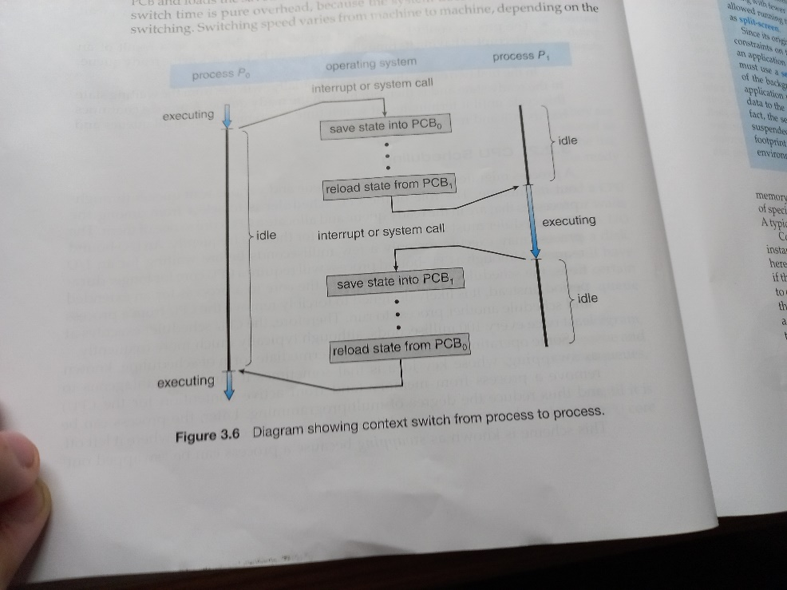

$$Consider the state of P_{0} and P_{1}.$$

|  |  |  |  |
| --- | --- | --- | --- |
| $$Time$$ | $$Process state$$ | | $$Executing$$ $$process$$ |
| $$P_{0}$$ | $$P_{1}$$ |
| $$1$$ | $$running state$$ | $$ready state$$ | $$P_{0}$$ |
| $$2$$ | $$ready state$$ | $$running state$$ | $$P_{1}$$ |
| $$3$$ | $$running state$$ | $$ready state$$ | $$P_{0}$$ |

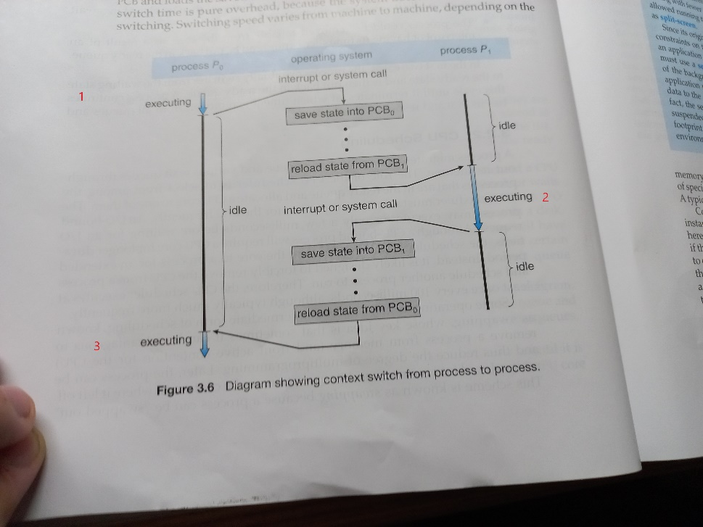

[ref]

OS textbook CH3-2-3 page 120-122

[Context switch - Wikipedia](https://en.wikipedia.org/wiki/Context_switch)