Cooperating process

[intro]

$$Cooperating processes are those who$$

$$affect other processes when one is affected.$$

[pro]

$$Q:Why do we need it?$$

$$A:Since it has some advantages.$$

$$\left(1\right)Modularity:$$

$$Modularity means that we can complete$$

$$many functionalities using many modules.$$

$$When we want to change a functionality,$$

$$we just have to remove or add some module$$

$$such that we can reuse it.$$

$$\left(2\right)Sharing informations:$$

$$Sharing information between$$

$$multiple processes can be done by cooperating processes.$$

$$\left(3\right)Convenience:$$

$$There are many taskes we need.$$

$$If they are managed by cooperating processes,$$

$$it is convenient to debug.$$

$$\left(4\right)Computation speedup.$$

$$Subtask of a single process can be parallely using$$

$$by cooperating processes.$$

$$\left[bonus\right]$$

$$Great Importance‼!$$

$$Q:How to make cooperating processes?$$

$$A:\left(1\right)Using shared memory model.$$

$$\left(2\right)Using message passing model.$$

$$It can be analogized by$$

$$interprocess communication models.$$

$$For interprocess communication models,$$

$$see OS textbook page 131.$$

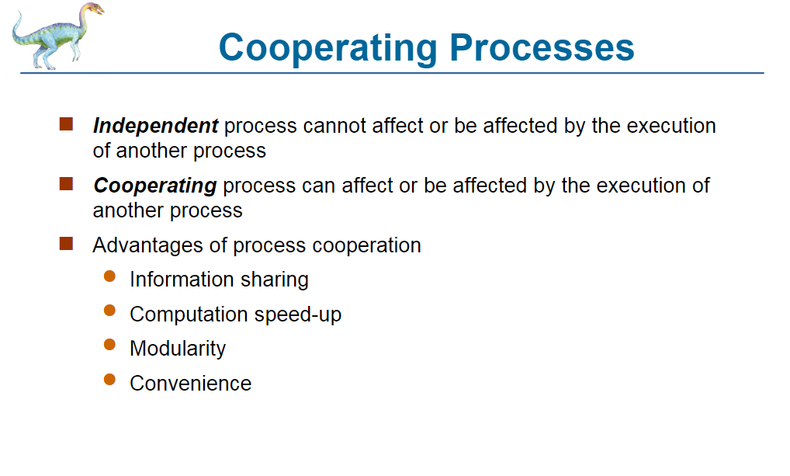

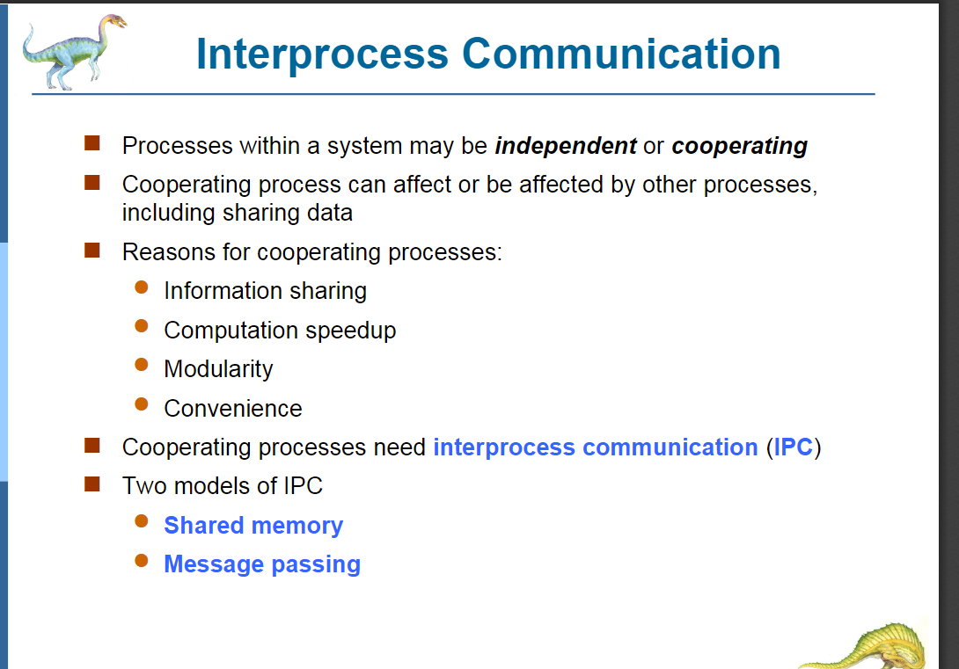

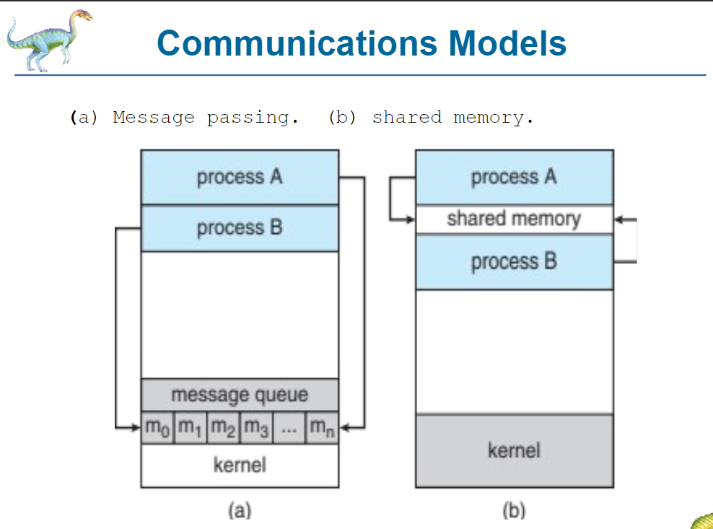

$$More details on this page.$$

$$\left[bonus\right]$$

$$Q:How to implement shared memory.$$

$$A:See bounded-buffer.$$

$$(my note talks about it bounded-buffer.)$$

[ref]

[Cooperating Process (tutorialspoint.com)](https://www.tutorialspoint.com/cooperating-process)