DMA

[abbr]

$$Directory memory access$$

[intro]

$$It is a feature of computer systems that allows certain$$

$$hardware subsystems to access main system memory$$

$$independently of CPU.$$

[application]

$$Many hardware uses DMA,including$$

$$\left(1\right)disk drive controllers.$$

$$\left(2\right)graphic cards.$$

$$\left(3\right)network cards.$$

$$\left(4\right)sound cards.$$

$$\left(5\right)Intra-chip transfer in multi-core processors.$$

$$\left(6\right)Memory to memory with copying and moving$$

$$data with memory.$$

$$\left(7\right)Larger copies$$

$$\left(8\right)Scatter-gather operations.$$

[illustration]

$$\left(1\right)Steps of DMA:$$

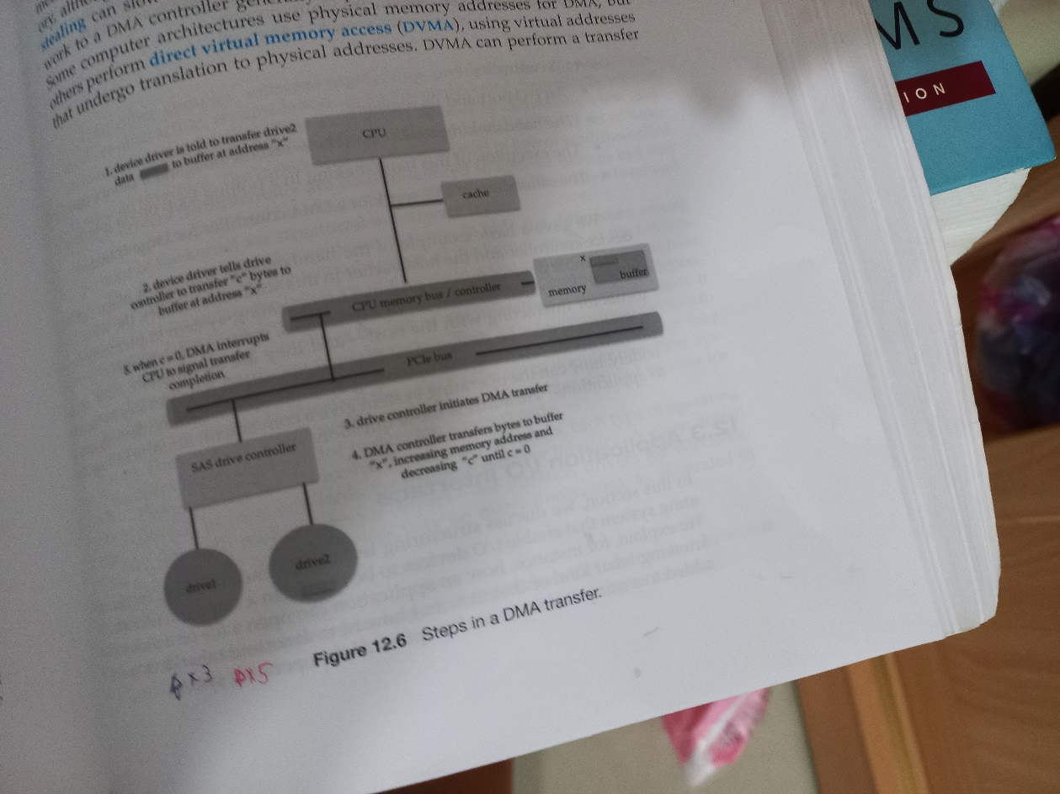

[ref]

[Direct memory access - Wikipedia](https://en.wikipedia.org/wiki/Direct_memory_access)