DFS

[abbr]

$$Distributed file system$$

[intro]

[feature]

$$\left(1\right)transparency.$$

$$\left(2\right)easy to use.$$

$$\left(3\right)high availability.$$

$$\left(4\right)scalibility.$$

$$\left(5\right)high reliability.$$

$$\left(6\right)data integrity.$$

$$\left(7\right)heterogenity.$$

[illustration]

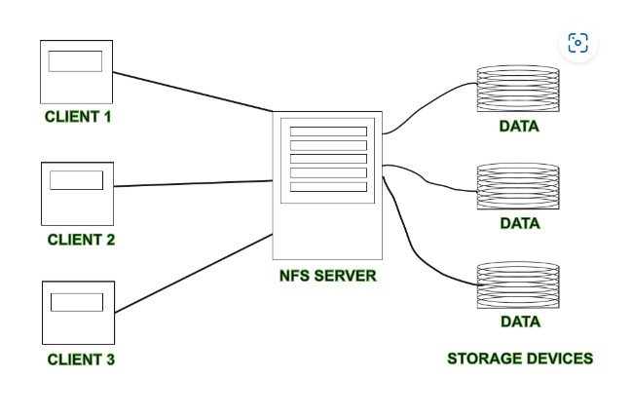

[pro]

$$\left(1\right)More users can access and store the data.$$

$$\left(2\right)It improves the availabilty of file, access time$$

$$and network efficiency.$$

$$\left(3\right)Transparency even if server or disk fails.$$

[con]

$$\left(1\right)Security is at stake.$$

$$\left(2\right)Possibility of data loss while transferring data.$$

$$\left(3\right)Database connection is complicated in case of DFS.$$

$$\left(4\right)There are chances that overloading will take place$$

$$if all nodes are tries to send data at once.$$

[type]

$Client-server based DFS.$

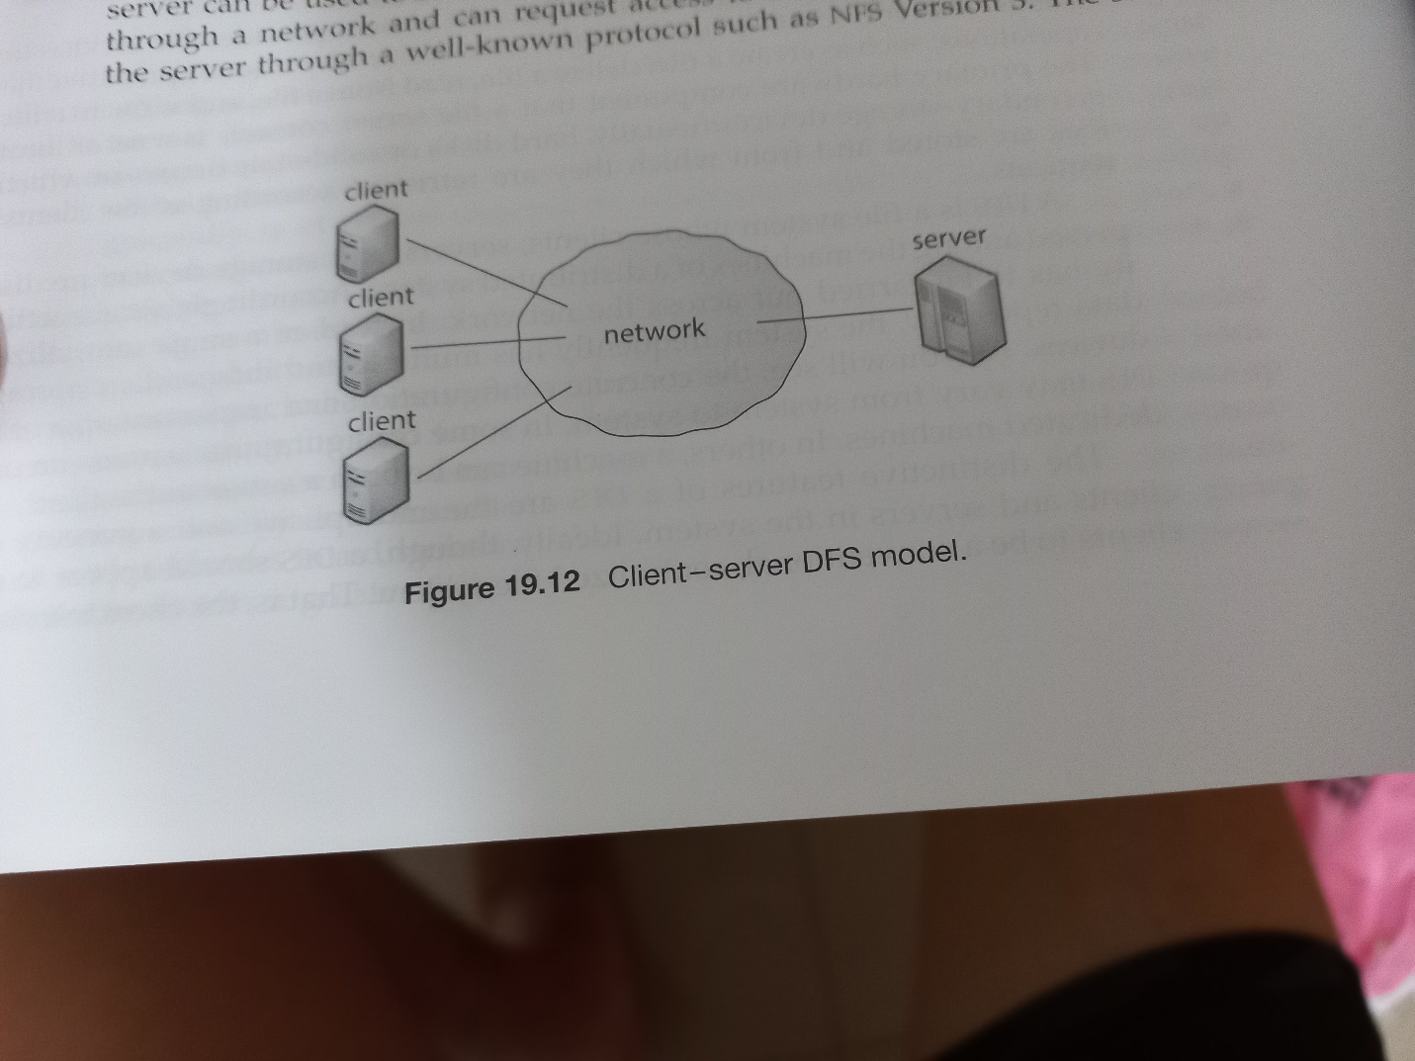

$Cluster-based DFS.$

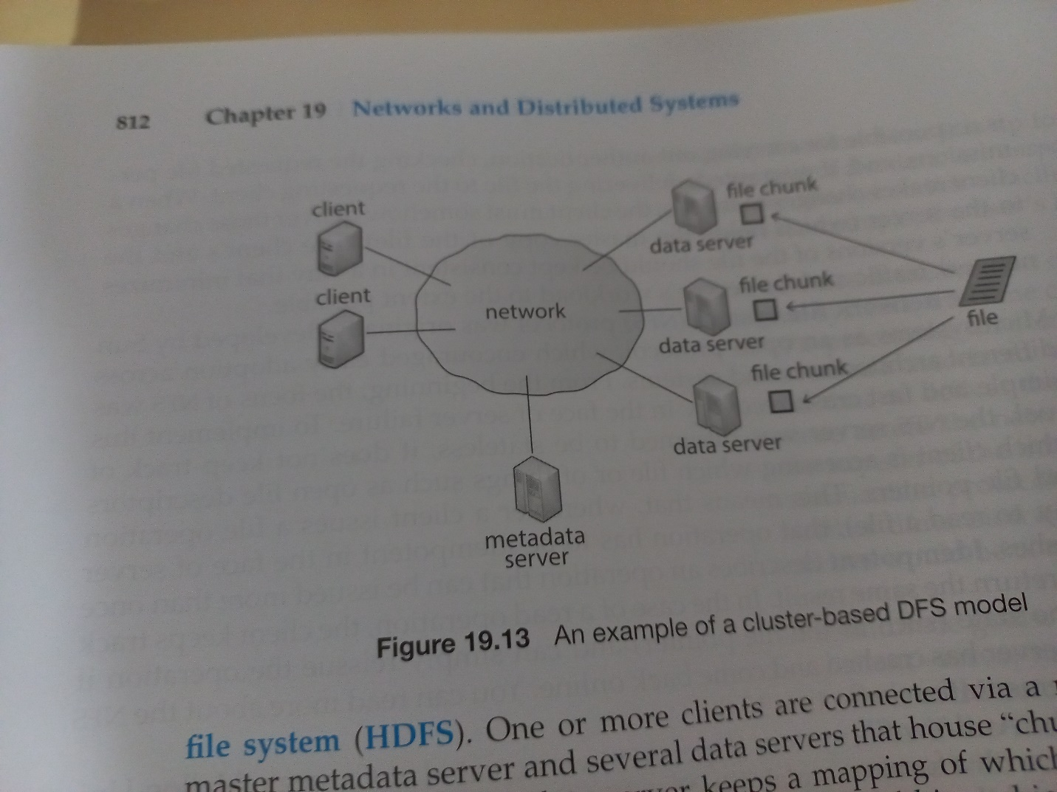

[ref]

[What is DFS (Distributed File System)? - GeeksforGeeks](https://www.geeksforgeeks.org/what-is-dfsdistributed-file-system/)