I/O bound

[intro]

$$An I/O bound is a condition in which time$$

$$it takes to complete a computation is determined principally$$

$$by the period spent waiting for I/O operations to$$

$$be completed.$$

$$This is opposite of CPU bound.$$

[relative terms]

$$1.I/O bound process$$

$$The process is spend more of its time doing I/O$$

$$than it spends doing compution.$$

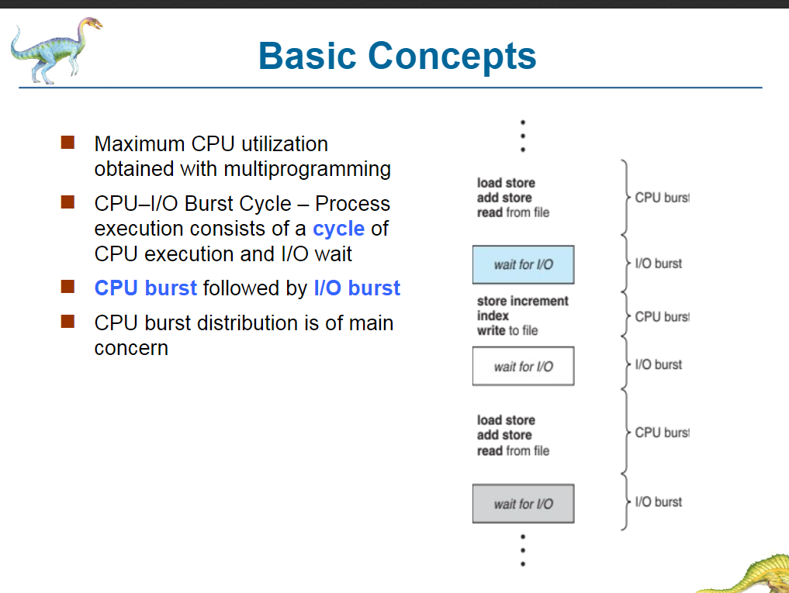

[ref]

[I/O bound - Wikipedia](https://en.wikipedia.org/wiki/I/O_bound)