Interrupt

[intro]

$$An interrupt can force a process to stop its execution.$$

$$After the interrupt action is done,$$

$$then the interrupted process will resume to execute.$$

$$The following figure illustrate$$

$$the major structure of execution of a process$$

$$when an interupt comes.$$

$$NOTE that$$

$$the circle tagged with number attached to$$

$$the directed edge is the step of execution.$$

$$The red line illustrate when an interrupts comes$$

$$what things will be executed first.$$

$$The pruple line illustrates the procedure$$

$$just after a IRQ is sent.$$

$$The blue line illustrates the procedure just after$$

$$the interrupt action is done.$$

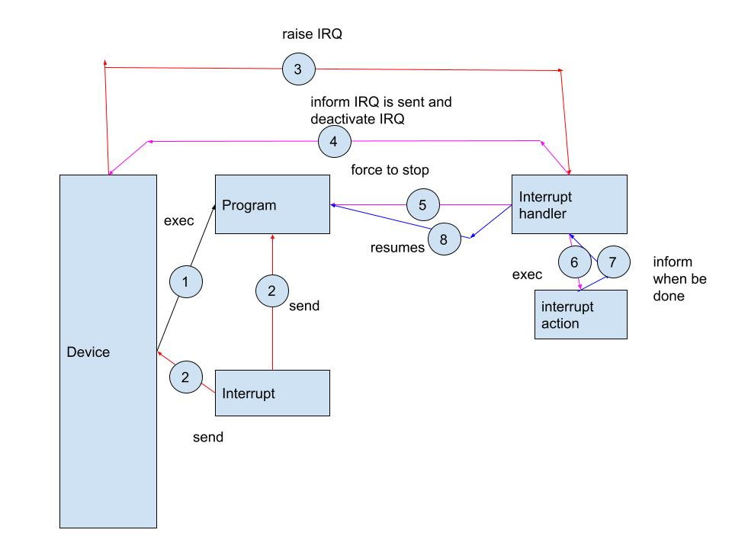

[type]

$$\left(1\right)Hardware interrupt.$$

$$\left(2\right)Software interrupt.$$

[trigger method]

$$\left(1\right)Level-triggered.$$

$$\left(2\right)Edge-triggered.$$

$$Before introduction of trigger method,$$

$$let^{'}s review signal transitions.$$

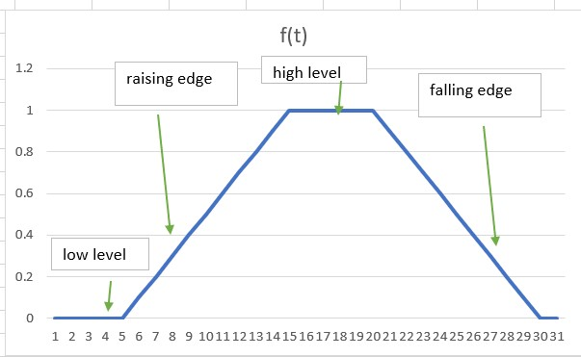

$$Fig \left(a\right) digital signal in practice$$

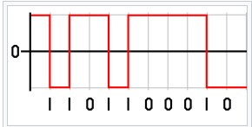

$$Fig\left(b\right) ideally digit signal$$

$$Idealy, the digital signal has low and high level$$

$$without rise latency.$$

$$i.e. The signal can change status from low level to high level$$

$$immediately \left(0s\right).$$

$$However, in practice, it does NOT happen.$$

$$When status is changed from low level to high level.$$

$$There must be exist rising edge.$$

$$Similarly, When status is changed from high level to low level.$$

$$There must be exist falling edge.$$

$$The time rising edge takes$$

$$\left(time from low level to high level\right)$$

$$is called rising latency.$$

$$\left(1\right)Level-triggered:$$

$$Level-triggered signal is emitted in specific level.$$

$$\left(2\right)Edge-triggered:$$

$$In other hand, edge-triggered signal is emitted$$

$$in rising edge or falling edge.$$

[handling method]

$$\left(1\right)polling.$$

$$\left(2\right)interrupt vector.$$

$$\left(3\right)nested interrupt.$$

$$\left(1\right)polling:$$

$$In polling, the first device encounter with IRQ bit set$$

$$\left(its bit is on\right) is served first.$$

$$\left(2\right)interrupt vector:$$

$$It is mentioned in my note (IVT.docx)$$

$$\left(3\right)interrupt nesting:$$

$$In interrupt nesting,$$

$$an interrupt request with highest priority$$

$$will be served first.$$

$$An interrupt request without priority will NEVER be served.$$

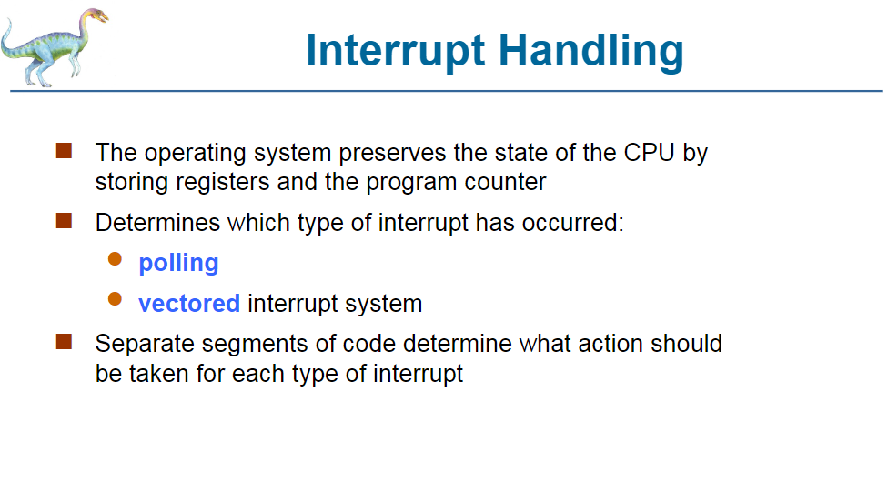

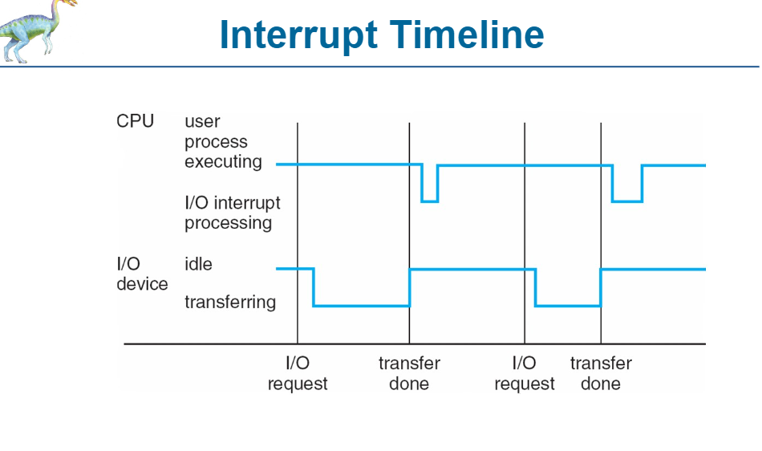

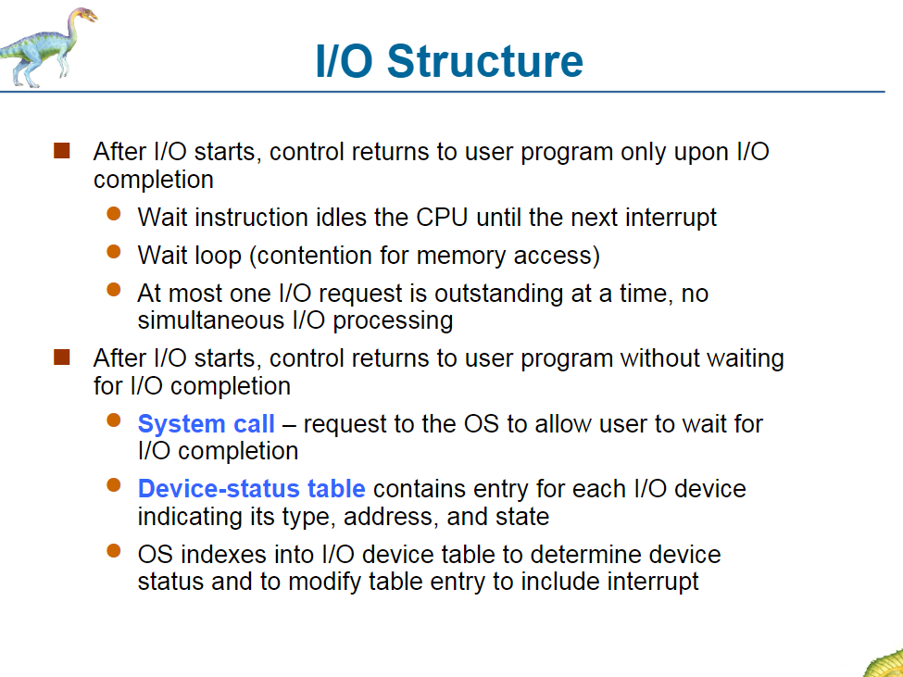

[ref]

[Signal edge - Wikipedia](https://en.wikipedia.org/wiki/Signal_edge#:~:text=A%20rising%20edge%20%28or%20positive%20edge%29%20is%20the,edge%29%20is%20the%20first%20edge%20of%20the%20pulse.)

[Interrupts - GeeksforGeeks](https://www.geeksforgeeks.org/interrupts/)