Linker

[intro]

$$A linker is an object that combines multiple object files$$

$$to make an executable file, an object file, or DLL.$$

[illustration]

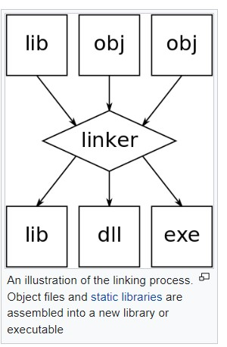

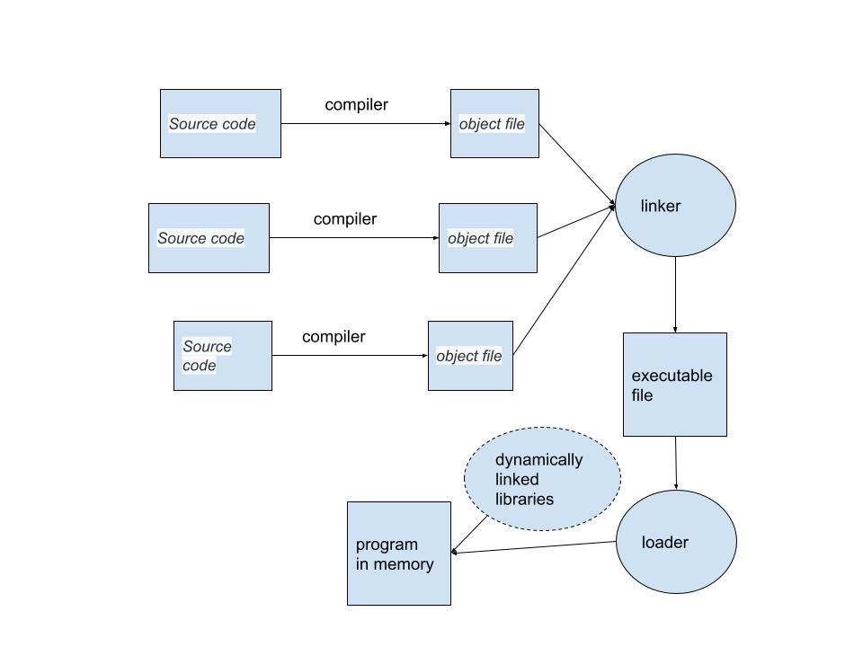

[ref]

[Linker (computing) - Wikipedia](https://en.wikipedia.org/wiki/Linker_%28computing%29)