Loader

[intro]

$$A loader is a progrom to load data.$$

[type]

$$1. absolute loader$$

$$2. relocatable loader$$

$$\left[intro\right]$$

$$According to memory address for relocation,$$

$$we can type them into these catergories.$$

$$1. absolute loader:$$

$$An object which reallocated by an absolute loader$$

$$must be reallocated at same memory address.$$

$$2. relocatable loader:$$

$$An object which reallocated by an absolute loader$$

$$may NOT be reallocated at same memory address.$$

$$For example,$$

$$for an absolute loader A,$$

$$Suppose the object O is allocated at 0x10 initially$$

$$with an absolute loader A.$$

$$Then O must be reallocated at 0x10$$

$$with the absolute loader A.$$

$$(The reason of O have to be reallocated are$$

$$O is interrupted etc.)$$

$$for a relocatable loader B,$$

$$suppose that the object O_{2} is allocated at 0x14 initially$$

$$with relocatable loader B.$$

$$Then O_{2} may be reallocated at 0x22$$

$$with the relocatable loader B.$$

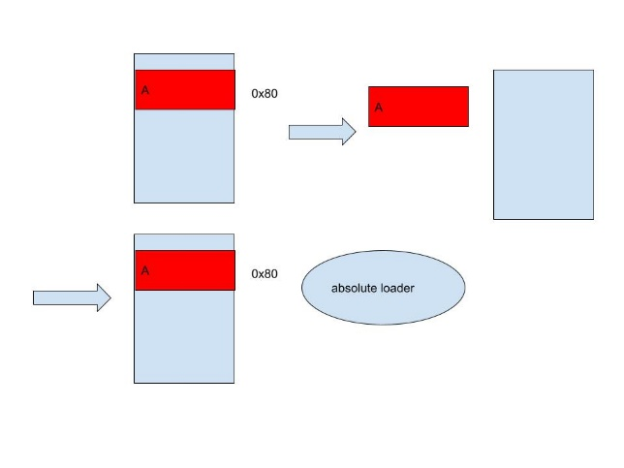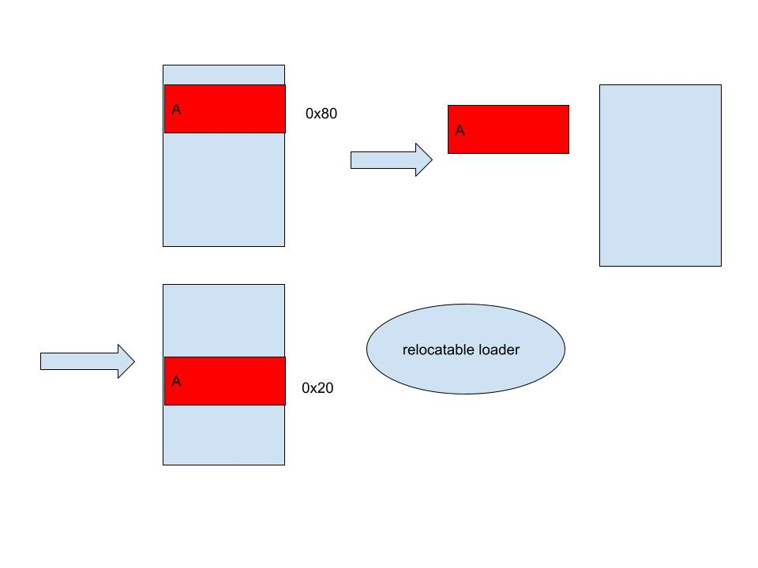

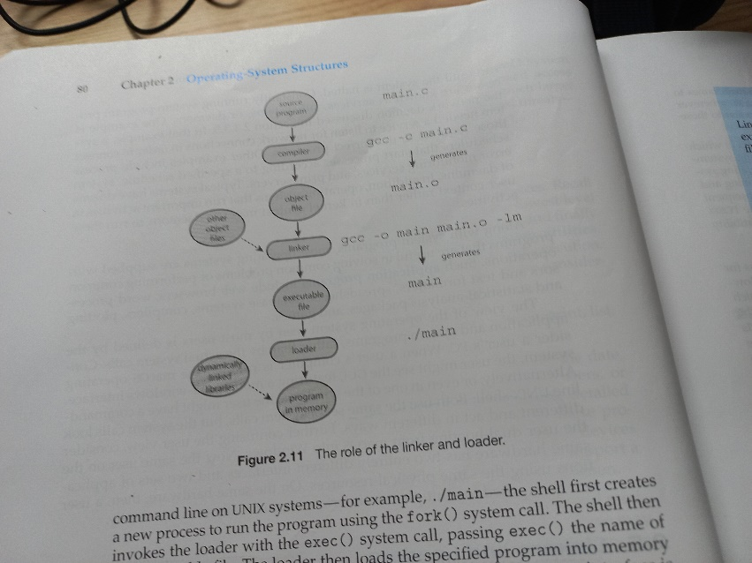

[ref]

[What is relocating loader? | CrazyEngineers](https://www.crazyengineers.com/threads/what-is-relocating-loader.34670)

[SP 6: Part 2: Absolute Loader | Program Linking Loader | Relocating Loader with Examples | Loaders - Bing video](https://www.bing.com/videos/search?q=absolute+loaders&docid=608018480255080372&mid=D62CD84307B405BDB69AD62CD84307B405BDB69A&view=detail&FORM=VIRE)