Memory

[intro]

$$A storage that stores data.$$

[type]

$$They have many types.$$

$$1.By data persistency:$$

$$\left(1\right) (NVM) Non-violatile memory:$$

$$\left[intro\right]$$

$$When the power is off, the data still does NOT disappear.$$

$$By this feature, it usually is used to be a secondary storage.$$

$$Three reasons of usage of secondary storage,$$

$$please refer Ex11-9 and Ex11-10.$$

$$\left[type\right]$$

$$\left(1.1\right) \left(HDD\right) Hard disk drive:$$

$$[intro]$$

$$\left(2\right) \left(VM\right)Voilatile memory:$$

$$\left[intro\right]$$

$$When the power is off, the data dispears.$$

[illustration]

$$1.Memory$$

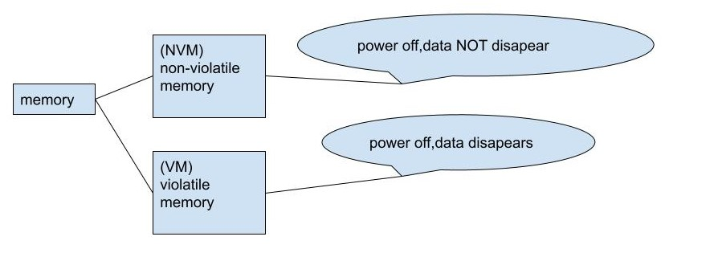

$$2.NVM$$

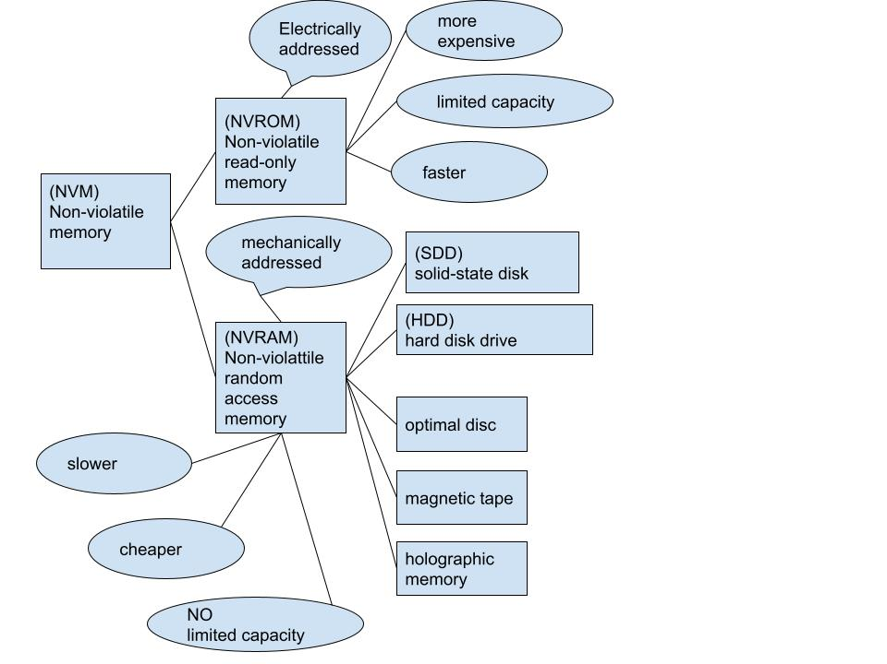

$$3.VM$$

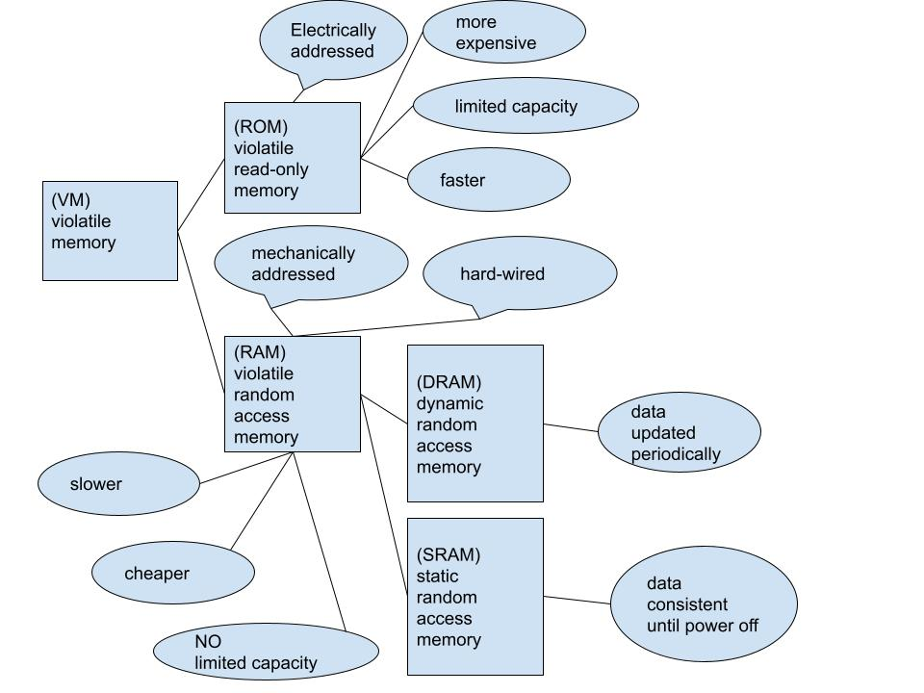

[issue]

$$Q1.Three reasons of usage of secondary storage of$$

$$NVM and HDDs.$$

Ex11-9

$$Q:Give three reasons to use HDDs as secondary storage?$$

$$A:\left(1\right)They are the largest random-storage device$$

$$for the price,providing terabytes of storage at a low cost.$$

$$\left(2\right)Many devices from external chassis to storage arrays$$

$$are designed to use HDDs, providing a wide variety of ways$$

$$to use HDDs.$$

$$\left(3\right)They maintain the same read and write performance$$

$$over their lifetime,unlike NVM storage devices,$$

$$which lose write performance as they get full and as they age.$$

Ex11-10

$$Q:Give three reasons to use NVM devices as secondary storage.$$

$$A:NVM devices are increasing in size and decreasing in price$$

$$faster than HDDs.$$

$$\left(1\right)High-speed NVM devices (including SSDs and$$

$$usually NOT including USB devices)$$

$$are much faster than HDDs. Secondary storage$$

$$speed has a large impact on an overall system performance$$

$$\left(2\right)NVM devices use less power than HDDs,$$

$$making them very useful for laptops and other portable,$$

$$battery-powered devices,$$

$$NVM devices can also be much smaller than HDDs and thus can,$$

$$for example, NVM devices can be surfured-mounted$$

$$to motherboards in devices like in smartphones.$$

$$\left(3\right)Because NVM devices have NO moving parts,$$

$$they tend to be much reliable than HDDs.$$

[ref]

1. NVM:

[Non-volatile memory - Wikipedia](https://en.wikipedia.org/wiki/Non-volatile_memory)

1. HDD:

[Hard disk drive - Wikipedia](https://en.wikipedia.org/wiki/Hard_disk_drive)