Microkernel

[intro]

$$Micro- :less$$

[concept]

$$1.Keep only essential componenets.$$

$$That is, 2.remove all nonessential components.$$

[pro]

$$\left(1\right)less space required.$$

$$\left(2\right)faster,$$

$$more space used, more memory allocation we used,$$

$$more time we spend.$$

$$\left(3\right)lower cost.$$

$$\left(4\right)more secure$$

$$since there are fewer functionalities and bugs.$$

$$\left(5\right)easiler maintenance$$

$$since there are fewer bugs.$$

[con]

$$\left(1\right)less functionality to extend.$$

[structure]

$$The following figure shows$$

$$the typical structure of microkernels.$$

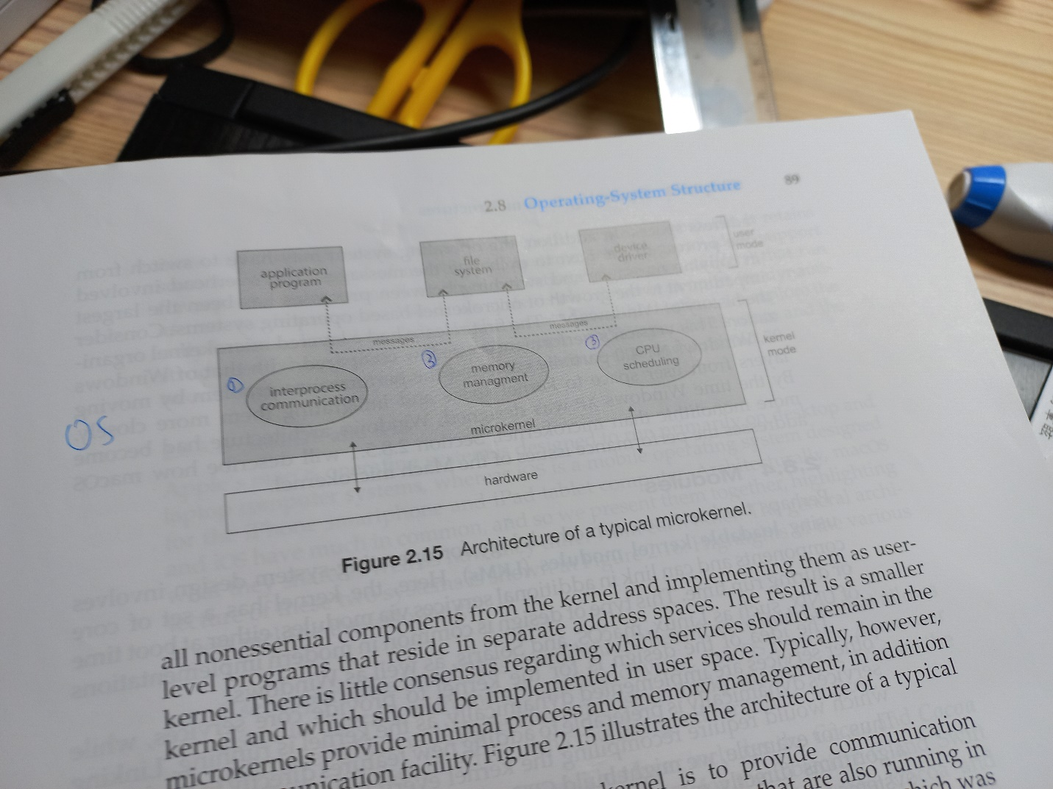

[ref]

[Microkernel - Wikipedia](https://en.wikipedia.org/wiki/Microkernel)