Monitor

[intro]

$$A monitor declares many objects for signals.$$

[implementation]

$$An implementation of a monitor using semaphores.$$

wait(mutex);

if(next_count>0)signal(next);

else signal(mutex);

x.wait()

{

x_count++;

if(next_count>0)signal(next);

else signal(mutex);

wait(x_sem);

x_count--;

}

x.signal()

{

if(x_count>0)

{

next_count++;

signal(x_sem);

wait(next);

next_count--;

}

}

[illustration]

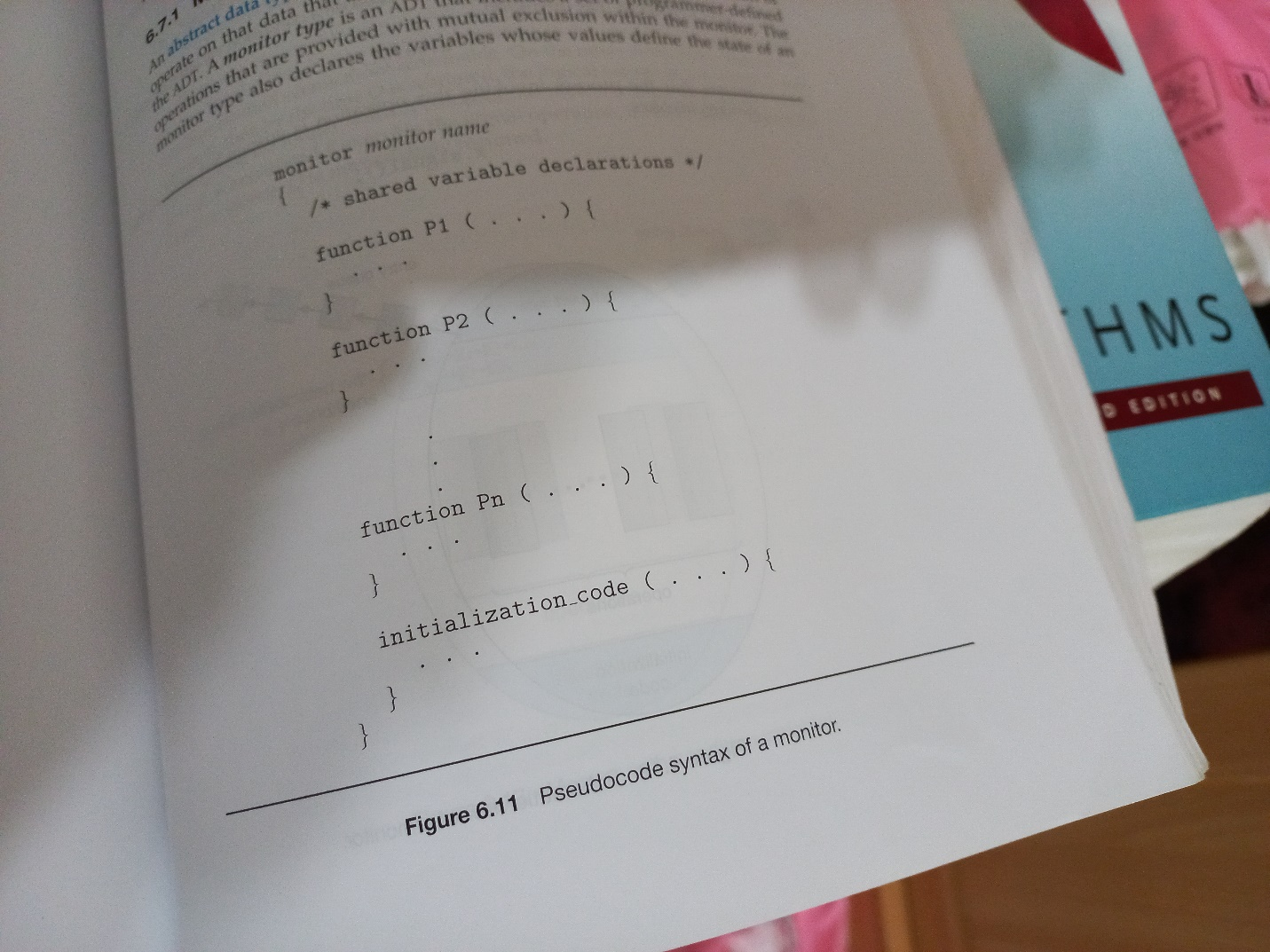

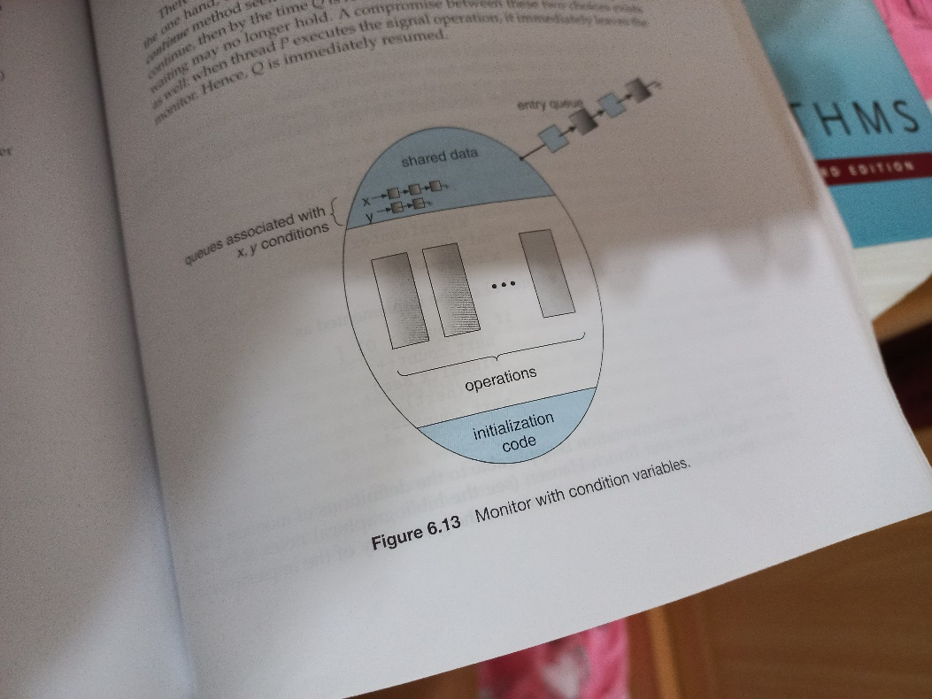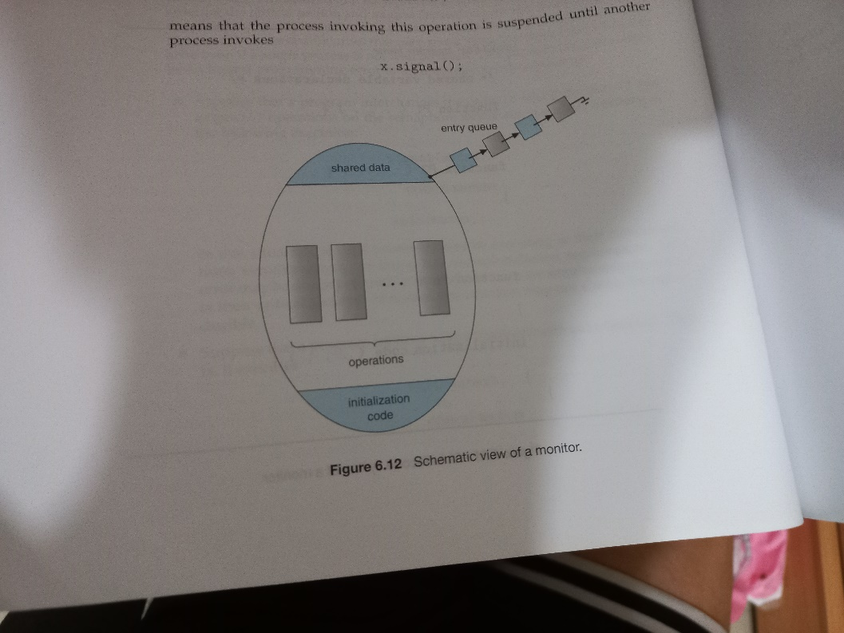

[ref]