Multiple Processor

[intro]

[type]

$$1.Homogeneous proccesor.$$

$$2.Heterogeneous processor.$$

$$1.Homogeneous proccesor:$$

$$Homo-:Same$$

$$All processes are handled in the same processor.$$

$$2.Heterogeneous multiprocessor:$$

$$Hetero-:different$$

$$All processes are handled in their own processors.$$

$$1.Asymmetric multiprocessing.$$

$$2.Symmetric multiprocessing.$$

$$1.Asymmetric multiprocessing:$$

$$Only 1 processor access the system data structure.$$

$$2.Symmetric multiprocessing:$$

$$Each process is self-scheduling.$$

$$All processes are in common ready queue, or$$

$$each process has its own private queue of ready processes.$$

[Affinity]

[type]

$$1.Soft affinity.$$

$$2.Hard affinity.$$

$$1.Soft affinity:$$

$$Attempting a process to run on same processor$$

$$\left(but NOT guarantee\right) when needed.$$

$$2.Hard affinity:$$

$$The process must be run on same processor \left(if needed\right).$$

[migration]

[type]

$$The reason about migration is that to load balancing.$$

$$1.Push migration.$$

$$2.Pull migration.$$

$$1.Push migration:$$

$$A CPU asks OS to assign the process into other CPU.$$

$$It happens when the CPU workload is too heavy.$$

$$2.Pull migration:$$

$$A CPU asks OS to assign the process from other CPU$$

$$into the CPU.$$

$$It happens when the CPU workload is too light.$$

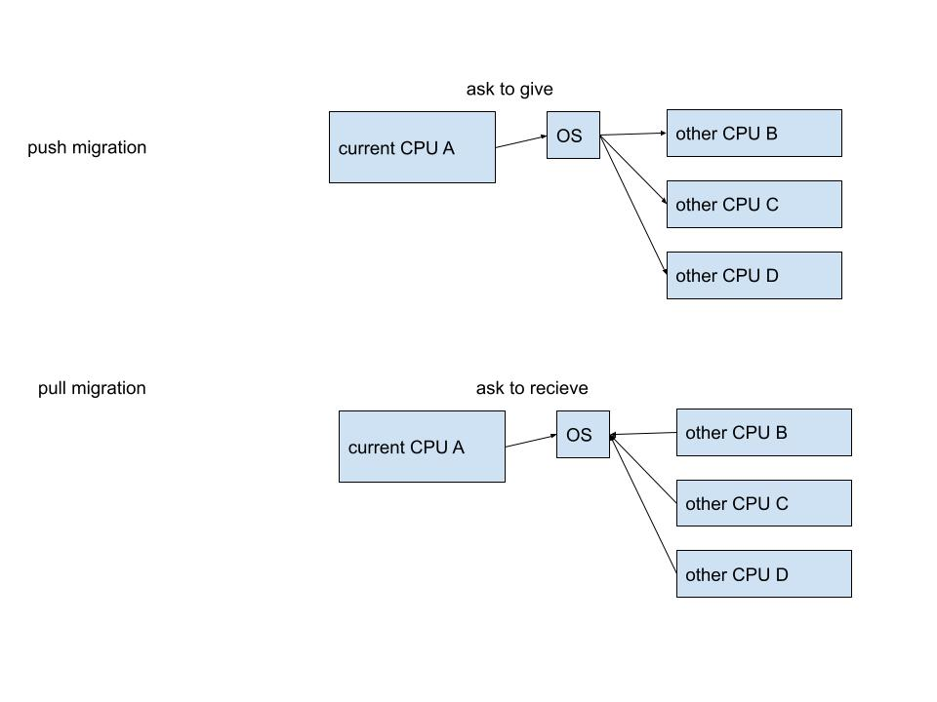

[ref]

[Multiple-Processor Scheduling in Operating System - GeeksforGeeks](https://www.geeksforgeeks.org/multiple-processor-scheduling-in-operating-system/)