Multiprocess

[intro]

$$Q:Why do we have multiprocess?$$

$$A:Consider a web browser with single process.$$

$$If one website causes a problem$$

$$=>The single process crashes or hanges$$

$$=>Other websites crash and hang.$$

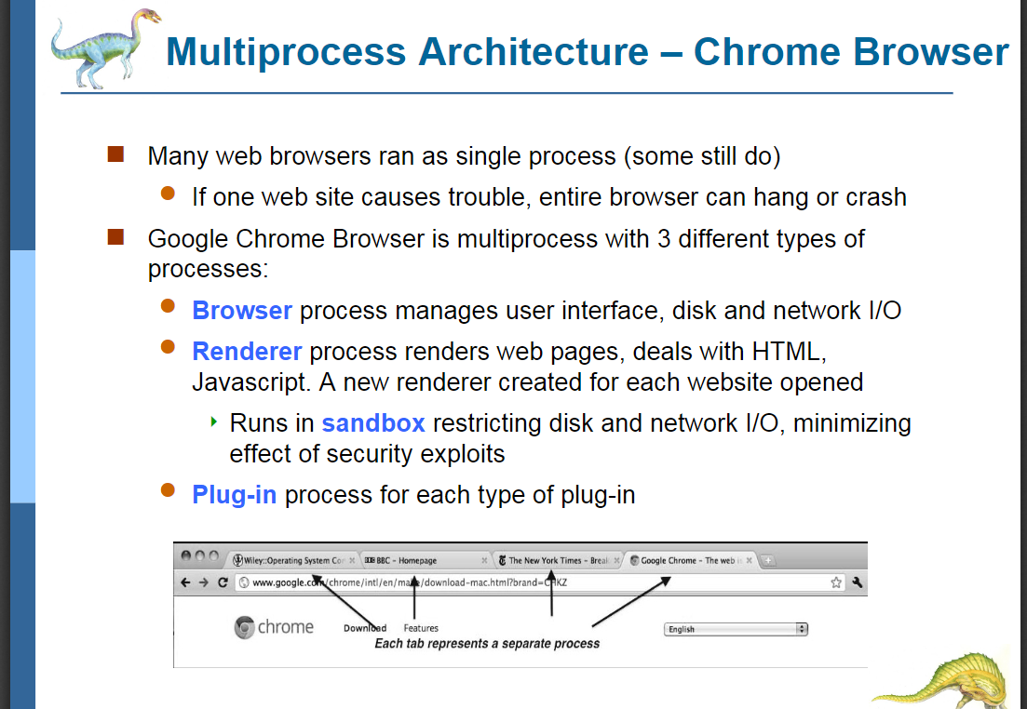

$$Since this reason,$$

$$there exist multiprocess web browsers.$$

$$Multiprocess web browsers use a multiprocess.$$

$$When a website is crashed or hanged.$$

$$The multiprocess will handle other websites.$$

$$You can consider a website is a process.$$

[E.g.]

$$At present, for google chrome,$$

$$it is multiprocess with 3 different types.$$

$$Browser process manages user interface,$$

$$disk and network IO.$$

$$Renderer processes renderes web pages,$$

$$deals with HTML, Javascript.$$

$$A new renderer created for each website opened.$$

$$Runs in sandbox restricting disk and network IO,$$

$$minimizing the effect of security exploits.$$

$$Plug-in process for each type of plug-in.$$

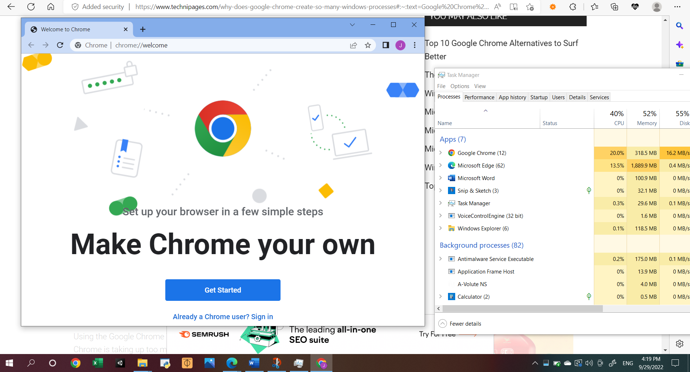



$$\left[bonus\right]$$

$$Q:How to look at process via google task manager?$$

$$A:\left(1\right)Open google chrome.$$

$$\left(2\right)select any one of pages from google chrome.$$

$$\left(3\right)Press \text{shift+esc}$$

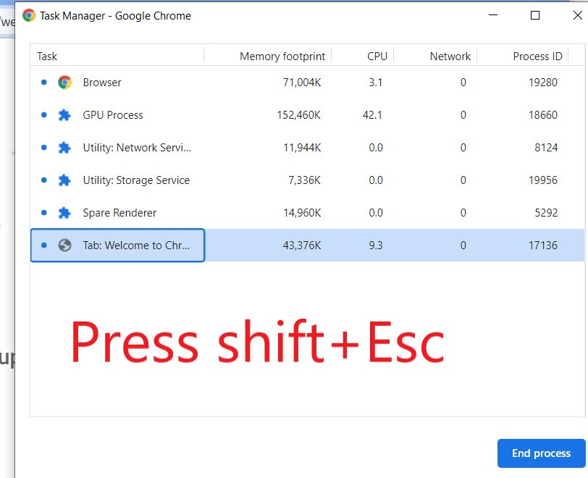

$$For more details see this page.$$

[ref]

[Google Chrome Creates Multiple Windows Processes (technipages.com)](https://www.technipages.com/why-does-google-chrome-create-so-many-windows-processes#:~:text=Google%20Chrome%20is%20designed%20to%20run%20functionality%20for,a%20process%20just%20for%20the%20main%20browser%20functionality.)