Multithread execution

[term]

Take a P-FIB pseudo code for example.

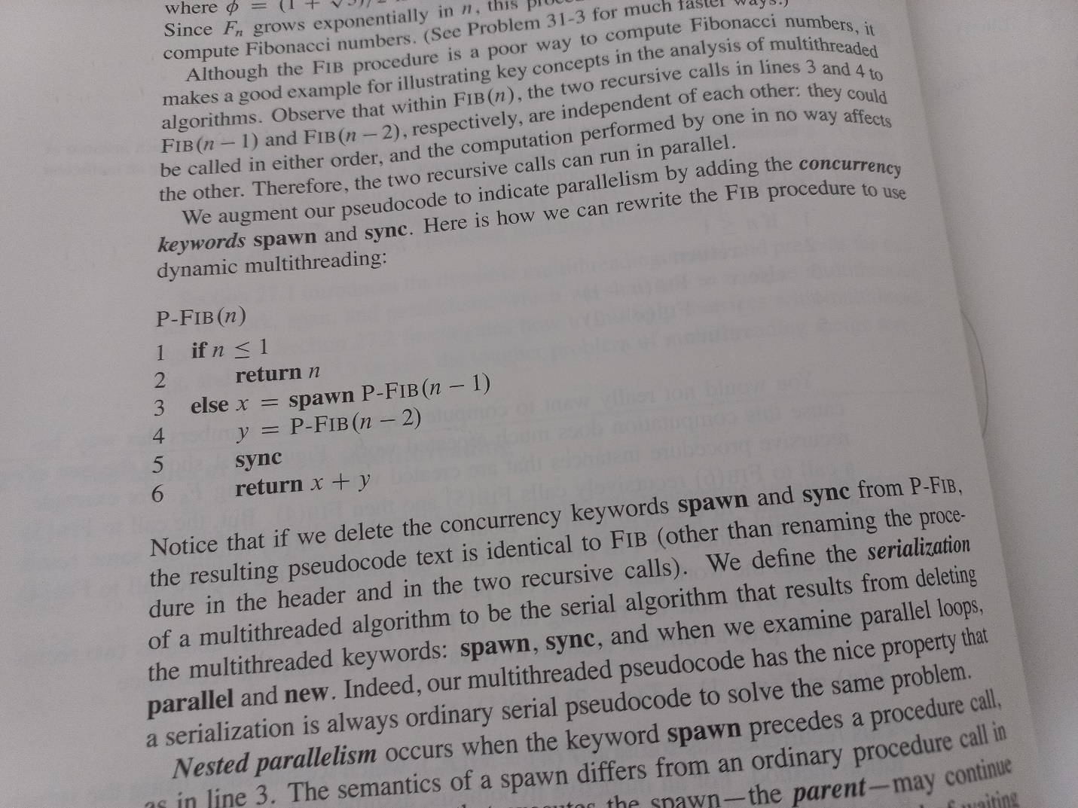

The procedure of computing P-FIB(4)

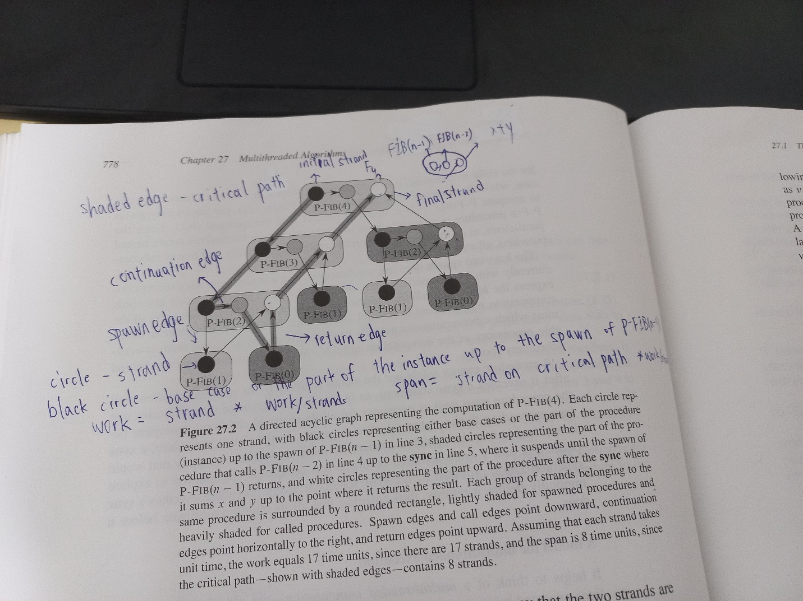

1. strand: vertex (or a circle)
2. black circle: base case of the part of the instance up to the spawn of P-FIB(n-1).
3. shaded circle: the part of the instance up to the call of FIB(n-2).
4. white circle: procedure of summing up x and y.
5. shaded edge: critical path
6. continuation edge: points to right.
7. spawn edge: points downward or right downward.
8. return edge: points to upward or right upward.
9. work(G): number of strands.
10. span(G) number of strands on the critical path.
11. initial strand: the source vertex of the graph.

Its indegrees must be 0. And it must be a black circle.

1. final strand: the sink vertex of the graph.

Its outdegrees must be 0. And it must be a white circle.

[intro]

[term]

[identity]

[term]

[identity]

[term]

[theorem]

Page from 782 of the textbook

[pf]